Shervice: A GT LANTIN Shuttle Service Management System with Driver Performance Analytics and Predictive Maintenance

A Capstone Project
Presented to the Faculty of
College of Informatics and Computing Sciences
BATANGAS STATE UNIVERSITY
The National Engineering University
Lipa City

In a Partial Fulfillment
of the Requirements for the Degree
Bachelor of Science in Information Technology
Business Analytics

By

Sean Martin L. Del Rosario
Ralph Emmerson V. Lucero
Filemon Laurel A. Mendoza

Ms. Lovely Rose Tipan-Hernandez
Adviser

October 2026

Table of Contents
1. INTRODUCTION 11
1.1 Project Context 11
1.2 Purpose and Description 15
1.3 Objectives of the Study 17
1.4 Scope and Limitations 19
1.5 Definition of Terms 22
2. REVIEW OF RELATED SYSTEMS/STUDIES 25
2.1 Technical Background 25
2.1.1 Web System Technologies 26
2.1.2 Cloud-Based Infrastructure 27
2.1.3 Predictive Analytics and Machine Learning 28
2.2 Related Literature 29
2.3 Related Studies 32
2.4 Related Systems 40
2.5 Synthesis 45
2.6 Conceptual Framework 46
3. DESIGN AND METHODOLOGY 48
3.1 Project Concepts 48
3.2 Development Model 50
3.3 Requirements Analysis 52
3.4 System Design 55
3.4.1 Software Requirements Specifications 89
3.5 Development 96
3.6 Testing and Evaluation 102
3.7 Deployment 128
3.7.1 Sustainability and Maintenance Plan 128
4. RESULTS AND DISCUSSION 132
4.1 Analysis of Shervice System Modules and Features 132
4.2 Machine Learning Model Evaluation and Performance Metrics 159
5. SUMMARY, CONCLUSIONS, AND RECOMMENDATIONS 176
5.1 Summary 176
5.2 Conclusions 178
5.3 Recommendations 179

LIST OF EQUATIONS
Equation 3-1 Euclidean Distance Formula for KNN 81
Equation 3-2 Multiple Regression Formula 82
Equation 3-3 K-means Clustering Formula 84
Equation 3-4 Root Mean Squared Error Formula 85
Equation 3-5 Coefficient of Determination Formula 86
Equation 3-6 Mean Absolute Error Formula 87
Equation 3-7 Accuracy Formula 87
Equation 3-8 Precision Formula 88
Equation 3-9 Recall Formula 88
Equation 3-10 F1-Score Formula 89

LIST OF TABLES
Table 3-1 Functional Requirements 91
Table 3-2 Trade Off Analysis 95
Table 3-3 Multiple Attributes 96
Table 3-4 Software Development Tool 99
Table 3-5 Hardware Development Tools 101
Table 3-6 Functional Suitability 106
Table 3-7 Performance Evaluation 108
Table 3-8 Usability 110
Table 3-9 Security 112
Table 3-10 Reliability 114
Table 3-11 Maintainability 116
Table 3-12 Functional Suitability Questionnaire 119
Table 3-13 Performance Efficiency Questionnaire 120
Table 3-14 Usability Questionnaire 121
Table 3-15 Security & Reliability Questionnaire 122
Table 3-16 Maintainability Questionnaire 123
Table 3-17 Portability Questionnaire 124
Table 3-18 Daily Functionality Questionnaire 125
Table 3-19 Speed & Reliability Questionnaire 126
Table 3-20 Ease of Use Questionnaire 127
Table 3-21 Access & Trust Questionnaire 128
Table 4-1 Evaluation of Driver Performance Classification (KNN) 161
Table 4-2 Accuracy of Vehicle Maintenance Forecasting (MLR) 163
Table 4-3 Validation of Destination Demand Profiling (K-Means) 165
Table 4-8 Overall Summary of End-User Evaluation 167
Table 4-9 Summary of Functional Suitability 168
Table 4-10 Summary of Performance Efficiency 169
Table 4-11 Summary of Usability 170
Table 4-12 Summary of Security 171
Table 4-13 Summary of Reliability 172
Table 4-14 Summary of Maintainability 173
Table 4-15 Summary of Portability 174
Table 4-16 Overall Summary of IT Expert Evaluation 175
Table 4-4 Summary of Daily Functionality 200
Table 4-5 Summary of Speed and Reliability 201
Table 4-6 Summary of Ease of Use 202
Table 4-7 Summary of Access and Trust 203

LIST OF FIGURES
Figure 2-1 Conceptual Framework 47
Figure 3-1 Agile Methodology (Obeya Associates, 2025) 50
Figure 3-2 System Architecture 57
Figure 3-3 Login Flowchart 58
Figure 3-4 Admin Flowchart 60
Figure 3-5 Staff Flowchart 60
Figure 3-6 Dashboard Flowchart 61
Figure 3-7 Analytics Flowchart 70
Figure 3-8 Settings Flowchart 71
Figure 4-1 Admin and Staff Dashboard 134
Figure 4-2 Trip Summary Management Interface 136
Figure 4-3 Summary Trips 137
Figure 4-4 Add and Edit Summary Interface 138
Figure 4-5 Vehicle Management Interface 139
Figure 4-6 Vehicle Registration Form 140
Figure 4-7 Maintenance/Repair Log Interface 141
Figure 4-8 Route Management Interface 142
Figure 4-9 User Management Interface 143
Figure 4-10 Driver Management Interface 146
Figure 4-11 Attendance Management Interface 147
Figure 4-12 Payroll Management Interface 148
Figure 4-13 Account Settings Interface 149
Figure 4-14 Executive Operations Dashboard 151
Figure 4-15 Driver Performance Classification Interface 152
Figure 4-16 Individual Driver Performance Interface 153
Figure 4-17 Internal Driver Evaluation Form 154
Figure 4-18 Vehicle Predictive Maintenance Interface 155
Figure 4-19 Individual Vehicle Maintenance Forecast 156
Figure 4-20 Destination Demand Profiling Interface 158
Figure 4-21 Destination Demand Profiling Trip Breakdown Interface 159

INTRODUCTION

1.1 Project Context
The transportation industry has undergone significant development driven by the necessity for continuous operational monitoring and efficient fleet management (Data Bridge Market Research, 2025). Internationally, Shuttle services are transitioning from manual tracking to centralized digital platforms. This shift is reliant on data-driven systems to monitor vehicle conditions, track driver performance, and anticipate maintenance requirements before critical failures occur (Insite, 2023). By moving away from manual records and reactive problem-solving, modern fleet operators are able to establish secure, transparent, and seamless workflows that ensure consistent service delivery.
In the Philippines, the modernization of transportation systems is heavily supported by national frameworks such as the Public Transport Modernization Program (PTMP), which advocates for industry consolidation, fleet management, and the digitalization of transport operations (PISTON, 2024). The program encourages local transport providers to adopt centralized monitoring systems to elevate service quality and ensure strict regulatory compliance. However, despite these recommended solutions, financial constraints and a lack of technological integration leave many mid-sized corporate and private shuttle services dependent on traditional methods (Pagero, 2022). These conventional practices limit their operational efficiency and their ability to adapt to an increasingly digitized logistical landscape.
Locally, the Lipa-Malvar corridor in Batangas serves as a critical industrial hub, anchored by the LIMA Estate, which is recognized as the largest privately-owned industrial park in the Philippines. LIMA Estate generates massive logistical demands that traditional public transportation networks are insufficient to support (InsiderPH, 2026). Consequently, private shuttle rental services have become an absolute operational necessity to accommodate the high-volume transit required by the strict shift schedules of these manufacturing enterprises. GT LANTIN manages a high-volume employee transport network for three major manufacturing clients, underscoring the critical need for a centralized digital management system. Specifically, the provider deploys 59 vehicles for EPSON handling up to 5,000 passenger trips per week, 12 vehicles for Bandai Namco managing up to 5,250 trips, and 5 vehicles for NX Logistics facilitating up to 2,100 trips. Ultimately, manually coordinating a total fleet of over 70 vehicles and more than 12,000 weekly passenger trips using only physical whiteboards and paper logbooks presents a severe administrative limitation, which strictly justifies the development of Shervice to centralize and automate their dispatching operations. Consistently mobilizing the workforce for these major corporations requires rigorous daily coordination and precise vehicle routing.
The business encounters significant operational challenges due to its continuous reliance on manual and redundant administrative methods. The management of driver records, vehicle assignments, and attendance is currently handled through physical logbooks, spreadsheets, and basic messaging applications. This fragmented approach inevitably results in disorganized data, a lack of process standardization, and frequent inaccuracies that cause delays in daily driver and vehicle operations. Consequently, the inability to monitor real-time vehicle status and track driver performance consistently hinders the company's compliance efforts and restricts its potential for scalable growth.
To address these operational challenges, the developers propose the development of Shervice: GT LANTIN Shuttle Service Management System with Driver Performance Analytics and Predictive Maintenance. The system will act as a centralized web-based platform that manages important operational information such as driver records, vehicle assignments, and trip schedules. Instead of relying on manual logbooks and multiple spreadsheets, administrators will be able to record and access data through a single organized system. To ensure the absolute integrity of these records, the platform will utilize Fingerprint Biometrics to automate attendance tracking, providing a verifiable and tamper-proof log of driver punctuality. This integration will help reduce errors, keep records more consistent, and make daily driver and vehicle operations easier to manage.
The integration of driver performance tracking utilizing predictive analytics was specifically chosen to transition the organizational management style from a reactive approach to a proactive operational strategy. Previously, the transport provider relied on manually calculating a 15-point evaluation scale at the end of an evaluation period, which often resulted in delayed administrative responses to driver absenteeism or declining service quality. By implementing predictive analytics, the proposed system leverages historical operational data, such as attendance patterns to mathematically forecast potential performance degradation before it severely impacts the daily dispatch schedule. This proactive capability is critical for GT LANTIN, as their primary corporate clients operate within highly demanding manufacturing sectors that require strict transportation punctuality. Ultimately, this predictive feature empowers the administrative staff to anticipate workforce shortages, address behavioral trends early, overlooking vehicle status, and allocate available resources more effectively, thereby ensuring continuous and reliable service delivery without relying on expensive physical tracking hardware.

1.2 Purpose and Description
The proposed system, Shervice, can help improve how rental shuttle businesses manage their daily driver and vehicle operations. The business currently relies on manual records or separate systems to monitor drivers, vehicles, and trips. Because of this, information can become disorganized and difficult to analyze. The proposed system provides a centralized platform where operational data can be stored, monitored, and analyzed, helping businesses manage their services more efficiently.
For shuttle service owners and administrators, the system can make it easier to track drivers, vehicles, schedules, and service performance. Instead of reviewing multiple files or manual records, administrators can access organized information on one platform. The system analytics features can also help them understand patterns in operations, such as driver performance, vehicle usage, and demand for shuttle services. These insights can support better decision-making and help businesses improve their overall operations.
For the staff, the system establishes a highly organized digital workflow that eliminates the previous reliance on physical whiteboards and cellular messaging. The system will utilize fingerprint biometrics to efficiently track attendance of each driver on duty. For the administrative staff, this centralization allows them to efficiently allocate transport resources and monitor live fleet deployment from a single dashboard. By ensuring that all schedules, attendance records, and route statuses are synchronized and accessible in real-time, the system drastically reduces miscommunication between deployed drivers and the dispatching office, thereby streamlining the entire daily operation.
In the Business Analytics field, this study shows how data collected from daily operations can be used to support better business decisions. The system organizes operational data and presents it through analytics dashboards that help administrators identify trends and performance indicators. By analyzing driver performance, vehicle utilization, and service demand, the system demonstrates how analytics can help businesses understand their operations and plan improvements. This highlights the role of business analytics in transforming raw operational data into meaningful insights that support strategic and decision-making processes.
Lastly, the study may also serve as a reference for future researchers and students who are interested in applying business analytics to transportation and service industries. It demonstrates how analytics tools, data management, and information systems can work together to solve real operational problems and improve business performance.

1.3 Objectives of the Study
The general objective of the study is to design and develop a centralized platform that automates record-keeping and provides data-driven operational insights for rental shuttle services to improve organizational efficiency and reliability.
Specifically, the study aims to achieve the following:
1.0 To design and develop a web-based management system using a modern technology stack for the frontend, backend logic, machine learning operations, and relational database management, featuring:
1.1. Driver Profile and Records Management
1.2. Vehicle Profile and Status Monitoring
1.3. Biometric Attendance and Punctuality Tracking:
1.4. Driver-Vehicle Assignment and Trip Summaries
1.5. Maintenance and Compliance Tracking
1.6. Real-time Notifications and Alerts
1.7. Staff Feedback Collection
2.0 To integrate Business Analytics tools and Machine Learning concepts to transform raw operational data into actionable insights, including:
2.1. Performance Analytics Dashboards for real-time KPI visualization.
2.2. Descriptive Analytics for generating historical vehicle utilization reports.
2.3. Predictive Analytics using Multiple Linear Regression for forecasting upcoming vehicle maintenance
2.4. Driver Performance Classification for categorizing drivers based on behavioral and performance issues.
2.5 K-Means Clustering for Destination Demand Profiling
3.0 To evaluate the system’s performance and the accuracy of the integrated analytics models using the following metrics:
3.1. Accuracy, Precision, Recall, and F1-score to determine the reliability of driver performance classification models.
3.2 Calculating Mean Absolute Error (MAE), Root Mean Squared Error (RMSE), and R-Squared to evaluate the accuracy of the maintenance forecasting model.
3.3 Utilizing the Silhouette Score to validate the consistency of the destination demand profiling.
3.4. System Quality Standards: Evaluating the overall system using ISO standards to ensure it meets the operational needs of GT LANTIN.

1.4 Scope and Limitations
Shervice is designed to centralize and automate the driver and vehicle operations of GT LANTIN Shuttle Rental Services. The platform strictly supports only two distinct user roles: Administrator and Staff. The Administrator and Staff manage comprehensive driver records, oversee vehicle dispatching, and monitor daily operational status. To ensure fleet reliability, the system tracks vehicle maintenance schedules and regulatory compliance deadlines. Additionally, interactive analytics dashboards provide management with data-driven insights into driver performance, punctuality, and overall fleet utilization. The system is developed to be responsive and accessible across standard web-enabled devices. The system incorporates a dedicated fingerprint biometric module at the dispatch terminal to strictly automate driver attendance, thereby ensuring the absolute integrity of punctuality data and eliminating the risks associated with manual logbook entries. The scope of this biometric tracking is limited to the physical terminal location, meaning only one hardware unit is available for attendance logging.
Despite its comprehensive design, the system operates within defined operational boundaries. The platform is strictly confined to the driver and vehicle operations of GT LANTIN Shuttle Rental Services for its existing corporate partners and does not include a public-facing portal or mobile application for external retail customer bookings and reservations. To ensure strict compliance with data privacy protocols, no actual personal records or sensitive information from clients, drivers, or staff will be provided to the developers. All system development, testing, and evaluation will rely exclusively on mock or sample data to fully protect user privacy.
Because dedicated system portals for external Client Officers-in-Charge (OIC) and Field Drivers are excluded from the system scope, all operational data management relies entirely on manual encoding the internal Administrator and Staff. The acquisition of shift schedules and routing locations remains the responsibility of the corporate clients, which are then officially inputted into the platform by the dispatch staff. Similarly, the system relies on manual data entry from the staff based on field reports submitted by drivers to monitor trip durations, route completions, and maintenance schedules.
To ensure absolute data integrity for the predictive analytics engine, the system strictly delimits manual attendance logging and relies exclusively on the integrated fingerprint biometric hardware at the dispatch terminal to record precise driver time-in and time-out. The system specifically excludes integration with external hardware, such as live GPS devices or On-Board Diagnostics sensors for automated geographical tracking and real-time engine diagnostics. This decision was informed by the client's current operational requirements and existing budgetary constraints. By focusing on centralized internal logs rather than automated vehicle hardware, the developers prioritize a cost-effective, scalable software solution that aligns with the business logic of GT LANTIN while still providing the necessary data for performance analytics and fleet management. The implementation and evaluation of the system are geographically delimited to the current operational routes of the business within the province of Batangas.
The system aims to resolve existing administrative challenges and enhance the operational efficiency of the business. It provides a tailored digital solution that organizes data management, streamlines daily fleet monitoring, and supports informed, strategic decision-making within the organization.

1.5 Definition of Terms
This section provides definitions of essential terms and concepts that apply to Shervice. The included definitions provide conceptual and operational definitions designed for a better understanding when discussing the system's features along with its processes and objectives.
Clients. Entities that engage in ongoing, collaborative partnerships with a business, characterized by long-term engagement, high service customization, continuous communication, and a high level of trust (Creatio, 2025). Operationally, the clients in this study are the multinational manufacturing corporations (which are EPSON, Bandai Namco, NX Logistics and their respective Officers-in-Charge. These companies maintain a strategic, contracted relationship with GT LANTIN to dictate customized daily shift schedules, explicitly distinguishing them from standard consumers.
Key Performance Indicators (KPI) Key Performance Indicators (KPIs) are quantifiable measures used to evaluate the success of an organization or of a particular activity in which it engages to ensure that operational goals are being met (Investopedia, 2024). In this project, KPIs refers to the visualizations that include the total trips per vehicle, real-time driver reliability classifications, and predictive maintenance alerts. Financial analytics, such as fuel consumption , shall fall outside the scope of this deployment.
OBD. OBD or On-Board Diagnostics is a built-in automotive diagnostic system that monitors engine performance and transmits real-time telematics data, such as live geographical location, speed, and fuel consumption (California ARB, 2025) The integration of OBD hardware and automated sensors is strictly delimited. The proposed system does not utilize OBD technology; instead, it relies exclusively on manual digital inputs from drivers and dispatching staff to track vehicle status and attendance, ensuring a highly cost-effective and software-centric implementation.
Officer-in-Charge (OIC). A designated administrative representative responsible for overseeing specific logistical operations and personnel on behalf of an organization (Indeed 2025). Operationally, the OIC in this study refers to the authorized representatives of the multinational corporate clients partnered with GT LANTIN. They serve as the primary managerial link between the manufacturing corporations and the transport provider. Within the proposed digital platform, the OIC is strictly responsible for providing customized daily shift schedules to the staff directly.
The Public Transport Modernization Program (PTMP). A national initiative by the Philippine government aimed at transforming the public transport sector into an efficient system that is comfortable, accessible, safe, sustainable, and affordable (NCTS UP Diliman, 2024). Operationally, PTMP serves as the regulatory backdrop for this study, justifying the transition from manual, dilapidated record-keeping methods to the digital, standardized fleet management practices implemented in the Shervice system.

REVIEW OF RELATED SYSTEMS/STUDIES
This chapter involves the review of related studies and systems that serve as the foundational framework for the development of the Shervice. The proponents gathered relevant information from existing transportation management platforms as well as supporting information on the importance of digitalized systems for supporting fleet management. This includes an in-depth analysis of technical stacks, operational tracking methodologies, and current findings on fleet digitalization. By examining these related systems and studies, the proponents aim to identify the essential features, potential challenges, and best practices that will ensure the proposed system's efficiency, data accuracy, and practical usability.

2.1 Technical Background
The technical background provided within this study is intended to offer a thorough examination of the concepts, methodologies, tools, and algorithms that are essential to the development of the proposed system, Shervice. This section is intended to provide a topical outline to assist the reader in navigating the essential technologies, software, hardware, data analytics, and machine learning that provide a foundation for the proposed system. The essential technologies provided within this section include shuttle management systems, web-based applications, database management, business analytics, machine learning, and performance metrics. This delineation of essential foundations is intended to provide an understanding of the rationale behind the proposed system, criteria for selecting tools, and essential methodologies.

2.1.1 Web System Technologies
To ensure accessibility and operational efficiency as stated in the project objectives, the system utilizes a responsive web-based approach that allows a single codebase to remain accessible across desktop monitors and terminal tablets used by the internal staff. The frontend of Shervice serves to two distinct user groups: Administrators and Staff. It is developed using a component-based architecture through Flutter and Dart to ensure a responsive and consistent user experience. Flutter’s reactive widget tree manages the visual presentation and interactive logic, ensuring the dashboard remains fluid for administrative staff monitoring live fleet updates. The backend infrastructure is implemented using a dual-runtime environment where Node.js with Express.js serves as the primary runtime for handling asynchronous tasks, RESTful API integrations, and high-velocity data ingestion from the biometric attendance terminal. Complementing this, Python is integrated via the Flask micro-framework specifically to handle high-level computational tasks and analytical microservices, ensuring the system can process complex calculations and execute the machine learning models required for performance forecasting.

2.1.2 Cloud-Based Infrastructure
The system relies on a robust backend designed to handle concurrent requests and secure data storage for GT Lantin’s operational needs, supporting features like driver-vehicle assignment and maintenance tracking. Shervice is hosted using reliable cloud infrastructure to provide the necessary web servers and databases while offering scalability and automated backups to protect operational records. The Database Management System (DBMS) utilizes PostgreSQL for the reliable management of structured driver records, trip schedules, and vehicle profiles, ensuring high data integrity and standards compliance. Additionally, the system integrates Supabase as a Backend-as-a-Service (BaaS) to provide secure authentication and real-time database listeners while maintaining the reliability of a relational PostgreSQL backend. To transform this raw data into actionable insights for the performance analytics dashboards, native Flutter visualization libraries, such as FL Chart, are integrated to represent complex transport data and maintenance trends in an accessible, interactive graphical format.

2.1.3 Predictive Analytics and Machine Learning
The core intelligence of Shervice lies in its ability to forecast future outcomes and provide data-driven insights rather than just displaying static information. Predictive analytics will involve the use of historical trip and maintenance logs to forecast upcoming vehicle maintenance and repair cycles, enabling more efficient fleet management. Various machine learning algorithms will be applied through the Python-based analytical engine, including the K-Nearest Neighbors for high-accuracy ensemble learning and Linear Regression for predicting continuous values like estimated arrival times (James et al., 2021). To evaluate the system’s performance and the reliability of driver performance classifications, the study will utilize specific evaluation metrics. These include Accuracy, Precision, Recall, and F1-score for classification tasks, alongside regression metrics such as Mean Absolute Error (MAE) and Root Mean Square Error (RMSE) to measure the deviation between estimated and actual maintenance cycles (Géron, 2022). Furthermore, the R² Score and Adjusted R² will be used to determine how well independent variables explain operational variability. Furthermore, the R² Score and Adjusted R² will be used to determine how well independent variables explain operational variability. Additionally, unsupervised learning techniques, specifically the K-Means Clustering algorithm, will be utilized for Destination Demand Profiling to group the 11 fixed corporate destinations based on passenger volume and fleet density, with the Silhouette Score serving as the primary metric to validate cluster cohesion and separation.

2.2 Related Literature
The evolution of fleet management and logistics is currently defined by a shift toward smart transportation and centralized digital ecosystems. Current academic literature establishes that transitioning from manual, passive logging to active, data-driven systems is essential for operational sustainability. The concept of Intelligent Transportation Systems highlights that applying advanced web and mobile technologies to transport infrastructure is critical for processing operational data, improving traffic flow, and enhancing overall service efficiency (Oladimeji et al., 2023). By integrating these technologies into centralized mobility platforms, transport providers are equipped with the necessary digital hubs to seamlessly manage schedules, resource allocation, and secure data storage (Miron et al., 2025). This digital transformation provides a reliable blueprint for overcoming legacy barriers, ensuring that human error in manual data entry does not cascade into logistical failures.
Operating within the dynamic vehicle rental and private shuttle market requires robust digital frameworks to maintain cost-effectiveness and strict schedule adherence. Relying on fragmented physical records often leads to data latency, which severely limits a transport provider's ability to maximize vehicle availability. Maintaining operational health in this sector requires digital risk management strategies to monitor vehicle conditions continuously, track potential damages, and prevent costly operational downtime (Jarašūnienė et al., 2024). Furthermore, shifting from rigidly manual administrative routes to technology-enabled, shared-fleet ecosystems relies heavily on centralized web interfaces to establish operational trust and ensure vehicles are dispatched efficiently (Turoń, 2023).
To transition from reactive problem-solving to proactive management, modern logistics heavily relies on the integration of business and predictive analytics. Business analytics goes beyond simple record-keeping; it involves analyzing historical data such as driver attendance and trip completion rates to uncover patterns and extract actionable value for supply chain optimization (IRE Journals, 2023). By utilizing centralized digital dashboards and data simulation environments, fleet managers can refine their operational strategies and optimize resource layouts in real-time (Faßbender et al., 2024). Building upon this, predictive analytics reshapes fleet performance by utilizing machine learning models to forecast future outcomes, such as anticipating mechanical failures before they occur. Implementing predictive analytics in fleet operations significantly reduces unplanned vehicle downtime and decreases maintenance costs, thereby enhancing strategic cost management and yielding a strong return on investment by eliminating recurring operational inefficiencies (Adekunle et. al, 2021).
In the Philippine context, the modernization of transport systems emphasizes the adoption of digital tools to manage severe traffic congestion and support the high-volume transit demands of rapidly expanding industrial zones. Modern local logistics increasingly rely on mobile and web applications to track routes, maintain sustainable traffic management, and bypass traditional operational challenges (Gumasing et al., 2023). The push for modernization is heavily supported by national frameworks that advocate industry consolidation and the digitalization of transport operations. Local assessments of this public transportation modernization reveal that the shift toward sustainable, technology-enabled fleet management directly supports the reliable, high-capacity schedules required by commuters and corporate clients alike (Zulueta et al., 2024). Bridging the gap between manual operations and digital infrastructure is therefore a fundamental necessity for enhancing operational standards and surviving in an increasingly competitive industrial landscape.

2.3 Related Studies
The review of related studies explores the fundamental concepts of transportation management inefficiencies, digital transformation in fleet operations, and data-driven performance analytics. A fleet management information system functions as a centralized digital database designed to streamline the internal dispatching, driver assignment, and maintenance scheduling of vehicles. By understanding how modern frameworks enhance supply chain efficiency, schedule adherence, and decision-making through analytics, the proponents can effectively tailor Shervice to resolve the specific operational challenges of local industrial transport.
The transportation sector plays a vital role in global economic growth and the continuous operation of large-scale industrial zones. However, despite its potential, the sector continues to face significant inefficiencies caused by manual tracking, inconsistent scheduling, and a lack of real-time monitoring. The concept of digital workflow automation involves transitioning manual data entry and physical record-keeping into a unified digital interface to reduce human error. Relying on physical logbooks and isolated spreadsheets creates fragmented supply chains where data is easily lost or misinterpreted. Companies that struggle with real-time vehicle status often suffer from downtime, which results in delayed service and transport, causing major issues in the business. Recent research indicates that a lack of centralized digital records leads to an average 15% increase in operational downtime due to the inability to respond to en-route disruptions and engine health warnings (Kaluvakuri & Peta, 2024).
Furthermore, the ripple effects of these operational delays extend beyond the transport provider and directly affect the corporate clients they serve. In logistical studies, commuter well-being is a concept that highlights how inefficient transportation and extended, unpredictable commute durations can have severe negative impacts on employee health and productivity, directly causing increased sickness absence among corporate workers (Wang & Li, 2021). Consequently, providing a reliable, dedicated shuttle service has been shown to be a critical factor in directly improving employee retention and maximizing the operational efficiency of the businesses they serve (Sumampong et al., 2026). To mitigate these workforce disruptions, transport providers must maintain strict operational transparency. However, without centralized management systems, coordinators struggle to oversee multiple simultaneous vehicle dispatches, leading to inevitable routing errors and delayed shift arrivals. The concept of predictive analytics involves using historical data to forecast future outcomes. Integrating predictive analytics into centralized dispatch platforms has been shown to improve routing response rates and efficiency by over 20%, significantly reducing gridlock-related delays (Gheorghe & Soica, 2025). Digital transformation has emerged as a key driver of modernization in fleet and transportation management. Transitioning from legacy administrative methods to digital platforms allows transport companies to streamline their entire workflow and achieve higher operational visibility. The concept of Intelligent Transportation Systems involves the application of advanced information and communication technologies to transport infrastructure. The integration of Intelligent Transportation Systems and digital management platforms has proven effective in significantly shortening driving times, reducing empty driving distances, and improving overall passenger satisfaction (Zhai, 2024). By utilizing centralized dashboards, the respective OICs gain a comprehensive view of their fleet, enabling dynamic scheduling that adapts to real-time administrative constraints.
Moreover, shifting from fixed, rigidly manual routes to technology-enabled, demand-responsive transportation ecosystems drastically improves transit sustainability and operational efficiency (Deka et al., 2023). Mobility management is a strategic framework that emphasizes replacing traditional administrative challenges with automated tracking tools to elevate service quality across large-scale transport networks (Litman, 2024). The global shift toward digitalized scheduling and centralized vehicle dispatching provides a reliable blueprint for overcoming legacy operational barriers, proving that digitization reduces overhead costs while maximizing fleet utilization. Studies by the International Transport Forum highlight that a 10% increase in average load utilization via digital asset-sharing and historical data integration can drastically reduce empty milage and operational overhead by 2025 (International Transport Forum, 2022). Integrating these robust digital frameworks minimizes human error, standardizes daily operations, and establishes a secure infrastructure for scalable enterprise logistics. Specifically, the concept of real-time data extraction and transform processes can reduce data latency by up to 85%, ensuring that human error in data entry does not cascade into logistical failures (Adenuga et al., 2024).
In the modern business landscape, operational analytics and data-driven frameworks have emerged as critical components of administrative decision-making. Operational analytics refers to the process of using historical business data to improve efficiency and streamline everyday tasks. Rather than simply recording what happened, modern systems use accumulated data to understand why events occurred and what might happen next. Utilizing human resource and operational analytics for attendance patterns allows organizations to move beyond traditional manual tracking toward proactive workforce management, helping identify risk factors and significantly reduce absenteeism (Chandrika, 2025).
Embedding these analytics tools within a fleet management system empowers operators to anticipate driver shortages and closely monitor exact dispatch punctuality. By cross-referencing this data, management can address potential delays before they negatively impact the client's production schedule. Furthermore, systematically analyzing historical data on vehicle utilization and maintenance logs ensures that fleets operate at peak condition, automatically flagging upcoming servicing needs and preventing costly operational disruptions on the road. The concept of preventive maintenance scheduling involves tracking equipment usage through time intervals to perform upkeep before a failure occurs. Preventive maintenance programs powered by historical log analytics have been found to eliminate 70% of asset failures and reduce maintenance costs by up to 30% compared to traditional reactive scheduling (Chen et al., 2025). Within the context of the business, these data-driven insights justify the transition from physical logbooks to a comprehensive analytics dashboard, bridging the gap between basic record-keeping and strategic business planning.
In the Philippines, rapid urbanization and industrial growth present complex logistical challenges that threaten the sustainability and safety of local transportation systems. A high population density and the rapid expansion of massive industrial zones in regions like CALABARZON amplify the need for smart, data-driven city frameworks to manage severe traffic congestion and high-volume transit demands (Saloma, 2025). In Calaca City and the broader Batangas province, the technological development of public transportation logistics remains heavily reliant on understanding commuter motivations such as accessibility, safety, and consistent transit quality (Ilagan, 2025).
Because traditional public utility vehicles often cannot meet the synchronized, high-capacity shift schedules of massive economic zones, private shuttle services step in to fill the critical gap. Despite the absolute necessity for efficient mobility, many local transport operators still rely heavily on fragmented communication channels, standard messaging applications, and physical records, leading to disorganized daily operations. In local contexts, the integration of intelligent transport modeling has been shown to resolve fragmented operations by replacing manual planning with data-driven frameworks, thereby significantly improving the operational efficiency and routing strategies of transport networks (Cueto et al., 2024). The persistent reliance on these manual dispatching methods severely restricts the capacity of private shuttle services to guarantee the strict punctuality required by multinational corporate clients. Local assessments of public transportation modernization in the Philippines reveal that relying on traditional, manual dispatching inevitably leads to severe service inefficiencies, whereas the shift toward technology-enabled fleet management directly supports the reliable, high-capacity schedules required by modern industrial environments (Zulueta et al., 2024). Upgrading these localized transport networks to centralized digital platforms is therefore critical not only for improving service delivery but for surviving in an increasingly competitive industrial landscape. Recent studies on Philippine urban mobility emphasize that bridging the gap between manual operations and digital infrastructure is a fundamental game-changer for enhancing operational standards and ensuring the strict transit reliability required by commuters and corporate clients alike (Ching & Chian, 2024).
To address these nationwide challenges, several local studies advocate for the direct implementation of digital transport frameworks tailored to the Philippine setting. Research into the Quezon City bus service demonstrated that factors including safety, comfort, and, most importantly, strict schedule reliability are the primary drivers of user satisfaction in dedicated shuttle services (Sy & Regidor, 2024). Translating this strict requirement for reliability to private utility vehicles, studies have shown that replacing manual terminal processes with digital solutions such as centralized tracking platforms profoundly enhances operational efficiency and addresses chronic issues like inconsistent scheduling and long wait times (Detera & Hanbal, 2024).
The successful integration of local digital dispatching systems further validates that automating attendance and route assignment dramatically reduces the administrative overhead burdening transport staff. Time and attendance tracking is an administrative concept that monitors employee punctuality to ensure operational reliability while simultaneously providing the verified data required for performance-based compensation. For instance, the transition to digital attendance monitoring in Philippine institutions has proven that digitizing time-in and time-out records significantly reduces manual workload, increases data accuracy, and streamlines weekly payroll summaries (Reynoso et al., 2025). Furthermore, providing an integrated platform that respects the specific operational constraints of Philippine logistics enables local operators to scale their businesses efficiently without overwhelming their workforce. The Bangko Sentral ng Pilipinas reports that the integration of digital database systems in local industries can optimize costs and improve workflow by automating routine administrative tasks (Caynila & Centeno, 2025). A proposed system tailored for GT LANTIN directly responds to these local inefficiencies by offering a centralized ecosystem where staff can seamlessly monitor shuttle assignments and leverage historical data to support informed, long-term business decisions, as national transport roadmaps confirm that integrating automated dispatching systems and digital management technologies drastically improves operational logistics and resource optimization across the country (DOST-PCIEERD, 2022).

2.4 Related Systems
This section reviews actual working systems documented in published academic literature. These systems represent fully developed, deployed software architectures that have successfully fixed operational challenges in transportation, fleet, and attendance management. By analyzing how these systems were developed and implemented, the proponents can establish a verifiable, industry-standard benchmark for the proposed project.
A working system that fixed the problem of uncoordinated manual vehicle recording is the Web-Based Fleet Management Information System developed by Fathorrahman and Widianto (2024) for PT Bagus Amelia Jaya. The developers built a web application using a User-Centered Design approach to completely replace manual logbooks. This working system features dedicated modules for fleet data, service schedules, and operational expenses, proving that transitioning to a centralized digital dashboard eliminates data loss and streamlines daily fleet monitoring.
Addressing the inefficiencies of paper-based shuttle logs, Lim and Tan (2024) developed the Campus Shuttle Tracking and Management System. This actual working system fixed the issue of disorganized passenger loading by replacing manual paper attendance with a digital application. The developers created an administrator website that centralized route management and student shuttle bookings, allowing management to seamlessly oversee dispatch operations without relying on complex, hardware-heavy infrastructure.
In the context of localized operational control, Mac et al. (2024) deployed a Centralized Fleet Management System for Healthcare Environments. This actual working system fixed the problem of uncoordinated medical transport by establishing a web-based Application Programming Interface and a centralized database. By using this digital hub to allocate tasks to a fleet of mobile robots, the developers proved that a centralized control architecture successfully optimizes task allocation and ensures strict schedule adherence.
To address the time-consuming nature of manual roll calls, Das and Sharma (2025) developed the Web-Based Student Attendance Monitoring System. This actual working system operates as a centralized web application where teachers electronically record attendance instead of using physical sheets. The system securely stores all time-in and time-out data in a PostgreSQL database, providing administrators with real-time access to attendance records and fixing the chronic problem of human error in manual data entry.
Finally, Biswas et al. (2022) engineered an IoT-Based Vehicle Tracking System for Khulna University. This actual working system fixed the problem of disconnected university shuttles by establishing a centralized web server that receives operational data from the fleet. While the proposed GT LANTIN system delimits live GPS tracking in favor of manual status updates, this published system’s web-based administrative dashboard serves as an excellent architectural blueprint for displaying consolidated fleet statuses to management.
An actual working system that fixed the problem of unverified employee time-ins in the Philippines is DIGIATT: A Digital Attendance and Accomplishment Report Monitoring System (Amora et al., 2021). The system replaced fragmented Google Forms and paper submissions with a unified web and mobile application. This working system automatically compiles daily time records and accomplishment reports directly for supervisors, demonstrating how a digital platform effectively monitors employee compliance without the need for complex payroll integrations.
Addressing the inefficiency of manual paper-based attendance in local private colleges, Acasamoso et al. (2025) developed an RFID-Based Attendance Monitoring System with Data Analytics. This actual working system fixed the administrative burden of manual logging by automatically recording a student's time-in and time-out directly into a centralized database upon scanning an ID card. This framework proves that digitizing attendance significantly reduces the workload on staff and ensures high data accuracy.
To resolve the issue of manual timesheets and time theft in local government units, Santos and Reyes (2024) deployed E-BIODEV: A Systematized Barangay Attendance Monitoring System. This actual working system fixed outdated administrative practices by utilizing a web-based database to capture daily time records. The system automatically generates compliance logs based on exact arrival and departure times, providing a highly reliable architectural reference for the attendance module of the proposed Shervice system.
Focusing on the modernization of vehicle logs, Cabrera and Magsino (2025) engineered a Parking Occupant Management System Using QR Code Solutions. Deployed in General Santos City, this actual working system fixed the inefficiencies and security risks of manual vehicle cataloging. The developers utilized AES-encrypted QR codes to securely log vehicle entries and exits via a digital dashboard, streamlining local parking operations and completely replacing traditional pen-and-paper vehicle recording.
Finally, Juliano et al. (2025) developed an Automated Vehicle Access Control System at President Ramon Magsaysay State University in Zambales. This actual working system fixed the problem of manual vehicle logging at campus entry points by leveraging computer vision to log vehicle license plates directly into a database. The successful implementation of this system proves that automating the vehicle logging process drastically reduces human error and establishes a secure, reliable repository for administrative oversight.

2.5 Synthesis
The integration of these technologies, along with findings from existing literature, creates a practical framework designed to solve the everyday operational headaches found in traditional shuttle and rental systems. A major gap in current logistics is the heavy reliance on scattered, manual record-keeping. This often leads to delayed information, heavy administrative workloads, and a significant increase in downtime because there is no coordinated way to handle sudden disruptions (Kaluvakuri and Peta, 2024). By using an Agile development approach, the Shervice system stays flexible. This allows the platform to adapt to the fast-paced environment at GT Lantin, where features can be improved based on actual feedback from the drivers and staff using the system every day.
The developers implemented a multi-component architecture to balance operational reliability with data-driven insights. The application services handle operational tasks such as attendance tracking, while the Python Flask environment supports K-Nearest Neighbors classification, Multiple Linear Regression forecasting, and K-Means clustering. Together, these components convert operational records into actionable fleet-management insights (James et al., 2021).
On the user side, the Flutter-based frontend facilitates fast, accurate data entry for the administrative staff, effectively eliminating traditional paperwork and the reliance on scattered physical whiteboards (Zhai, 2024). Operational updates and manual field reports submitted by drivers are immediately encoded by staff into PostgreSQL and reflected on the Admin Dashboard in real-time. This alignment replaces outdated logbooks with a modern, professional tool for quick decision-making. Ultimately, this transforms raw logs into actionable intelligence, helping GT Lantin modernize its transport operations in the Philippines (Zulueta et al., 2024). By ensuring seamless interoperability between these frameworks, the platform establishes a scalable digital infrastructure capable of optimizing fleet performance while maintaining the highest standards of data integrity and system availability. Additionally, this robust technical framework allows for future expansions, ensuring the system can adapt to evolving logistical demands while providing consistent, high-performance monitoring.

2.6 Conceptual Framework
The conceptual framework of this study utilizes the Input-Process-Output (IPO) model to illustrate the systematic flow of data within the streamlined, two-tier Shervice platform. This model outlines how raw operational inputs, exclusively managed and encoded by the internal Administrator and Staff, are systematically transformed through rigorous data preparation, machine learning algorithms, and API integrations. By mapping this architecture, the framework demonstrates how the system processes daily logistical data into actionable business intelligence, ultimately providing management with the visualizations and predictive reports necessary to optimize fleet operations. Figure 2-1 presents the specific components of the input, process, and output phases.
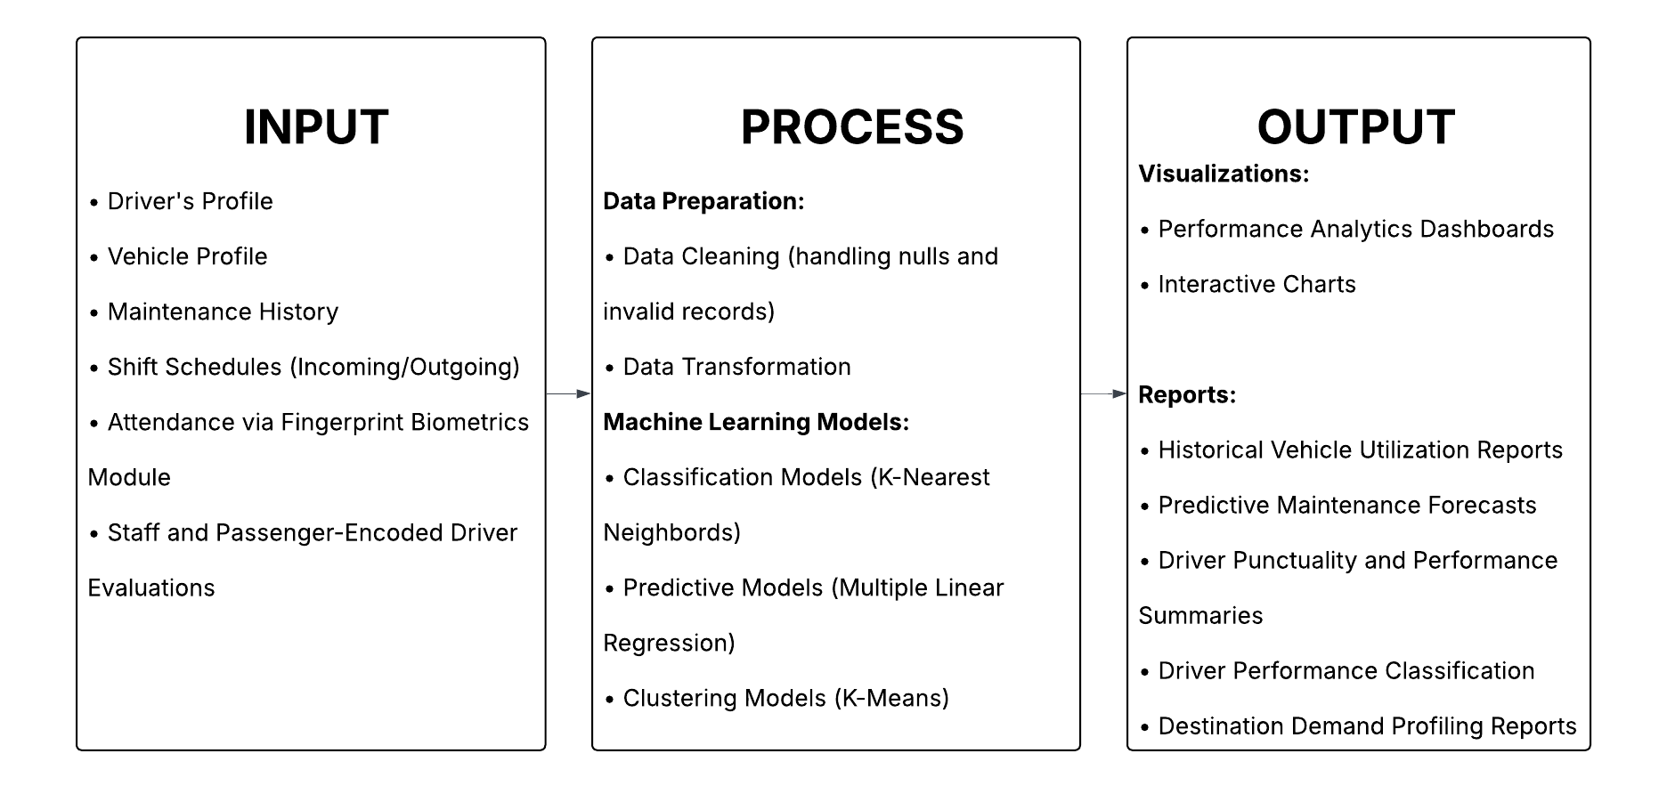
Figure 2-1 Conceptual Framework

DESIGN AND METHODOLOGY
This chapter presents the design and methodology utilized in the development of Shervice. It outlines the fundamental project concepts, the chosen software development model, and a comprehensive requirements analysis detailing the current operational state of the organization. The methodologies discussed in this section serve as the structured blueprint for transforming the manual dispatching processes of the company into a centralized digital framework.

3.1 Project Concepts
Shervice is a management system designed to modernize the business operations of GT LANTIN Shuttle Rental Services by transitioning from physical logbooks and whiteboard-dependent processes to an integrated digital platform. As a private utility transport provider operating within the province of Batangas, GT LANTIN faced challenges in managing vehicle availability, driver assignments, and daily attendance due to fragmented records and manual tracking. The system addressed these inefficiencies by centralizing internal operations into a single web-based dashboard, ensuring smoother administrative workflows and more accurate data management.
At its core, the platform establishes a streamlined operational model built exclusively around two internal roles: Administrator and Staff. Through the system, the administrative staff manages comprehensive master records, while dispatching staff coordinate daily operations by assigning drivers and vehicles across 11 fixed corporate drop-off and pick-up destinations. These operational movements are strictly categorized as Incoming (transporting employees from pickup nodes to the client company headquarters) or Outgoing (escorting employees from the headquarters back to external drop-off points). To maintain payroll accuracy, the system enforces a strict weekly workflow where driver attendance, trip completion details, and operational summaries are retrieved every Thursday and formally processed for administrative review every Friday, enabling staff to calculate wages and input financial extras.
Digital transformation and data-driven evaluation lie at the foundation of the concept. By automating essential tasks such as biometric attendance tracking and resource allocation, the platform significantly increases operational efficiency. Predictive analytics further extends the system value by utilizing predictive classification models to evaluate historical driver performance, attendance logs, and staff-encoded field reports. These algorithms forecast potential workforce shortages, predict shifts in driver reliability, and flag maintenance needs. These data-driven insights empower the management of GT LANTIN to align their fleet deployment with the strict shift schedules required by the manufacturing industry, avoiding issues such as delayed arrivals or sudden vehicle breakdowns.
Transparency and internal communication also form a vital component of the model. By providing a centralized digital timetable, the system eliminates the heavy dependence on scattered third-party messaging applications and physical whiteboards for dispatch instructions. This integrated scheduling feature ensures a more organized record of daily deployments, strengthens internal accountability, and supports the prompt resolution of operational concerns based on verified staff evaluations.

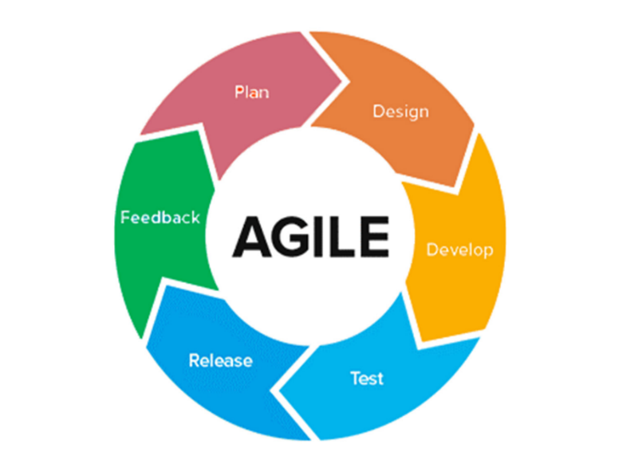
Development Model

Figure 3-1 Agile Methodology (Obeya Associates, 2025)

As shown in Figure 3-1, the development of Shervice followed the Agile methodology as its Software Development Life Cycle model. The Agile method addresses the limitations of traditional development approaches through its adaptable framework and iterative nature, which promote stakeholder collaboration and incremental delivery (Alsaqqa et al., 2020). Unlike rigid linear models, the Agile approach allows developers to adapt to evolving administrative requirements by breaking the project into manageable iterations known as sprints (Pressman & Maxim, 2020).
The development process was carried out in iterative sprint cycles. Each sprint focused on the gradual implementation of specific system modules, such as the dispatching matrix, the biometric attendance logger, the maintenance tracker, and the analytics dashboard. Utilizing Agile for web-based management systems ensures that core functionalities are developed and tested early, significantly reducing the risk of systemic failures during final deployment (Sommerville, 2021). Furthermore, all system testing during these sprints relied exclusively on mock data to guarantee the absolute protection of user privacy.
By employing the Agile methodology, the Shervice project gained several advantages. Agile enables the early release of functional components, ensures adaptability to changing administrative rules, and minimizes risks through iterative testing. It also allows developers to refine the predictive algorithms based on continuous stakeholder feedback. This structured yet flexible approach ensured that the system evolved in strict alignment with the operational boundaries of GT LANTIN while supporting sustainable digital transformation.

Requirements Analysis
A comprehensive requirements analysis is a critical phase in system development that evaluates the current operational situation to identify specific administrative challenges and workflow inefficiencies (Valacich & George, 2020). GT LANTIN Shuttle Rental Services previously relied on manual whiteboards, printed spreadsheets, and fragmented physical records to manage its fleet dispatches and driver attendance. While this approach provided a basic means of administrative control, it introduced several inefficiencies that assess the operational effectiveness of the transport provider. One of the major challenges was the lack of real-time synchronization between the dispatching staff and operations in the field. Administrative staff often struggled to update vehicle availability promptly upon receiving schedules from corporate clients, resulting in overlapping assignments. Furthermore, tracking the exact attendance status of drivers across different terminals slowed down shift deployments and reduced operational visibility. These inefficiencies created logistical challenges that threatened the strict punctuality expected by their corporate partners in the manufacturing sector.
Another significant issue lay in the limited ability of the organization to generate actionable insights from existing physical data. With attendance logs scattered across paper folders and a complete lack of standardized performance evaluations, the management had difficulty evaluating driver reliability or assessing service quality systematically. This lack of predictive capability and structured evaluation often resulted in reactive management, leading to unexpected vehicle downtime and unmitigated driver absenteeism, all of which negatively impacted service quality. Furthermore, internal communication regarding schedule changes posed severe challenges. The staff relied heavily on personal cellular calls and standard messaging platforms to distribute route assignments, which led to fragmented communication records and misunderstood instructions. Given these issues, there was a clear need for an integrated fleet management system that centralized administrative operations, streamlined weekly attendance processing, and provided comprehensive visibility over driver performance and fixed destination demand. Using Fingerprint Biometric attendance, replacing vulnerable manual logbooks with verified biometric inputs, the system establishes a robust data foundation for its analytical engines to classify driver reliability and forecast vehicle maintenance needs with precision.
The successful design and implementation of Shervice required a clear understanding of stakeholder roles, as accurately mapping user needs is essential for safely transitioning an organization from manual to digital workflows (Dennis et al., 2021). The system was developed in consultation with GT LANTIN to ensure that it met the specific internal requirements of its primary users while respecting the established project delimitations. The platform is strictly restricted to two internal roles: the Administrator and the dispatching Staff. The Administrator oversees the entire transportation operation and the overall health of the fleet, requiring high-level access to manage user accounts, review predictive analytics dashboards, and oversee master records (excluding external roles). Meanwhile, the dispatching staff manages the day-to-day allocation of transport resources across the 11 fixed destinations. They require a reliable digital interface to input vehicle availability, assign drivers to specific incoming and outgoing corporate shifts, monitor daily operational status, process Thursday/Wednesday attendance and payroll extras, and handle vehicle maintenance logs without relying on physical whiteboards. External entities such as Client Officers-in-Charge (OICs), drivers, and passengers do not access the platform directly; all operational schedules, field reports, and evaluations are managed and encoded centrally by the internal Administrator and Staff.

3.4 System Design
The System Design serves as the technical blueprint for the developer’s capstone project. It translates the operational requirements of GT LANTIN Shuttle Rental Services into a functional and scalable digital platform. The primary goal of this design is to establish a seamless flow of information. This covers everything from the moment a driver logs attendance at the biometric terminal or staff encodes field reports, all the way to the backend processing where raw data is converted into actionable business intelligence. By implementing a unified and organized structure, the system can efficiently handle daily logistical tracking alongside complex machine learning algorithms without overwhelming the end-users. The core of this technical blueprint is defined by its overarching system architecture.
System Architecture
Figure 3-2 presents the high-level system architecture of Shervice. It defines how the various technological components of the web-based platform interact, including the internal user interfaces accessed exclusively by the Administrator and Staff, the biometric hardware terminal for driver attendance, the centralized cloud database, and the predictive analytics engine. This conceptual model provides a comprehensive overview of the digital infrastructure required to support the daily operations of GT LANTIN, demonstrating how data is securely transmitted and processed without reliance on complex geographical tracking hardware.
At its core, the Application Layer leverages a dual-runtime environment, utilizing Node.js to handle day-to-day operations such as access control, scheduling, and logistics tracking, while Python and Flask are dedicated to executing the machine learning models for performance classification, maintenance forecasting, and destination demand clustering. Finally, the Data Layer employs a structured PostgreSQL database, supported by Supabase, for the secure, real-time storage of dynamic transactional logs, staff evaluations, and master profiles. This entire stack is cloud-hosted, ensuring that the management team has constant access to live dashboards and predictive analytics.

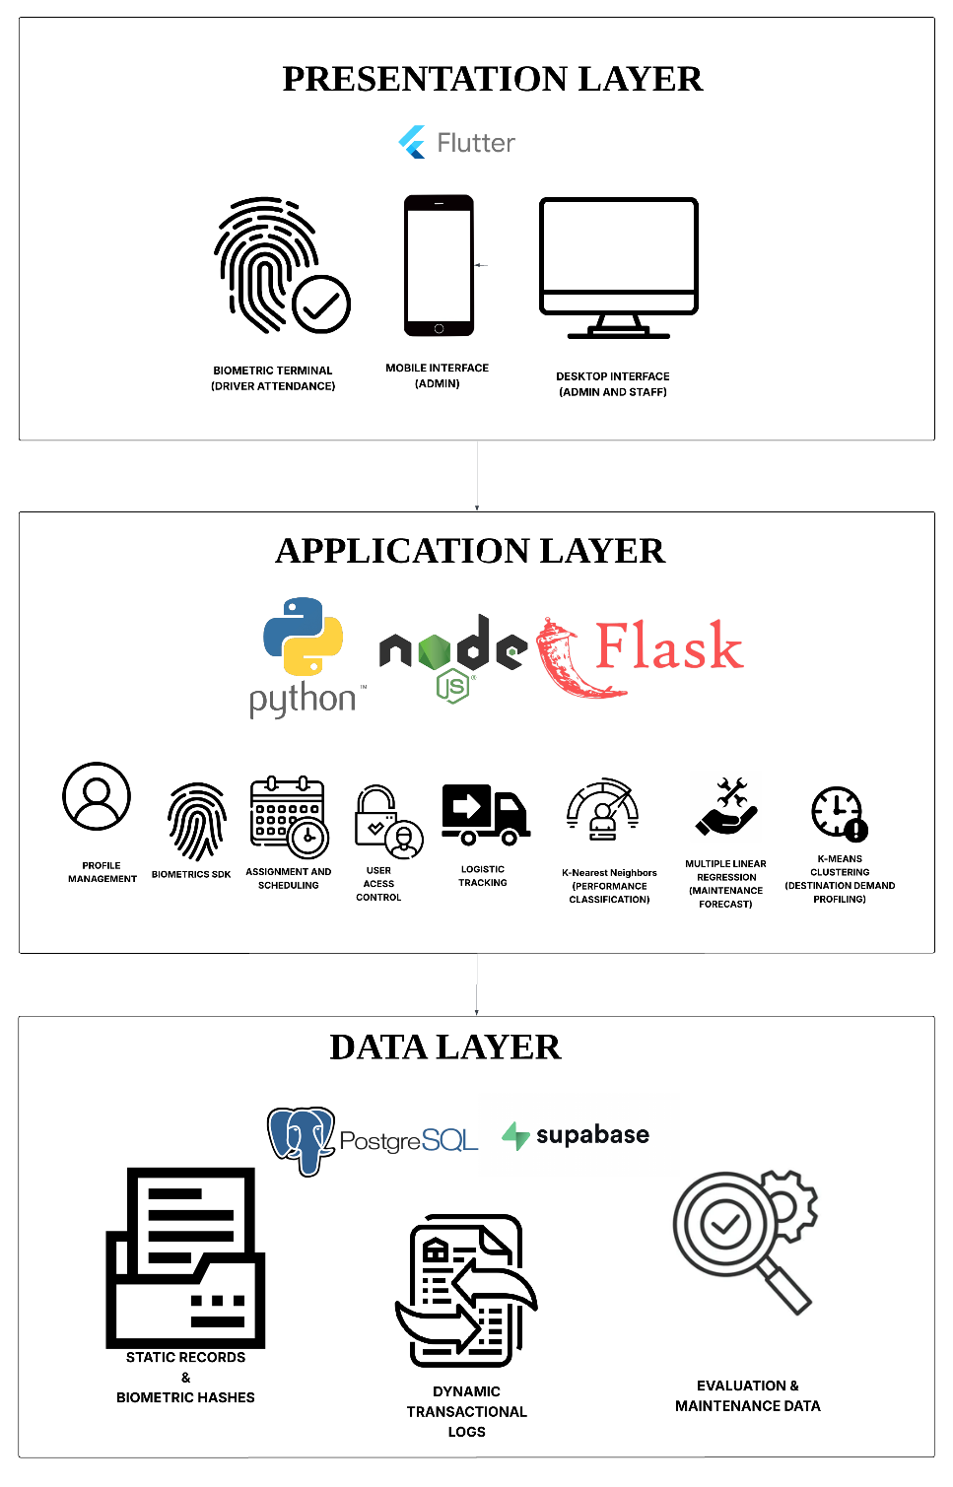
Figure 3-2 System Architecture

System Flowchart
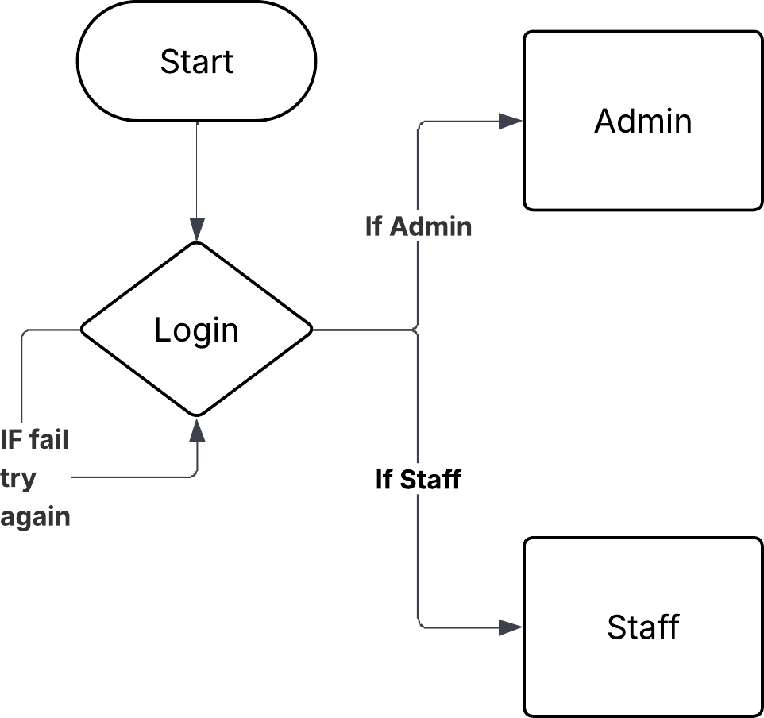
The System Flowchart section provides a sequential representation of the logical processes within the proposed platform. It visualizes the step-by-step execution of core administrative tasks, such as assigning vehicle routes, logging digital driver attendance, and calculating performance scores based on passenger feedback.

Figure 3-3 Login Flowchart
Figure 3-3 shows the secure login flow using Role-Based Access Control. Upon entering their credentials, the system authenticates the user and automatically redirects the user to the appropriate Admin or Staff interface. If authentication fails, the system returns to the login prompt so the user can try again.
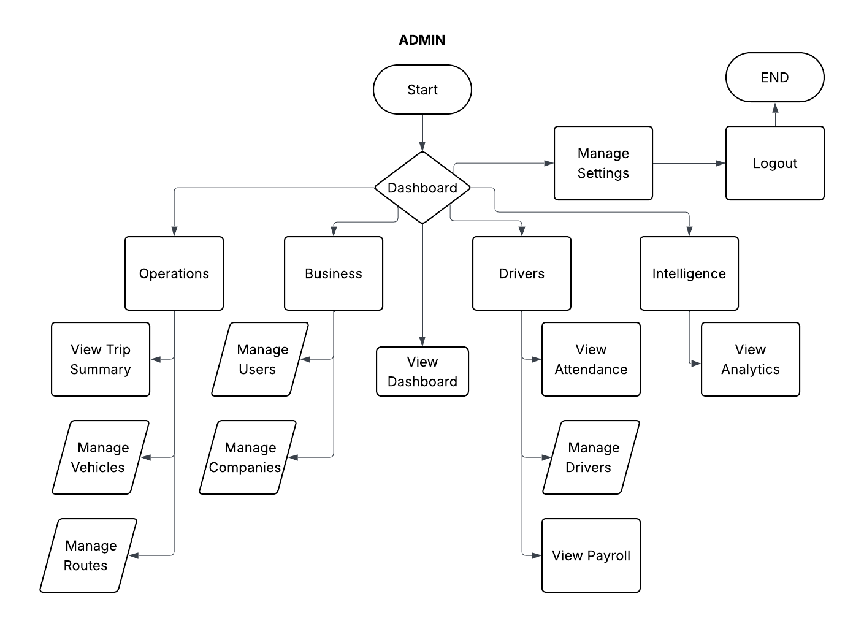

Figure 3-4 Admin Flowchart
Figure 3-4 presents the Admin flowchart. After successful authentication, an Admin is redirected to the Admin Portal and can access the dashboard, trip summaries, vehicles, users, companies, routes, drivers, attendance, payroll, and analytics. Administrative permissions allow the Admin to manage organizational data, monitor operations, review records, and access analytical and driver-evaluation tools.
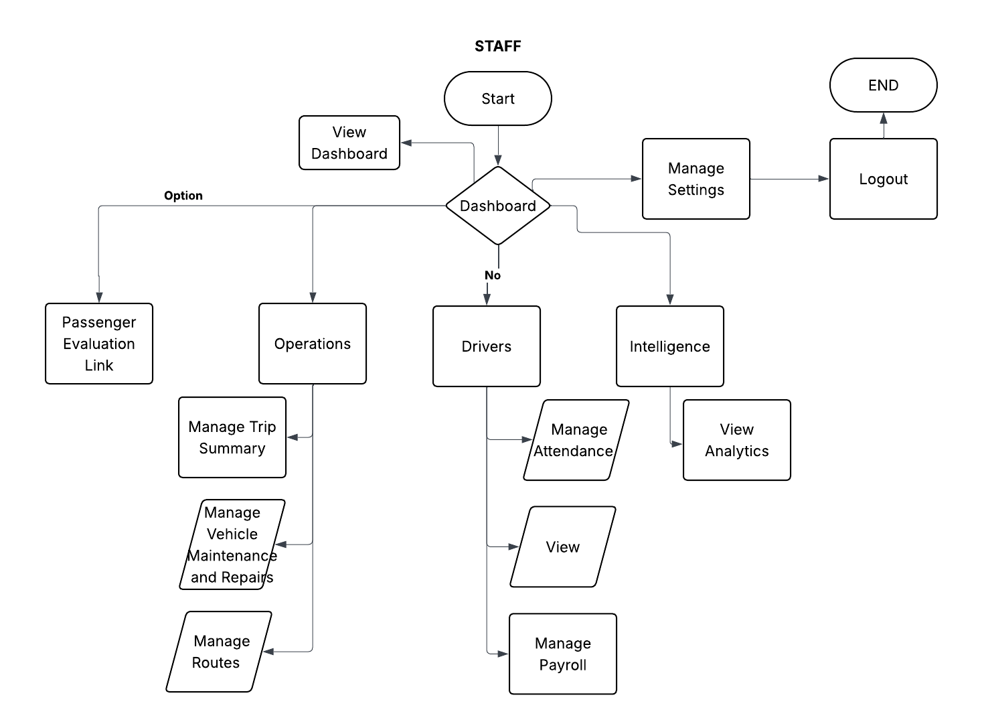
Figure 3-5 Staff Flowchart
Figure 3-5 presents the Staff flowchart. After successful authentication, a Staff user is redirected to the Staff Portal and can access the dashboard, trip summaries, vehicles, routes, drivers, attendance, payroll, and analytics. Staff permissions focus on daily operational activities such as adding trip summaries, importing attendance records, recording maintenance issues, editing payroll information, updating route data, and the passenger evaluation link.

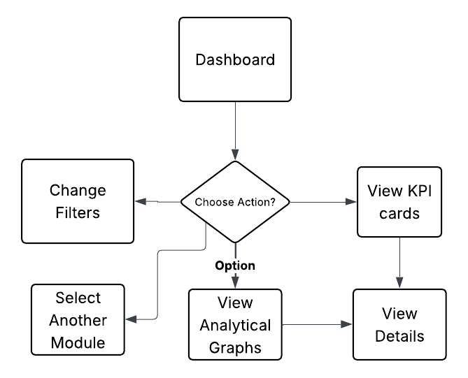

Figure 3-6 Dashboard Flowchart

Figure 3-6 presents the Dashboard flowchart. The Dashboard serves as the main overview interface for Admin and Staff users after they log in. The system retrieves operational data from the backend and displays summarized key performance indicators, including total trips, total passengers, active drivers, active vehicles, due maintenance, and due repairs. It also presents visual reports such as client monthly dispatches, total trips by month, driver ratings, top-performing drivers, and maintenance or repair trends. Users may filter the displayed information by month or year and refresh the dashboard to retrieve the latest data.
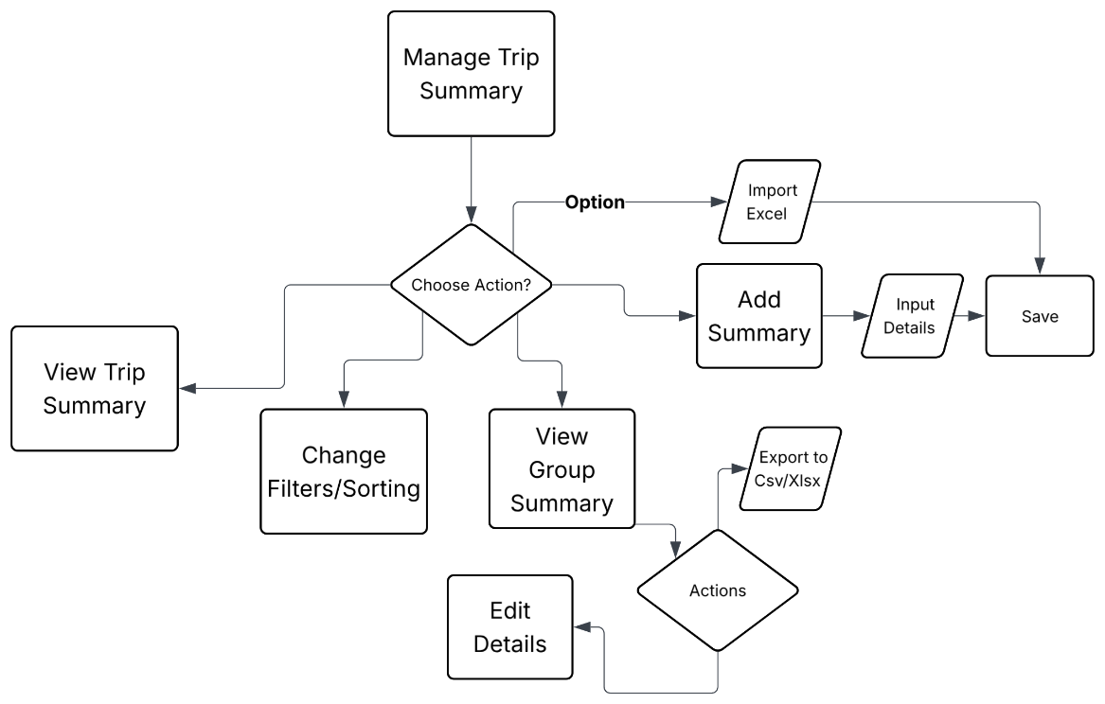

Figure 3-7 Trip Summary Flowchart

Figure 3-7 Trip Summary Flowchart

The Trip Summary module allows users to view and manage trip records. Staff users can add new trip summaries and import trip data, while Admin users are limited to viewing the available trip information. Users may also filter records, view grouped summaries, edit permitted details, and export trip information when applicable.

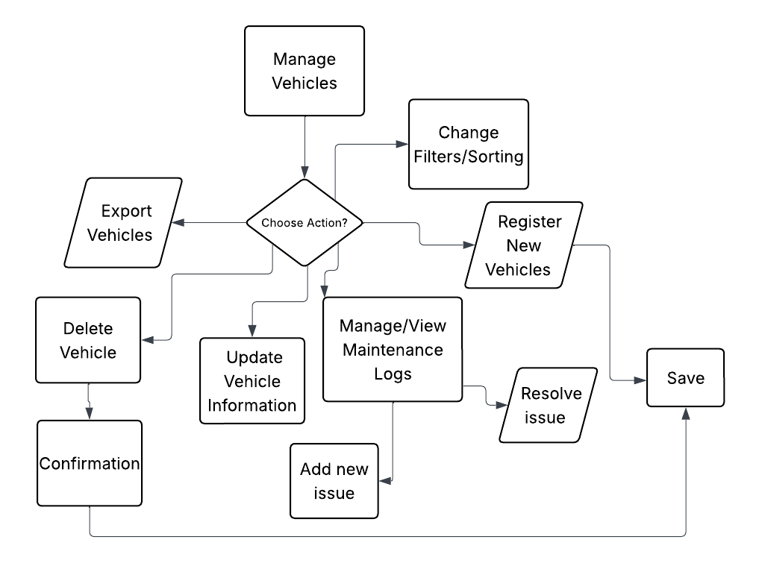

Figure 3-8 Vehicle Management Flowchart

Figure 3-8 Vehicle Management Flowchart

The Vehicle module allows Admin users to register new vehicles and edit or update existing vehicle information. Admin users can also view vehicle maintenance logs. Staff users are responsible for adding and recording new maintenance issues or logs. This separation ensures that vehicle records remain controlled by the Admin while daily maintenance updates can be entered by operational Staff.

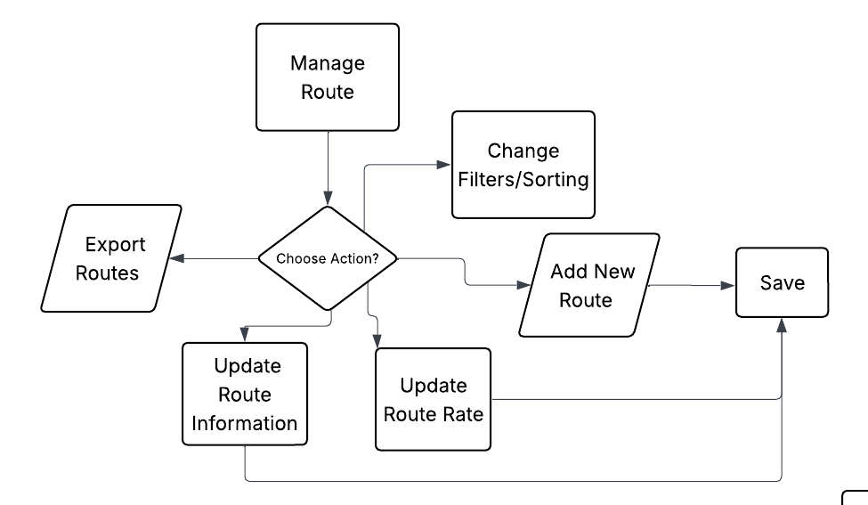

Figure 3-9 Route Management Flowchart

Figure 3-9 Route Management Flowchart

The Route Management module allows both Admin and Staff users to manage route information. Authorized users can add new routes, edit route details, update route rates, change filters, and export route records. These changes support the management of destinations, route assignments, and related operational information.

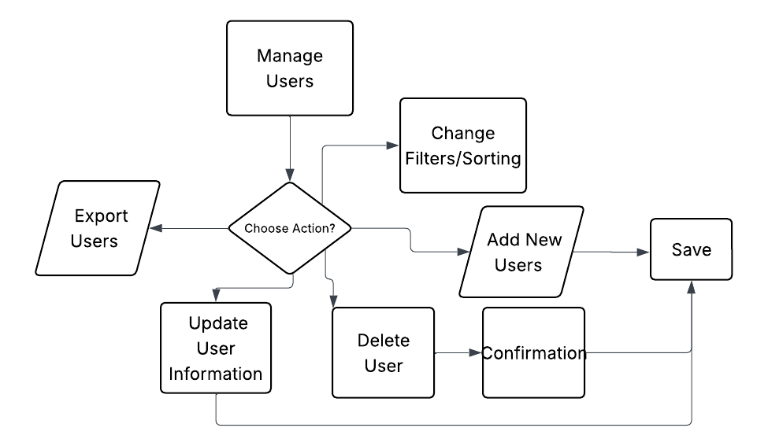

Figure 3-10 User Management Flowchart

Figure 3-10 User Management Flowchart

‘
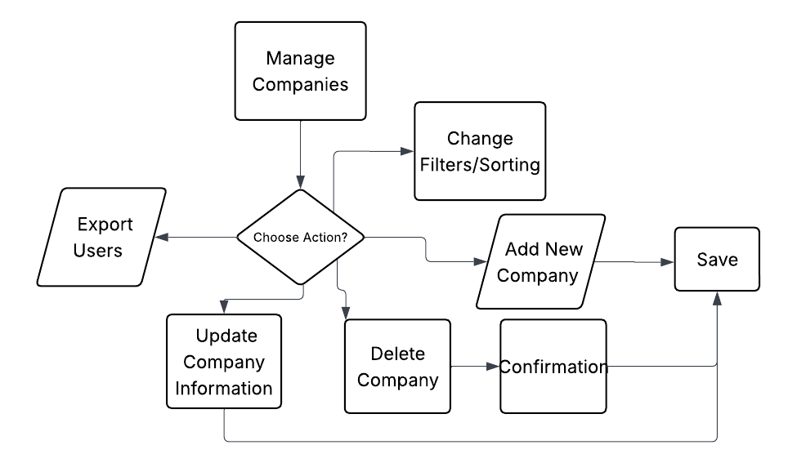
The User Management module is available only to Admin users. Admins can add new users, update user information, modify account details, and delete users when necessary. Staff users do not have access to this module and cannot manage system accounts.

Figure 3-11 Company Management Flowchart

Figure 3-11 Company Management Flowchart

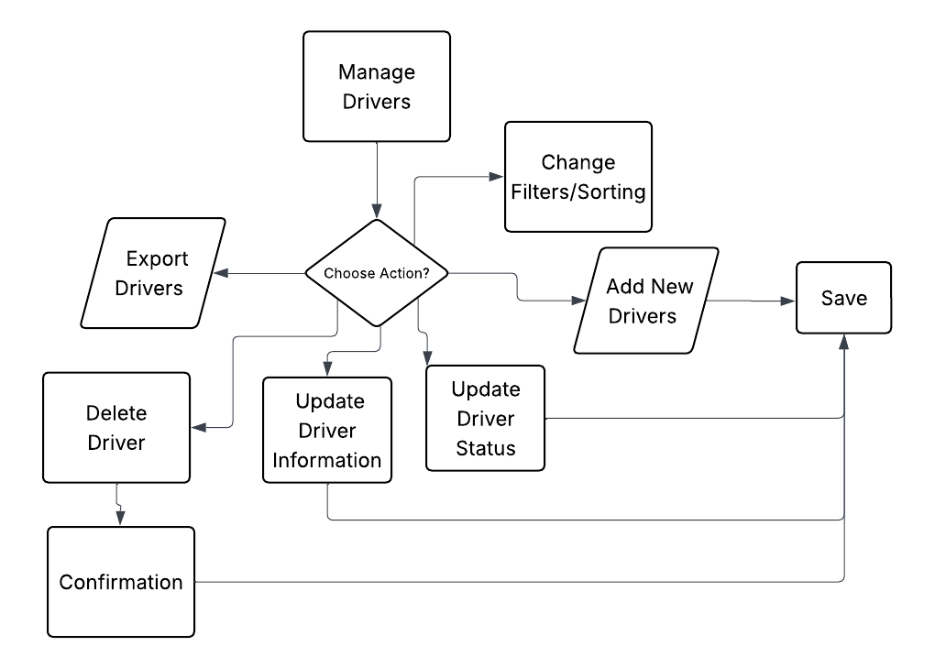
The Company Management module is available only to Admin users. Admins can add new companies, update company information, and manage existing company records. Staff users do not have access to this module because company administration is restricted to authorized Admin personnel.

Figure 3-12 Driver Management Flowchart

Figure 3-12 Driver Management Flowchart

The Driver Management module allows Admin users to add new drivers, update driver information, edit driver statuses, and manage driver records. Staff users have view-only access to driver information and cannot add, update, or modify driver records.

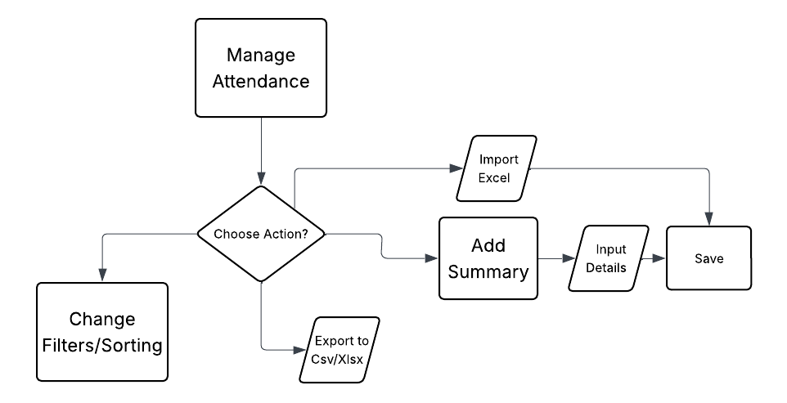

Figure 3-13 Attendance Management Flowchart

Figure 3-13 Attendance Management Flowchart

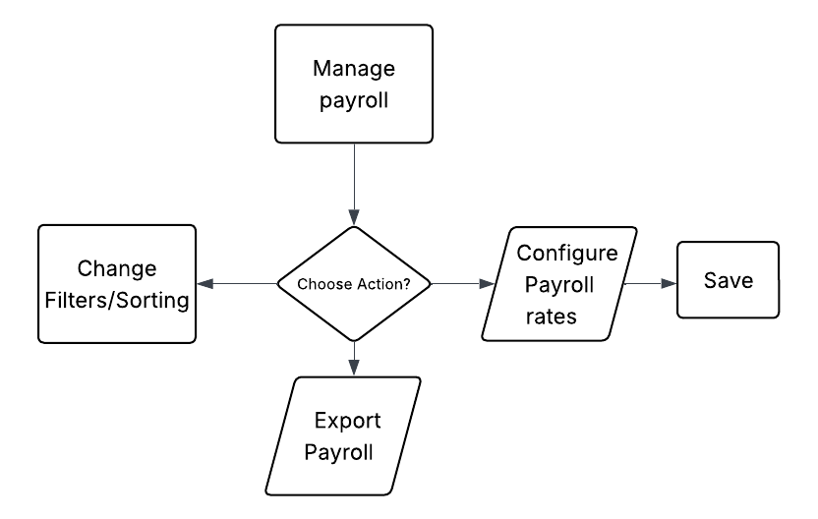
The Attendance module provides different functions based on the user’s role. Admin users can view attendance records and monitor employee attendance information. Staff users can import new attendance records from biometric systems and manage the imported attendance data for operational and payroll purposes.

Figure 3-14 Payroll Management Flowchart

Figure 3-14 Payroll Management Flowchart

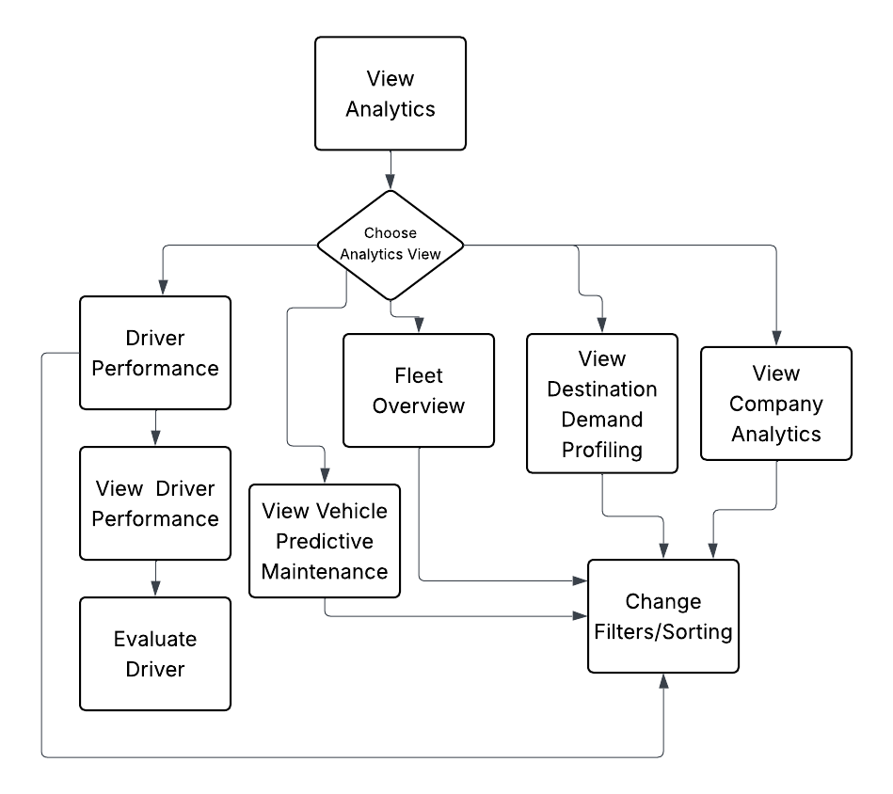
The Payroll module allows Staff users to edit payroll information and manage payroll-related records. Staff may update payroll details, configure applicable payroll information, and export payroll reports. Payroll data can then be used for compensation processing and operational reporting.

Figure 3-7 Analytics Flowchart

Figure 3-7 presents the Analytics flowchart. The Analytics module is available to both Admin and Staff users and provides access to Fleet Overview, Driver Performance, Vehicle Predictive Maintenance, Destination Demand Profiling, Company Analytics, and other analytical views. Authorized users can filter and sort analytical data, review performance results, monitor predictive insights, and evaluate drivers based on available operational records.
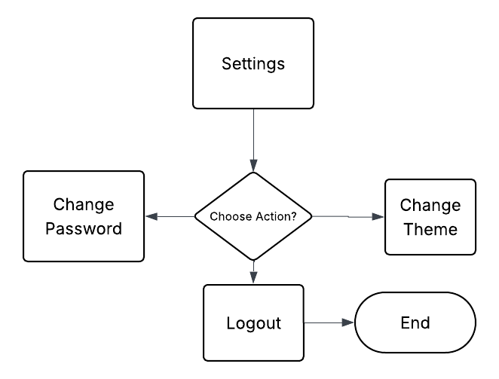

Figure 3-8 Settings Flowchart
Figure 3-8 presents the Settings flowchart. The Settings area is accessed through the user profile menu and provides account and application preferences. Users may toggle dark mode, change their password after validation, and securely log out after confirmation. Invalid password details generate an error message, while canceling logout keeps the user in the current portal.
Data Flow Diagrams
Figures 3-11 through 3-17 present the Data Flow Diagrams for the Shervice platform. These diagrams detail the movement and transformation of information from user inputs and operational records through the processing modules, analytics engine, and secure database repositories. They define the data inputs, system processes, storage points, and outputs required to maintain accurate performance tracking and reliable fleet dispatching.
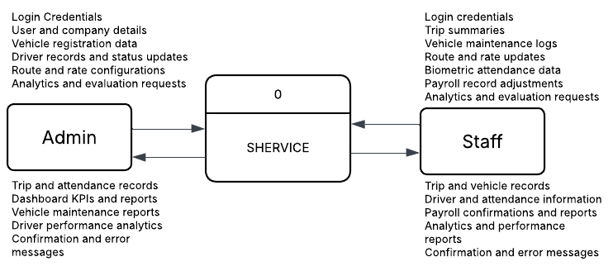

Figure 3-16 Data Flow Diagram (Level 0)

The diagram shows the Admin inputting strategic and structural data, including login credentials, user and company details, vehicle registration data, driver records and status updates, route and rate configurations, and analytics and evaluation requests. In return, the Admin receives comprehensive outputs from the system such as trip and attendance records, dashboard KPIs and reports, vehicle maintenance reports, driver performance analytics, and confirmation and error messages.
Simultaneously, the Staff handles daily operations by inputting login credentials, trip summaries, vehicle maintenance logs, route and rate updates, biometric attendance data, payroll record adjustments, and analytics and evaluation requests. Subsequently, the system provides the Staff with trip and vehicle records, driver and attendance information, payroll confirmations and reports, analytics and performance reports, and confirmation and error messages. By defining these relationships, this top-level view establishes exactly where external information enters and exits the platform without exposing underlying logic. This diagram serves as a blueprint for detailed DFD levels, ensuring all data flows are accounted for and the Shervice platform's scope is effectively communicated before moving into internal architectural design.
By defining these relationships, this top-level view establishes where information enters and exits the platform without exposing underlying logic. This diagram serves as a blueprint for detailed DFD levels, ensuring all data flows are accounted for and the Shervice platform's scope is effectively communicated before moving into internal architectural design.
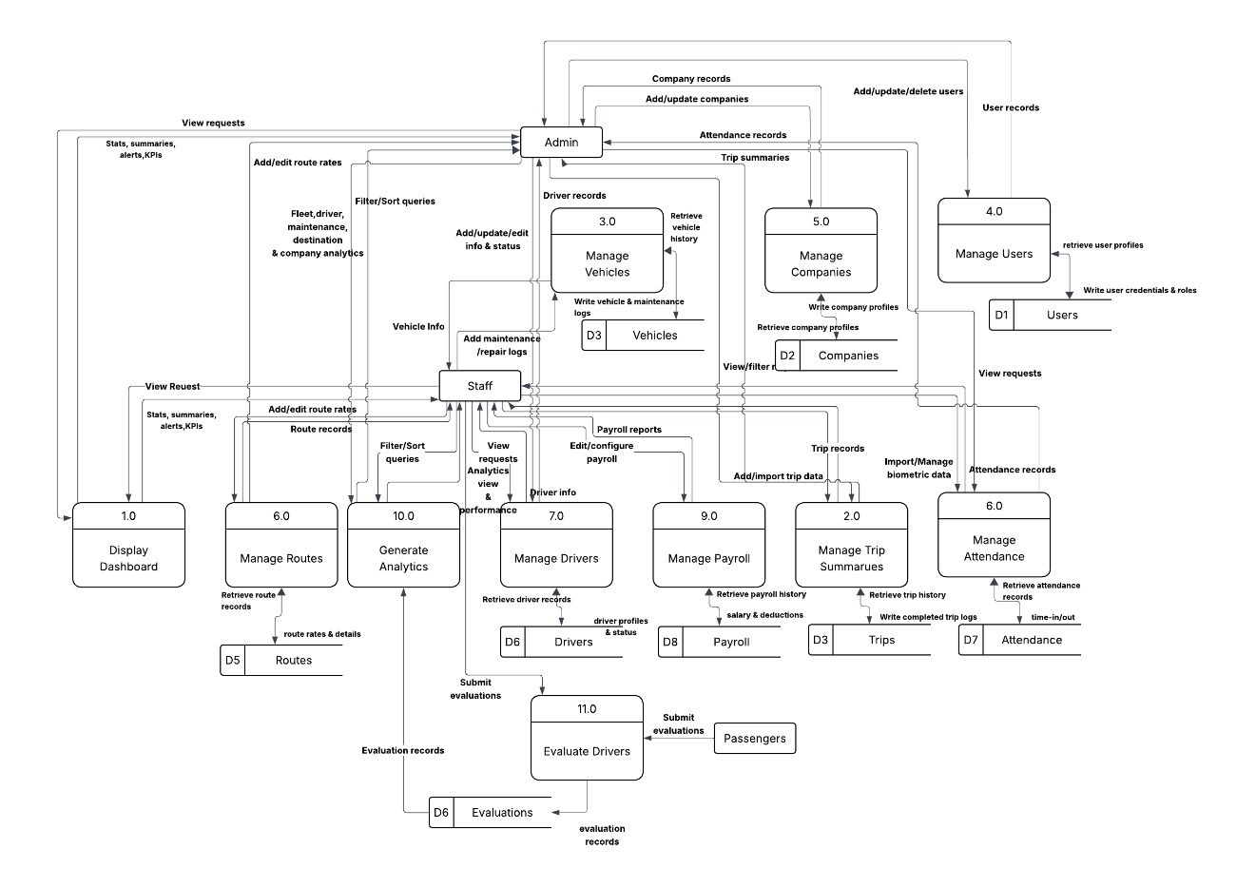
Figure 3-17 Data Flow Diagram (Level 1)
The Level 1 Data Flow Diagram explicitly details the systematic routing of structural and operational information within the Shervice platform between the two primary user entities: the Admin and the Staff. Initially, the system processes organizational data submitted by the Admin to securely populate and manage the central data stores, including users, companies, vehicles, routes, and drivers. Administrative processes ensure that the Admin retains exclusive control over account creation, company administration, and structural profile updates. These core management processes interact directly with dedicated databases to establish the foundational hierarchy and logistical parameters required before daily operational activities commence.
Simultaneously, the system manages the continuous influx of active operational data handled primarily by the Staff. Through the Staff Portal, users interface with various operational modules to input trip summaries, update route statuses, and adjust payroll configurations, routing this information securely into the Trips, Routes, and Payroll data stores. Concurrently, Staff users import biometric records into the attendance management process and log new mechanical issues into the vehicle maintenance module. This division of labor ensures that while the Admin oversees high-level structural data, the Staff actively drives the daily logistical, attendance, and maintenance data flowing into the operational databases.
The culmination of this systematic data flow occurs within the core analytics and dashboard modules. The system programmatically extracts information across all integrated data stores including trip records, driver statuses, vehicle maintenance logs, and attendance metrics. This comprehensive dataset flows into the central analytics process to generate actionable insights, such as predictive maintenance alerts, driver performance evaluations, and destination demand profiling. Finally, the system routes these metrics into dynamic outputs, delivering strategic fleet overviews and dashboard KPIs to the Admin, while providing immediate operational performance reports and alerts directly to the Staff interface.
Machine Learning Pipeline
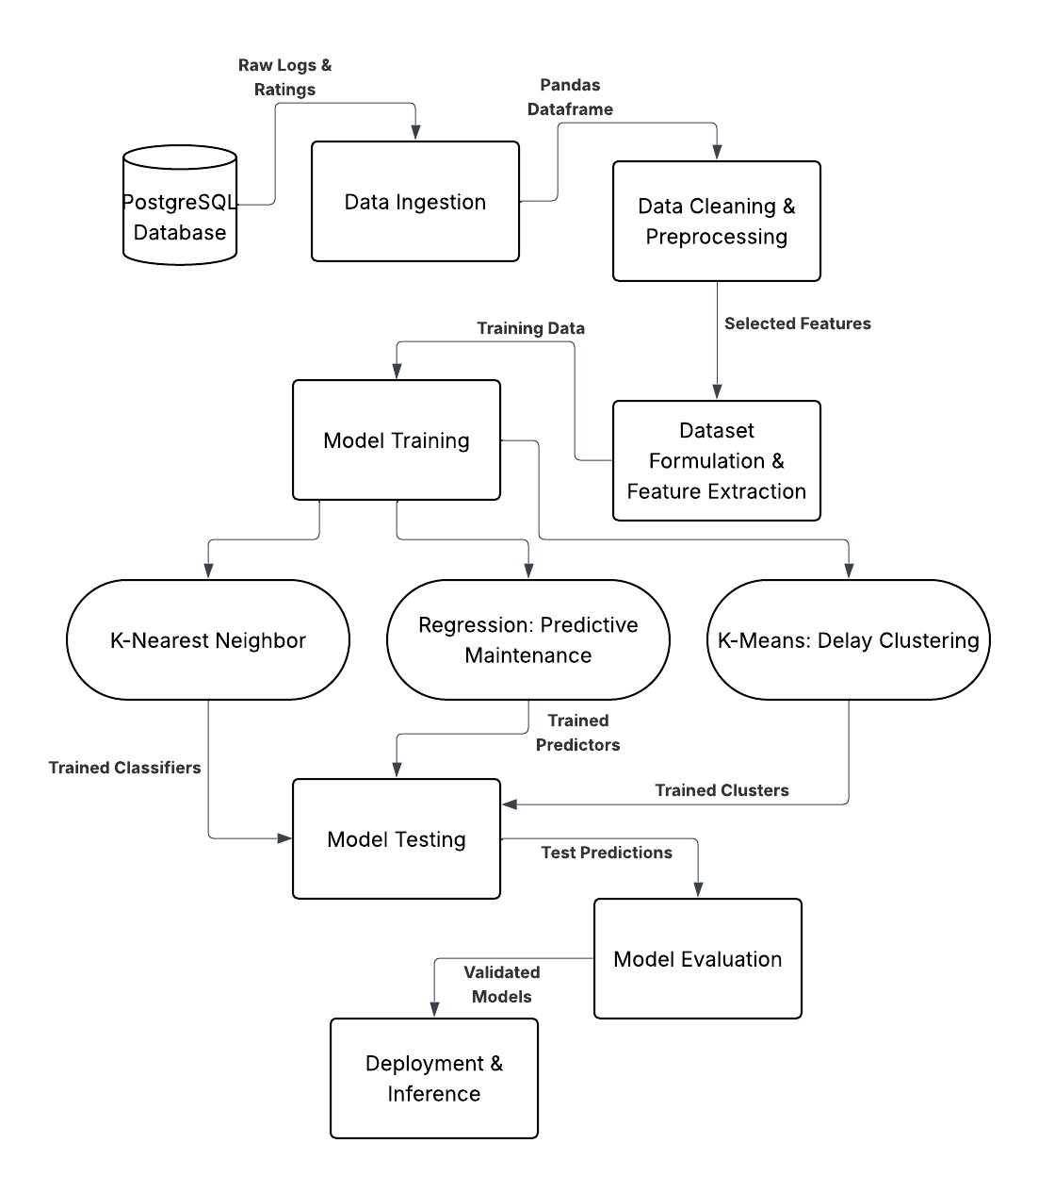
The Machine Learning Pipeline will serve as the core analytical engine for the Shervice platform by transforming raw daily logs into predictive business intelligence for GT LANTIN. This automated framework is engineered to handle large volumes of logistical data, ensuring that every piece of information from fuel consumption to delivery timelines contributes to a broader operational strategy. The pipeline is structured into seven sequential phases designed to extract, process, train, test, and evaluate data before deploying actionable insights directly to the administrative dashboards. By standardizing these phases, the system ensures that the predictive models remain accurate over time, allowing the organization to move from reactive management to proactive, data-driven decision-making. This end-to-end process minimizes manual data handling, reduces the margin for error, and provides a scalable foundation for future analytical growth within the Shervice ecosystem.

Figure 3-18 Machine Learning Pipeline

1. Data Ingestion
The machine-learning pipeline begins by retrieving operational records from the Supabase database. The primary data sources are the driver_profile, evaluation, trip_schedule, attendance_record, vehicle, and maintenance_log tables. These records contain driver performance, trip activity, attendance behavior, vehicle workload, and maintenance history.
For driver classification, evaluation, trip, and attendance records are combined by driver and time period. For maintenance forecasting, vehicle, trip, and repair records are combined by vehicle and date. For destination demand analysis, trip records are grouped by route or destination.
2. Data Cleaning and Preprocessing
The retrieved records are cleaned and transformed before model training. Dates are converted into a consistent date format, missing numeric values are handled using defined fallback values, and records are grouped according to driver, vehicle, destination, and month. Routine maintenance inspections are separated from explicit repair events. Only repair events are used as the maintenance-failure target because routine inspections do not necessarily indicate vehicle failure.
Numerical features are standardized before KNN, Multiple Linear Regression, and K-Means processing. Standardization prevents variables with larger numerical ranges from dominating the model.
3. Dataset Formulation and Feature Extraction
The system creates three model-specific datasets.
The Driver Performance Dataset is created by combining driver profiles with driver evaluation records, trip schedules, and attendance records. Evaluation records provide average safety, punctuality, and professionalism scores. Trip schedules provide the number of trips assigned to each driver. Attendance records provide total minutes late, present counts, half-day counts, and absence counts. These values form the eight features used by the driver classification model.
The Vehicle Maintenance Dataset is created from vehicle profiles, trip schedules, and repair records. The model extracts nine features: vehicle age, trips during the previous 90 days, passengers during the previous 90 days, average passengers per trip, average load factor, heavily loaded trips, lifetime trip count, previous repair count, and days since the last repair. Only maintenance records classified specifically as repairs are used to create future repair targets.
The Destination Demand Dataset is created by grouping trip schedules according to route name. For each route, the system calculates total passenger volume, trip frequency, and the number of distinct vehicles assigned to the route. These three features are used to identify similar demand patterns between routes.
4. Model Training and Testing
The formulated datasets enter the Model Training phase, which functions as the core analytical stage of the platform. Three machine-learning algorithms are used according to the operational objectives of GT LANTIN: K-Nearest Neighbors for driver classification, Multiple Linear Regression for predictive maintenance, and K-Means clustering for destination demand profiling.
K-Nearest Neighbors (KNN) for Driver Performance
The Driver Performance module uses a K-Nearest Neighbors classifier. Before training, the eight driver features are standardized using StandardScaler. The target labels are generated using rule-based conditions based on safety, punctuality, professionalism, attendance, lateness, and trip activity.
The system classifies drivers into Elite Performer, Consistent Performer, Tardiness Risk, Safety Risk, and Needs Review. The production KNN model uses three neighbors with distance-based weighting. After evaluation, the serving model is retrained using the complete available driver dataset so that all current drivers receive a classification. The trained model and scaler are saved as joblib files.
The KNN algorithm determines similarity using Euclidean distance:
$$d\left(x,y\right)=\sqrt{\sum_{i=1}^{n}{{\left(x_{i}-y_{i}\right)}^{2}}}$$
Equation 3-1 Euclidean Distance Formula for KNN
Where d represents the Euclidean distance, x is the target driver's feature vector, y is the historical neighbor's feature vector, and n is the number of evaluated performance features.
Multiple Linear Regression for Predictive Maintenance
The Vehicle Maintenance module uses Multiple Linear Regression to estimate the number of days until the next recorded repair event. Training examples are created from historical vehicle observations where a future repair event is known.
If at least ten valid training observations are available, the system standardizes the nine vehicle features and trains a linear regression model. If insufficient historical data is available, the system uses a workload-based fallback calculation instead of a trained regression model.
The resulting forecast is stored as a vehicle risk score and can be requested for an individual vehicle or for the complete fleet. The model forecasts repair risk but does not create, resolve, or modify staff maintenance records. Operational maintenance alerts remain based on unresolved maintenance logs entered by staff.
The multiple linear regression model is represented in Equation 3-2:
$$γ = β_{0} + β_{1}x_{1} + β_{2}x_{2} + … +β_{n}x_{n} + ϵ$$
Equation 3-2 Multiple Regression Formula
Where y is the predicted target, x represents the vehicle features extracted from the database, β represents the estimated coefficient for each feature, β₀ is the intercept, and ε represents the error term.

K-Means Clustering for Destination Demand Profiling
The Route Analytics module uses K-Means clustering to group routes with similar demand characteristics. The model processes passenger volume, trip frequency, and assigned vehicle count for each route. Before clustering, the features are standardized using StandardScaler.
The system uses up to three clusters, depending on the number of available routes. When three clusters are available, the resulting groups are interpreted as Low Demand Destinations, Steady Demand Destinations, and High Demand Destinations. These descriptive labels are assigned after clustering according to the average passenger volume of each cluster.
The Destination Demand module uses K-Means clustering to group routes with similar operational demand. The model uses total passenger volume, trip frequency, and the number of distinct vehicles assigned to each route. K-Means assigns each route to the nearest cluster centroid using the distance shown in Equation 3-3:

$$d\left(x,c_{j}\right)=\sqrt{\sum_{i=1}^{n}{{\left(x_{i}-c_{j,i}\right)}^{2}}}$$
Equation 3-3 K-means Clustering Formula
Where "WCSS" is the objective function to be minimized, "x" represents a specific destination data point, and "c" represents the spatial centroid of its assigned cluster.

5. Model Testing
The supervised machine learning models in the system are evaluated using chronological holdout methods to simulate real-world future predictions, while the unsupervised model is evaluated using internal clustering metrics. The dataset partitioning strategies and data volumes for each module are summarized in Table 3-1.

Model | Data Used | Training | Testing
KNN driver classification | 378 monthly observations | 294 | 84
Multiple Linear Regression | 6374 vehicle records | 5,099 | 1,275
K-Means destination profiling | 9,701 trips, 17 destinations | Not applicable | Not applicable

For the Driver Performance model, historical driver information before each month is used to construct the features, while the driver’s activity during that month is used to generate the target label. The training period covers January through August 2026, while the test period begins in September 2026. The distribution of these categorical target labels across the training and testing sets is detailed in Table 3-2.

Classification Label | Training Set | Testing Set | Total
Consistent Performer | 140 | 40 | 180
Safety Risk | 63 | 18 | 81
Elite Performer | 49 | 14 | 63
Tardiness Risk | 37 | 12 | 49
Needs Review | 5 | 0 | 5
Total | 294 | 84 | 378
The Vehicle Maintenance model is evaluated using a chronological 80/20 split. The training data covers January 1, 2026, through July 15, 2026, while the test data covers July 15, 2026, through October 20, 2026.
As noted in Table 3-1, the Route Analytics model does not use a conventional training and testing split because K-Means is an unsupervised-learning algorithm. Instead, it is evaluated using the silhouette coefficient, which measures the separation and cohesion of the generated route clusters.
During production deployment, the driver and maintenance models are retrained using all eligible historical records after the evaluation process is completed. The separate evaluation script is used strictly to measure performance on the held-out data.
6. Model Evaluation
Following the testing phase, the system will conduct a comprehensive Model Evaluation to quantify the predictive accuracy and reliability of the deployed algorithms. This phase is critical to ensure that the generated business intelligence meets the strict operational standards of GT LANTIN.
Root Mean Squared Error (RMSE)
Root Mean Squared Error assesses the precision of the maintenance forecasting model. Unlike MAE, RMSE squares the residuals before averaging them, penalizing larger prediction errors more heavily. A lower RMSE indicates that predictions are closely clustered around actual maintenance events. The calculation is shown in Equation 3-4.

$$RMSE= \frac{1}{n}\sum_{i=1}^{n}{\left|{(y}_{i} - \dot{y_{i})}² \right|}$$
Equation 3-4 Root Mean Squared Error Formula
Coefficient of Determination (R²)
The Coefficient of Determination, or R², represents the proportion of variance in the dependent variable explained by the regression model. In the context of vehicle wear and performance analysis, it indicates how well inputs such as passenger count, trip count, and historical maintenance frequency predict the outcome. The formula is shown in Equation 3-5.

$$R²=1-\frac{∑{(y}_{i} -\hat{y_{i}} )²}{∑(y_{i}-\hat{y_{i}})²}$$
Equation 3-5 Coefficient of Determination Formula
Mean Absolute Error (MAE)
Mean Absolute Error is a regression metric for evaluating the Shervice predictive maintenance model. It calculates the average magnitude of prediction errors without considering direction, providing management with an interpretable measure in days. The formula is shown in Equation 3-6.

$$MAE= \frac{1}{n}\sum_{i=1}^{n}{\left| y_{i} - \dot{y_{i}} \right|}$$
Equation 3-6 Mean Absolute Error Formula
Accuracy
Accuracy is a fundamental classification metric representing the ratio of correctly predicted driver-performance observations to the total dataset. Because accuracy can be misleading for imbalanced datasets, it is evaluated alongside precision and recall. The formula is shown in Equation 3-7.
$$Accuracy = \frac{TP + TN}{TP + TN + FP +FN}$$
Equation 3-7 Accuracy Formula
Precision
Precision, also called Positive Predictive Value, evaluates the exactness of positive classifications within the driver-performance module. High precision reduces false alarms and helps prevent reliable drivers from being incorrectly flagged. The formula is shown in Equation 3-8.
$$PRECISION = \frac{TP}{TP + FP }$$
Equation 3-8 Precision Formula
Recall
Recall, also known as sensitivity, measures the system's ability to identify all actual instances of poor driver performance. High recall helps ensure that safety or service risks are not missed. The formula is shown in Equation 3-9.

$$Recall= \frac{TP}{TP + FN}$$
Equation 3-9 Recall Formula
F1-Score
The F1-score is the harmonic mean of precision and recall and provides a balanced assessment of classification performance for imbalanced datasets. The formula is shown in Equation 3-10.
$$F_{1}= 2\frac{precision ⋅ recall}{precision + recall}$$
Equation 3-10 F1-Score Formula
7. Deployment and Inference
After the models are trained and evaluated, their results are made available through Flask API endpoints. The driver classification endpoint returns the classification assigned to a specific driver. The vehicle prediction endpoints return the estimated maintenance risk, extracted vehicle metrics, training status, and forecast information for an individual vehicle or the complete fleet. The route clustering endpoint returns route clusters, demand summaries, assigned vehicles, and operational recommendations.
The Flutter frontend requests these results through the Python backend and presents them in the Analytics and Dashboard modules. Admin and Staff users can view driver classifications, vehicle maintenance forecasts, route demand profiles, and related operational reports. These machine learning outputs are intended to support decision-making and fleet planning, while the underlying operational records remain managed through the normal system modules.

Software Requirements Specifications
Figure 3-10 presents the Use Case Diagram and summarizes how the Admin and Staff roles interact with the major Shervice modules. The Software Requirements Specifications section then defines the detailed functional and non-functional requirements that the platform must fulfill to support GT Lantin’s business processes and comply with quality, usability, and reliability standards.

Functional Requirements
The functional requirements describe the specific capabilities that Shervice was designed to deliver. The platform supports two primary user roles, Administrators and staff, each with distinct role-based functionalities.
Table 3-1 Functional Requirements
Category | Feature | Description
System Access | Role-Based Authentication | Authenticates users and automatically redirects them to the Admin and Staff portal based on secure credentials.
Driver Features | Attendance Logging | Records exact time-in and time-out for daily shifts via a mobile-responsive interface for punctuality tracking.
 | Trip Logging | Inputs trip details, including departure and arrival times, to update the operational database in real-time.
 | Vehicle Reporting | Submits reports on the mechanical condition and health of assigned shuttle units directly from the field.
Admin & Staff Features | Analytics Dashboard | Provides a real-time overview of fleet utilization, attendance patterns, and KPIs via interactive Flutter-based charts.
 | Records Management | Allows for the creation and management of comprehensive digital profiles for all drivers, staff, and vehicle units.
 | Maintenance Tracking | Monitors fleet health through manual service inputs and sends automated alerts for renewals or scheduled upkeep.
 | Predictive Forecasting | Employs machine learning models to forecast maintenance cycles and fuel consumption trends based on historical logs.
 | Real-time Notifications | Sends immediate push alerts to the dashboard for new driver logs or urgent maintenance issues reported by operators.
Data & Feedback | Evaluation Collection | Collects qualitative feedback from staff and admin evaluation, it is used to feed the driver performance analytics module.
 | Schedule Transmission and Confirmation | Transmits detailed daily shift schedules to the platform and tracks digital receipt confirmations to ensure logistical alignment with the transport provider.

Non-Functional Requirements
The non-functional requirements define the performance standards, security measures, and analytical benchmarks necessary to ensure the proposed system functions reliably within GT Lantin’s high-frequency operational environment. These benchmarks are established to satisfy the Product Quality Model defined by ISO/IEC 25010.
The proposed system should meet performance standards, the proposed system must deliver a seamless, high-speed user experience by eliminating latency and ensuring near-instantaneous load times. The architecture will utilize a fluid, responsive design that adapts dynamically to diverse hardware, providing full functionality and optimized layouts for both mobile devices and high-resolution desktops.
Regarding security, the system will implement a robust Role-Based Access Control (RBAC) framework. This feature ensures that every user or stakeholder is assigned specific permissions tailored to their unique responsibilities, maintaining strict data integrity and organizational accountability.
In terms of the Analytical Benchmark, the proposed system will utilize a diverse array of advanced analytical visualizations to generate highly accurate and precise reports. These visual tools, ranging from dynamic charts to interactive dashboards, are designed to reveal actual, real-time insights into the overall performance of the system. By translating complex datasets into clear graphical representations, the system empowers stakeholders to identify operational trends, pinpoint inefficiencies, and make informed, data-driven decisions that enhance the platform's long-term effectiveness.

Database Design
Figure 3-9 presents the Entity Relationship Diagram for the Shervice platform. It defines the structured architecture of the PostgreSQL database and the tables and foreign-key relationships required to maintain data integrity while supporting machine learning queries. The normalized structure separates authentication accounts from operational personnel records and links driver, vehicle, maintenance, trip, attendance, and evaluation data.
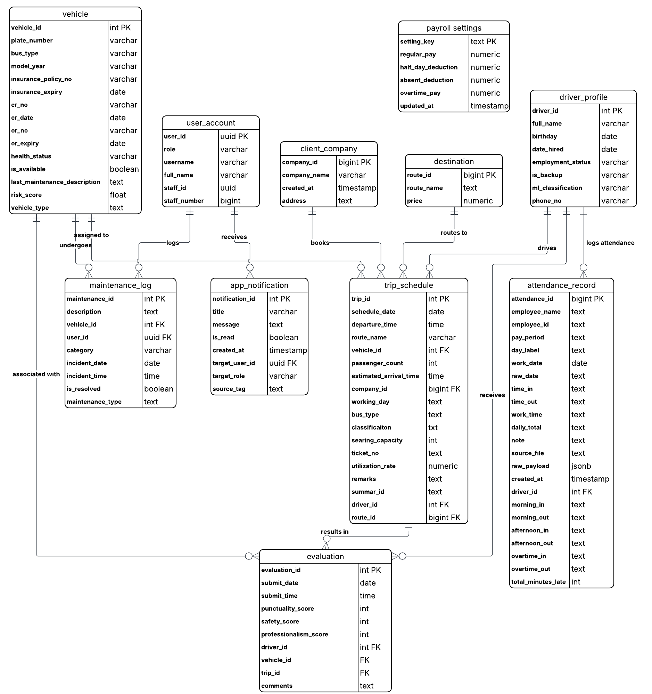

Figure 3-19 Entity Relationship Diagram

Trade-off and Multiple Attributes
This Trade-off analysis and Multiple Attribute section will provide a structured methodology to resolve these inherent conflicts. By systematically assigning specific weights to various operational factors such as cost, functionality, and implementation risk, this approach allows organizations to objectively evaluate competing solutions. Ultimately, it enables management to quantify compromises and logically select the alternative that delivers the highest overall operational value to the transport provider.
Table 3-2 Trade Off Analysis
Trade-Offs | Description | Implication
Real-time vs. Cost | Utilizing Socket.io and Supabase for instantaneous dashboard updates. | Increases technical complexity and potential managed service fees.
Security vs. Speed | Implementing JWT and Role-Based Access Control (RBAC) for all data access. | Slightly increases API overhead but ensures strict data privacy for GT Lantin.
Analytical Depth vs. Simplicity | Integrating a Flask-based engine and ML models like KNN. | Requires a dual-engine backend and more significant server resources.

The first significant decision involves balancing real-time capabilities against overall cost. By utilizing Socket.io and Supabase for instantaneous updates, the development introduces greater technical complexity and potential fees. Secondly, the developers weighed security against processing speed. Implementing JWT and Role-Based Access Control slightly increases API overhead, but is necessary to ensure data privacy. Finally, the analysis contrasts analytical depth with architectural simplicity. Integrating a dedicated Flask-based engine for machine learning significantly enhances predictive capabilities, although it requires a more complex dual-engine backend and more significant resource
Table 3-3 Multiple Attributes
Attributes | Specific Goals and Metrics
Performance | API response time under 500ms and real-time sync latency under 1s.
Reliability | Daily automated database backups and verified system uptime.
Maintainability | Clean separation of logic between the Node.js primary server and Flask microservices.
Scalability | Architecture designed to support an increasing number of drivers and vehicle units.

In terms of performance, the specific goals require an API response time of under 500 milliseconds and a real-time synchronization latency of under one second to ensure immediate data availability. To guarantee system reliability, the operational standards mandate daily automated database backups alongside continuously verified system uptime. Furthermore, the attribute of maintainability is achieved through a strict separation of programming logic between the primary Node.js server and the dedicated Flask microservices.

3.5 Development
The development of the Shervice platform will utilize a modern, scalable technology stack to ensure high operational performance, maintainable code, and long-term technical sustainability. This section outlines the specific tools and technologies integrated throughout the software development life cycle, divided into software and hardware requirements. The selected software tools support the frontend, the dual-engine backend, and the analytical processing layers, while the hardware requirements define the physical specifications necessary for the development, testing, and cloud hosting of the system.

Software Development Tools
A specialized stack of web technologies will be utilized to build the Shervice platform, focusing on real-time data handling and predictive intelligence. These tools enable the development team to manage complex logistics data, handle staff coordination, and maintain a centralized repository for vehicle maintenance records.
The development of the Shervice platform relies on a robust, modern technology stack to ensure system performance, scalability, and accurate predictive capabilities. For the client side, Flutter 3.12 or higher serves as the primary frontend framework for building the reactive administrative and driver dashboards. This is supported by Dart, which facilitates faster compilation and hot reload capabilities during development. State management across these interfaces, including authentication states and driver-vehicle assignments, is handled natively by Flutter's state management.
To connect the frontend interface with the backend services, the native Dart http package acts as the API client. The primary backend environment operates on Python, providing a server-side runtime capable of managing high-concurrency requests and driver logs, while Flask 3.1 is employed to construct the essential RESTful API endpoints.
Table 3-4 Software Development Tool
Category | Tool / Version | Purpose
Frontend Framework | Flutter (Dart SDK 3.12+) | Primary framework for building the reactive, cross-platform Admin and Driver dashboards.
Backend API Framework | Flask (3.1.3) | Python micro-framework serving as the core backend to handle RESTful API endpoints, routing, and system logic.
Backend-as-a-Service | Supabase (v2.31 / Flutter v2.15) | Provides secure user authentication, managed database hosting, and real-time data listeners across both Flask and Flutter.
Database Engine | PostgreSQL | Relational database underlying Supabase used for maintaining strict data integrity for trip schedules, maintenance logs, and vehicle registries.
Data Processing | Pandas (2.3.3) | Core Python library for cleaning, aggregating, and structuring historical shuttle logs on the backend before analytical processing.
Machine Learning | Scikit-learn (1.8.0) | Python library utilized for implementing predictive algorithms (e.g., clustering or regression) for route delays and maintenance forecasting.
Frontend Data Visualization | FL Chart | Flutter charting library used to render interactive data visualizations and analytics on the Admin dashboard.
API Client (Frontend) | Native HTTP | Replaces Axios. Used natively within Flutter for secure REST API communication and bidirectional socket connections with the Flask backend.
Typography & UI | Google Fonts & Material UI | Integrates standard typography and responsive UI component libraries directly into the Flutter frontend.

To facilitate instant push notifications on the administrative dashboard, the native web_socket_channel package is integrated for real-time bidirectional communication. Furthermore, Supabase operates as a Backend-as-a-Service, delivering secure authentication protocols and real-time database listeners. Data integrity for critical trip and maintenance records is maintained using a PostgreSQL relational database. For the predictive analytics component of the platform, the Flask backend also hosts the machine learning models and data services. Within this analytical engine, Pandas 2.3 is responsible for cleaning and structuring historical shuttle logs prior to processing, while Scikit-learn 1.8 is for implementing algorithms for performance classification and maintenance forecasting.

Hardware Development Tools
The following section outlines the hardware resources utilized by the developers, categorized by their primary functions, to ensure that both the programming and evaluation phases are adequately supported.
Table 3-5 Hardware Development Tools
Category | Tool | Purpose
Development Hardware | Intel i5/Ryzen 5 + 8GB RAM | Workstations for development
 | SSD Storage (50GB min) | Fast processing and load times
Testing Hardware | Smartphones (Android)
 | Desktop Monitors | Admin/Staff dashboard layout testing
Attendance Logging | NGTeco K4 Biometrics Fingerprint Time Attendance Machine | Attendance logging for drivers
Networking | Broadband (10 Mbps+) | Stable internet for cloud synchronization
For the core development hardware, the project utilizes workstations equipped with Intel i5 or Ryzen 5 processors paired with 8GB of RAM to handle complex programming tasks, alongside a minimum of 50GB of SSD storage to ensure fast processing and application load times. During the evaluation phase, testing hardware includes Android and iOS smartphones, which are employed specifically to test the mobile responsiveness of the field interface used by the admin and staff. The processing of raw biometric data into actionable punctuality metrics involves a structured pipeline that bridges the physical hardware with the analytical backend. By utilizing the NGTeco K4 Biometric Fingerprint Time Attendance Machine, the system ensures that every entry in the Operational Log is verified and tamper-proof.

Because the biometric terminal operates entirely offline, data is not transmitted over the network in real time. Instead, authorized staff manually extract the raw, timestamped attendance logs via a USB flash drive in an Excel spreadsheet format during the weekly administrative cutoff, typically every Wednesday or Thursday. The staff then imports this spreadsheet directly into the Shervice web portal. Upon upload, the Node.js backend ingests and cleans the data to ensure only unique, valid timestamps are utilized for performance analysis. Finally, the system calculates the variance between the biometric timestamp and the assigned schedule to populate the Operational Log and provide data for the driver performance classification models. Furthermore, standard desktop monitors are used to thoroughly evaluate the layout and usability of the administrative dashboard. The networking category specifies a broadband connection with a minimum speed of 10 Mbps, which is strictly required to maintain stable internet access for continuous cloud synchronization throughout the development lifecycle.

3.6 Testing and Evaluation
The testing and evaluation phase provides the formal Verification and Validation required by ISO/IEC 25010 to ensure the proposed system fulfills its intended software quality standards. Verification confirms that the technical architecture matches the design inputs across key characteristics like Functional Suitability and Compatibility, while validation ensures the system effectively resolves the operational fleet management challenges at GT Lantin. By following this structured framework, the project maintains a documented audit trail of all test results and corrective actions taken to address non-conformities. This systematic approach guarantees a reliable, secure deployment and provides the objective evidence of performance necessary for a high-standard software product.

3.6.1 Verification and Validation Plan
The verification and validation plan keeps the project aligned with its requirements and quality objectives. Verification examines whether the Node.js API communicates with the Flask analytics engine correctly and whether the Flutter frontend displays data accurately.
Validation evaluates whether the completed system meets the needs of the Admin and Staff users at GT Lantin. The developers confirm that features such as automated attendance processing and maintenance alerts improve daily work and refine any feature that does not meet operational needs.

3.6.2 System Testing and Bug Detection
The developers will implement an exhaustive multi-stage testing and quality assurance framework to ensure the reliability, speed, and integrity of the system. To begin this process, the team will conduct comprehensive integration testing which focuses on the critical data handshake between the Flutter frontend and the Node.js application layer. This phase is designed to ensure that all digital records, ranging from driver profiles to vehicle maintenance logs, move seamlessly across the system’s architecture and are accurately committed to the PostgreSQL database without data loss or corruption.
By verifying these internal communication pathways early, the developers can ensure that the primary data source remains consistent even as the system handles complex relational records. This foundational testing is essential for maintaining data integrity before deploying the Python-based predictive modules.

3.6.3 Test Procedure
The following test procedures are structured according to the ISO/IEC 25010 quality model to provide a rigorous evaluation of the platform’s technical integrity. By focusing on key characteristics such as Functional Suitability, Usability, and Security, these tests verify that the system architecture meets all design specifications while validating its performance under real-world operational conditions.
Functional Suitability ensures core features like trip logging and predictive analytics meet operational needs. Using K-Nearest Neighbor and clustering, the system validates Functional Correctness, delivering evidence-based maintenance alerts and delay forecasts for reliable fleet management.
Table 3-6 Functional Suitability
Test Case | Scenario | Expected Result | Actual Result
TF-FS-01 | Data Logging: A user submits a trip or summary record; 1.1 User fills out the required fields; 1.2 The Flask backend processes and routes the data to PostgreSQL. | The system records the data accurately, and the new entry immediately reflects on the Admin and Staff dashboards. | The submitted trip or summary record was saved correctly in PostgreSQL and appeared immediately on the Admin and Staff dashboards.
TF-FS-02 | Maintenance Alerting: A user logs a new vehicle repair entry; 1.1 The status changes in the database; 1.2 The backend triggers a notification. | A detailed alert regarding the vehicle's maintenance status is pushed to the Staff and Admin panels. | After the repair entry was logged, the vehicle status updated and a detailed maintenance alert appeared on the Staff and Admin panels.
TF-FS-03 | Data Filtering: A user adjusts the dashboard calendar filters; 1.1 Staff selects a specific date range; 1.2 The system queries the database. | The charts and data tables update to display only the records that fall within the chosen timeframe. | Selecting a date range refreshed the charts and tables to show only records within the specified period.
TF-FS-04 | Delay Forecasting: A user checks the prediction module; 1.1 The Python backend runs historical logs through the K-Nearest Neighbors model; 1.2 The interface plots the results. | Arrival predictions and delay classifications appear on the screen within the acceptable accuracy limits. | The prediction module processed the historical logs and displayed arrival forecasts and delay classifications within the acceptable accuracy range.
TF-FS-05 | Role-Based Routing: A user attempts to log in; 1.1 The user inputs credentials; 1.2 Supabase verifies the session token and associated role. | The application restricts visible menus and data access according to whether the account holds Admin or Staff privileges. | The verified account was routed to the correct interface, and menus and data were limited according to the Admin or Staff role.
TF-FS-06 | Biometric Integration: A third-party terminal scans a fingerprint; 1.1 The hardware exports the attendance log; 1.2 The Flask API catches the incoming data. | The PostgreSQL database automatically logs the attendance event, matching the correct timestamp to the specific Driver ID. | The imported fingerprint log created an attendance record with the correct Driver ID and timestamp in PostgreSQL.
Evaluating performance involves measuring how the system handles resources and response times in live environments. Because mobile data connectivity in the Philippines can be highly inconsistent, these benchmarks confirm that the application can handle synchronization delays of 10 to 15 seconds. This buffer prevents the interface from locking up or crashing during busy morning dispatch hours.
Table 3-7 Performance Evaluation
Test Case | Scenario | Expected Result | Actual Result
TF-PE-01 | Leaderboard Load: A user accesses the driver leaderboard during peak hours; 1.1 The screen is opened; 1.2 The system fetches aggregated data from PostgreSQL. | Time-Behaviour: The requested data finishes loading in under 3 seconds to maintain a responsive feel. | The driver leaderboard loaded successfully within the three-second acceptance threshold during peak-hour testing.
TF-PE-02 | Network Sync: The application tries to push data over a weak mobile connection; 1.1 The user experiences a 4G/LTE signal drop; 1.2 The app queues the sync. | Adaptability: The frontend remains usable, completing the data synchronization once the connection stabilizes within a 10–15 second window. | The application remained usable during the signal interruption, queued the pending data, and completed synchronization after the connection stabilized.
TF-PE-03 | Prediction Rendering: A user runs a shuttle delay forecast; 1.1 The request is sent; 1.2 The Flask API executes the machine learning inference. | Capacity: The dashboard plots the predictive data without freezing the main user interface thread. | The forecast request completed and the dashboard rendered the predictive results without freezing or blocking user interaction.
TF-PE-04 | Multi-Module Operation: A user navigates rapidly between KPIs, vehicle logs, and notifications; 1.1 Multiple tabs are opened; 1.2 The server handles overlapping requests. | Resource Utilization: The system processes concurrent API calls efficiently without noticeable frame drops or lag. | The system handled overlapping requests while the user moved between modules, with no noticeable lag or frame drops.
TF-PE-05 | Continuous Usage: A staff member leaves the app open for an entire shift; 1.1 The app runs actively and in the background; 1.2 Device metrics are monitored. | Efficiency: The mobile device does not overheat, and battery consumption remains within normal limits for a standard background application. | During continuous shift-length use, the application remained stable without abnormal device heating or excessive battery consumption.
Usability testing verifies that staff can complete routine tasks quickly with minimal training. The three-click navigation rule, clear labels, and input validation reduce delays and data-entry errors in fast-paced dispatch work.
Table 3-8 Usability
Test Case | Scenario | Expected Result | Actual Result
TF-US-01 | Navigational Depth: A user tries to find specific trip logs from the main dashboard; 1.1 The sidebar menu is opened; 1.2 The user navigates to the target page. | Operability: The target data is successfully reached in three clicks or fewer. | The user reached the requested trip logs from the main dashboard in three clicks or fewer.
TF-US-02 | New User Onboarding: A staff member uses the system for the very first time; 1.1 They open a submission form; 1.2 They follow the on-screen labels. | Learnability: The user successfully completes the task relying solely on the interface's visual cues. | The first-time user completed the form successfully using only the labels and visual instructions provided by the interface.
TF-US-03 | Input Validation: A user accidentally types letters into a numeric form field; 1.1 The user enters text for passenger counts; 1.2 They hit submit. | User Error Protection: The frontend blocks the submission and displays a clear red warning message next to the field. | The form rejected the nonnumeric passenger count and displayed a clear validation message beside the affected field.
TF-US-04 | Interface Aesthetics: A user operates the dashboard outside in direct sunlight; 1.1 The app is opened in a high-glare environment; 1.2 The user attempts to read KPIs. | Accessibility: The dark mode contrast and typography scale keep all critical text legible regardless of lighting. | Critical KPI text remained readable in the high-glare environment because of the interface contrast and typography.
TF-US-05 | Mobile Responsiveness: A user switches between a smartphone and a tablet; 1.1 The app is loaded on different screen resolutions; 1.2 The user tests button interactions. | Appropriateness: The layout shifts dynamically, keeping text readable and touch targets large enough to tap accurately. | The layout adjusted correctly on smartphone and tablet screens, and all text and touch controls remained readable and usable.
Security testing verifies that proprietary fleet metrics and personnel data are protected through Role-Based Access Control (RBAC) and HTTPS encryption. These controls restrict administrative reports to authorized users and reduce internal and external data risks.
Table 3-9 Security
Test Case | Scenario | Expected Result | Actual Result
TF-SEC-01 | Unauthorized Access: A basic staff account tries to view the admin analytics page; 1.1 The user forces the admin URL route; 1.2 The system checks the session token. | Confidentiality: The RBAC layer denies the request and kicks the user back to their authorized dashboard. | The forced Admin route was denied, and the Staff user was redirected to the authorized dashboard.
TF-SEC-02 | Data Encryption: The system sends sensitive payroll or trip logs to the server; 1.1 A form is submitted; 1.2 Data travels over the network. | Integrity: SSL/HTTPS protocols encrypt the packets in transit, preventing anyone on the network from reading the payload. | Sensitive form data was transmitted through HTTPS, and the network payload was not readable as plain text.
TF-SEC-03 | Session Security: A user leaves their computer unattended; 1.1 The dashboard sits idle for 30 minutes; 1.2 The user comes back and tries to click a button. | Authenticity: The session token expires, forcing the user to log in again to prevent physical unauthorized access. | After 30 minutes of inactivity, the session expired and the user was required to authenticate again.
TF-SEC-04 | Input Sanitization: A tester attempts to break the database by typing SQL commands into the login box; 1.1 Malicious syntax is entered; 1.2 The login button is pressed. | Accountability: System sanitizes the input, preventing database breaches or unauthorized command execution. | The malicious SQL input was sanitized and rejected without executing a database command or exposing data.
TF-SEC-05 | Credential Validation: A former employee tries to log in; 1.1 They type in their old username and password; 1.2 The database checks their employment status. | Non-repudiation: The system blocks access because the user profile is no longer flagged as "Active." | The inactive former employee account was rejected and could not access the system.
Reliability testing verifies uptime, fault recovery, and data synchronization under load. Local caching and automatic resynchronization keep the system stable during peak transit hours (6:00 AM–10:00 AM).
Table 3-10 Reliability
Test Case | Scenario | Expected Result | Actual Result
TF-REL-01 | Fault Tolerance: A user loses their internet connection halfway through filling out a form; 1.1 The WiFi drops; 1.2 The user finishes typing and hits save. | The app caches the payload locally and automatically sends it to the database when the network reconnects. | The unfinished payload was retained during the connection loss and was sent automatically when network access returned.
TF-REL-02 | Peak Availability: Dozens of users interact with the system simultaneously; 1.1 Heavy traffic hits the server; 1.2 The API continues processing routes. | The hosting environment maintains 99.9% uptime without throwing timeout errors or crashing. | The system remained available under simultaneous user activity and processed requests without timeouts or crashes.
TF-REL-03 | Data Recoverability: The app is accidentally swiped closed during an active session; 1.1 The process is killed; 1.2 The user re-opens the application. | The session manager restores the last stable state so the user does not have to log in from scratch. | When the application was reopened, the last stable session state was restored without requiring the user to start over.
TF-REL-04 | Database Redundancy: A temporary database connection drop occurs on the backend; 1.1 The Flask API fails to reach PostgreSQL; 1.2 The server catches the error. | The system implements an automatic retry mechanism, recovering the connection without permanently locking out the user. | The API detected the temporary database failure, retried the connection, and recovered without permanently locking out the user.
TF-REL-05 | Operational Maturity: The server runs continuously over a 48-hour testing window; 1.1 The API is left online; 1.2 Memory usage is tracked. | No memory leaks occur, and API response times remain consistent across the entire test period. | The server completed the 48-hour run without detected memory leaks, and API response performance remained consistent.
TF-REL-06 | Hardware Timeout: The physical biometric scanner loses connection to the network; 1.1 The Flask API expects a scheduled sync; 1.2 The connection times out. | The system logs the failure and alerts an Admin, allowing Staff to process attendance manually as a fallback. | The scanner timeout was logged, an Admin alert was generated, and manual attendance processing remained available.
Maintainability testing verifies that the modular architecture can be updated without disrupting the Flutter frontend. Separating the Python backend and predictive models reduces technical debt, supports reusable components, and enables future upgrades with minimal downtime.
Table 3-11 Maintainability
Test Case | Scenario | Expected Result | Actual Result
TF-MNT-01 | Modular Update: A developer rewrites a route in the Flask API; 1.1 The new Python code is deployed; 1.2 The server is restarted. | The backend logic updates successfully without causing errors or requiring changes in the Flutter codebase. | The revised Flask route deployed successfully and continued working with the existing Flutter application without client-side changes.
TF-MNT-02 | Database Scalability: The team needs to track a new metric, adding a column to a table; 1.1 The PostgreSQL schema is altered; 1.2 The API is refreshed. | The database accepts the new column without breaking existing queries or requiring a complete structural wipe. | The new database column was added successfully, and existing queries continued to run without schema-related errors.
TF-MNT-03 | Unit Testability: A developer runs a script to check the ML calculations; 1.1 The test suite executes; 1.2 The math is validated against known benchmarks. | The core algorithms (like K-Nearest Neighbors) output expected results, passing the automated checks. | The automated tests completed successfully, and the K-Nearest Neighbors calculations matched the known benchmark results.
TF-MNT-04 | Component Reusability: A designer changes the color of the primary data tables; 1.1 The master theme file is updated; 1.2 The developer checks the dashboard. | The visual change automatically applies to every table across the entire application simultaneously. | Updating the master theme changed the primary table color consistently across all application tables.
TF-MNT-05 | Error Logging: A server-side crash is simulated; 1.1 A bad payload is forced into the API; 1.2 The system catches the exception. | The backend prints a clear, detailed stack trace to the console, allowing developers to isolate and fix the bug quickly. | The simulated server error was captured and produced a detailed stack trace that identified the source of the failure.
Software must continue to evolve after deployment. Maintainability testing verifies that the system is modular and reusable. Changes to the Python Flask API should not disrupt the Flutter frontend, allowing future developers to refine the machine learning models or add new vehicle types without affecting core operations. This reduces technical debt and supports cost-effective long-term maintenance.

3.6.4 Evaluation Procedure
To ensure that Shervice meets recognized software quality benchmarks, the developers established a structured evaluation process. The study used purposive sampling to gather feedback from 10 IT experts and 10 end users, specifically GT Lantin administrators and staff. The evaluation examined whether the Flutter, Python Flask, and PostgreSQL architecture addresses the organization's operational requirements.
The primary tool for gathering these insights was a survey structured around a five-point Likert scale. By basing the questions on standard ISO 25010 software quality characteristics, respondents had a clear, quantifiable way to rate the system's performance. Ultimately, this approach helps guarantee a stable deployment while leaving a solid, documented trail of the platform's reliability.

3.6.4.1 Shervice Evaluation Form for IT Experts
This first section focuses on Functional Suitability. We need to validate that the platform's core features, like logging trips and running predictive analytics, actually align with what GT Lantin needs on the ground.
Table 3-12 Functional Suitability Questionnaire
Functional Suitability | 5 | 4 | 3 | 2 | 1
1. The system accurately generates and displays actionable business intelligence (e.g., K-Means Destination Demand Profiling) to support strategic fleet allocation and resource planning.
2. The system correctly aggregates the weekly Thursday/Wednesday operational data (biometric attendance and completed trips) to accurately process baseline payroll and financial extras without calculation errors.
3. The system correctly performs calculations without errors, such as computing a driver’s exact average rating from multiple evaluations.
This questionnaire is to evaluate the Performance Efficiency by measuring time-behavior and resource utilization under real-world conditions.

Table 3-13 Performance Efficiency Questionnaire
Performance Efficiency | 5 | 4 | 3 | 2 | 1
4. The analytics dashboards and predictive machine learning models (e.g., maintenance forecasting) process historical data and generate visual reports quickly without disrupting daily administrative workflows.
5. The application remains smooth and responsive when rapidly navigating between different tabs (like Fleet, Drivers, and Schedules).
6. The system does not noticeably slow down, freeze, or cause the device to lag after being used for an extended period.
This questionnaire is to evaluate the Usability of the interface, focusing on operability and learnability for the Staff who operate in fast-paced environments. By enforcing a "three-click rule," the evaluation ensures the interface is intuitive enough for use with minimal training.
Table 3-14 Usability Questionnaire
Usability | 5 | 4 | 3 | 2 | 1
7. The analytics dashboards visually communicate Key Performance Indicators (KPIs) clearly and logically, enabling management to immediately interpret trends and make informed business decisions.
8. The system clearly alerts the user if they enter incorrect information (like typing letters in a number field) and explains how to fix it.
9. The layout, colors, and text are organized logically, making it easy to find specific buttons, records, or menus.
This questionnaire is to evaluate the Security & Reliability of shuttle operations involving sensitive personnel data and proprietary fleet KPIs. This section validates confidentiality and integrity through Role-Based Access Control (RBAC) and SSL/TLS encryption.
Table 3-15 Security & Reliability Questionnaire
Security & Reliability | 5 | 4 | 3 | 2 | 1
10. The system enforces strict data governance by ensuring that sensitive operational and financial records are exclusively accessible to authorized Admin and Staff roles.
11. The system correctly restricts access so that different users (Admin and Dispatch Staff) can only view and edit the specific pages meant for their role.
12. The system securely masks passwords during login or registration and does not expose sensitive authentication tokens in plain text.
13. The weekly data pipeline maintains absolute data integrity, ensuring that raw biometric attendance and dispatch logs seamlessly synchronize with the central analytics engine without data loss or corruption.
14. Information remains consistent across the app (e.g., completing a trip schedule immediately updates the dashboard statistics without causing errors).
15. If the application is accidentally refreshed or closed, it recovers gracefully without permanently corrupting recent work or data.
This questionnaire is to evaluate the Maintainability of the system to ensure the long-term sustainability of the Shervice architecture. This evaluation focuses on the modularity of the dual-engine backend, verifying that updates to Python/Flask logic can be implemented without disrupting the Node.js primary server.
Table 3-16 Maintainability Questionnaire
Maintainability | 5 | 4 | 3 | 2 | 1
16. The system's predictive modules and analytics thresholds reliably update their risk assessments as new business data, passenger volumes, and repair logs are continuously added over time.
17. The system provides clear status indicators (like "Active", "On Leave", or "Maintenance Alert") that make it easy for administrators to monitor fleet health.
18. The layout of the administrative settings is straightforward, meaning future IT staff could easily learn how to manage and update the database record
Finally, we test Portability to see how well the system adapts to different screen sizes and hardware setups.
Table 3-17 Portability Questionnaire
Portability | 5 | 4 | 3 | 2 | 1
19. The application automatically adjusts to fit different screen sizes cleanly, without text overlapping or buttons getting cut off.
20. The system functions consistently and reliably whether it is being viewed on a mobile device screen or a larger desktop computer monitor.

3.6.4.2 Shervice Evaluation Form for End Users
For the end users, the focus shifts to Daily Functionality. We want to know how the platform feels for the active dispatch staff and whether real-time updates and notifications actually help them during standard operations.
Table 3-18 Daily Functionality Questionnaire
Daily Functionality | 5 | 4 | 3 | 2 | 1
1. The notifications keep me informed about how the overall system is performing.
2. Automated features, such as driver classifications or predictive maintenance, are accurate based on the data entered.
3. The dashboard displays updated data immediately after a driver logs a trip.
We then look at Speed and Reliability to make sure the app can run continuously through a full shift without draining batteries or randomly dropping connections.
Table 3-19 Speed & Reliability Questionnaire
Speed & Reliability | 5 | 4 | 3 | 2 | 1
4. The application and its charts load very quickly (under 3 seconds) without making me wait.
5. The system doesn't delete my entered data when there are temporary internet interruptions.
6. I can leave the app open during my shift without it freezing or draining my battery unusually fast.
The Ease of Use section checks if the visual contrast and data entry rules hold up in a busy, on-the-go work environment.
Table 3-20 Ease of Use Questionnaire
Ease of Use | 5 | 4 | 3 | 2 | 1
7. I can find the critical information I need in three taps/clicks.
8. If I make a mistake (like typing letters instead of numbers), the system stops me and clearly explains how to fix it.
9. The screen colors, text size, and layout make the app easy to read, whether I am outdoors in the sun or in a dark vehicle.
Lastly, Access and Trust verifies that active sessions stay logged in reliably and that users only see the menus they are supposed to see.

Table 3-21 Access & Trust Questionnaire
Access & Trust | 5 | 4 | 3 | 2 | 1
10. The system correctly restricts my view, so I only see the menus and information meant for my specific job role.
11. The application successfully maintains my session, keeping me logged in even after closing and reopening the app or browser.

3.7 Deployment
The deployment plan for the Shervice platform outlines a systematic approach for transitioning the system from a development environment to full operational status for GT Lantin. This stage ensures complete integration and thorough testing of all technical components, including the Node.js and Flask backend services, cloud hosting environments, and the biometric attendance hardware, prior to the official launch. The process is designed to minimize operational risks and guarantee a stable, secure, and user-friendly system through careful planning and phased implementation. This phase serves as a vital step in establishing Shervice as a reliable digital platform that optimizes fleet management, destination demand profiling, and driver performance tracking.

3.7.1 Sustainability and Maintenance Plan
The maintenance strategy of the Shervice platform focuses on ensuring continuous system functionality, security, and analytical performance through scheduled daily, weekly, and monthly activities. Daily tasks include log inspections of the real-time notification engine and general system health checks to ensure server responsiveness. Weekly maintenance is aligned with the Thursday data retrieval and Friday payroll processing workflow, involving the application of security patches to the backend frameworks, verification of biometric data synchronization, and reviewing the performance metrics of the integrated machine learning models to ensure forecasting accuracy remains high.
Monthly operations include full system diagnostics, PostgreSQL database optimization, and performance tuning to maintain efficiency as trip logs and attendance data volumes increase. Regular database backups via Supabase and verification procedures are also implemented to safeguard data reliability and integrity. Users can access technical support through in-system help tools, providing a direct channel for the internal Admin and Staff to report operational anomalies. Feedback gathered from these support activities will guide future system improvements and the development of further training modules strictly for the dispatching team.
The long-term sustainability of Shervice depends on a proper system handover to GT Lantin, consistent software updates, and an adaptable maintenance framework designed to meet evolving logistical needs and technological advancements in transport management.

Risk Management Plan
The risk management strategy identifies potential technical, operational, and external threats that could affect the platform’s performance. To mitigate these risks, robust cloud infrastructure and regular stress testing are employed to detect and address technical challenges proactively. Security risks, such as unauthorized access to driver records or data breaches, are minimized through JWT encryption, strict role-based access control limited exclusively to Admin and Staff, and periodic security audits.
Operational risks, such as inaccurate manual log entries by staff or model drift in the predictive analytics engine, are managed through continuous testing, active monitoring of data inputs, and the integration of internal user feedback to prevent functional inconsistencies. External risks, including potential server outages or internet connectivity disruptions at the dispatch terminal, are addressed through the use of reliable hosting services and local data caching measures for the biometric hardware. To strengthen user adoption, the proponents will implement training programs to ensure the Admin and Staff are comfortable utilizing the digital system. Through these combined efforts, the Shervice platform sustains reliability, user trust, and long-term operational resilience for GT Lantin.

RESULTS AND DISCUSSION
This chapter presents and discusses the results of the system evaluation to determine whether Shervice: GT LANTIN Shuttle Service Management System successfully met its stated objectives and functional requirements. The evaluation was conducted through functional test cases, User Acceptance Testing (UAT) involving key stakeholders, and an assessment based on the ISO/IEC 25010 Software Quality Model.

4.1 Analysis of Shervice System Modules and Features
The Shervice system consists of integrated operational and analytical modules developed to address the inefficiencies of manual fleet and logistics management. The platform centralizes driver, vehicle, trip, attendance, maintenance, and evaluation records while providing data-driven insights for dispatch and fleet planning.
The following subsections present the system features according to the operational and business analytics objectives established in Chapter 1.

Objective 1.1: Driver Profile and Records Management
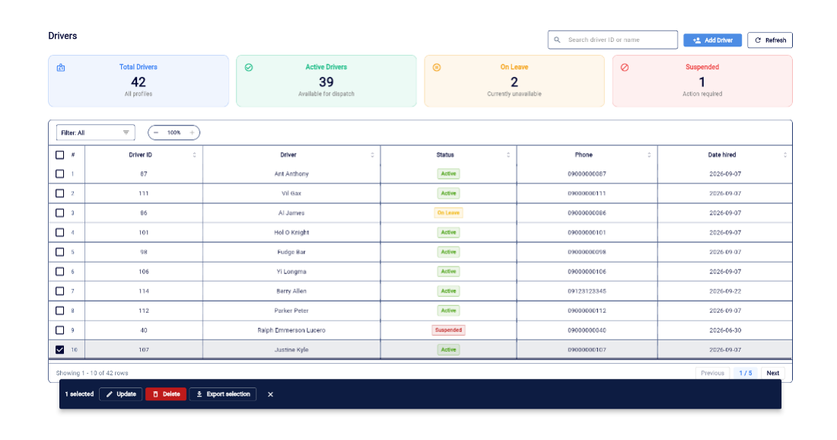
Figure 4-12 Driver Management Interface

Figure 4-11 Driver Management Interface
As shown in Figure 4-10, this interface presents the Driver Management module, which allows administrators to monitor and manage driver profiles and operational availability. The top section features summary cards that track total registered profiles alongside real-time availability metrics, categorizing personnel as Active Drivers ready for dispatch, On Leave, or Suspended. The data table displays essential contact information and hiring dates while utilizing color-coded status badges to help users quickly identify the current operational state of each driver. Because this module relies on the established data handling behavior of the overall system, the interface maintains a clean layout where administrators can click the top action button to initialize a new profile or select an existing row to trigger the standard update, delete, and export functions.
Objective 1.2: Vehicle Profile and Status Monitoring
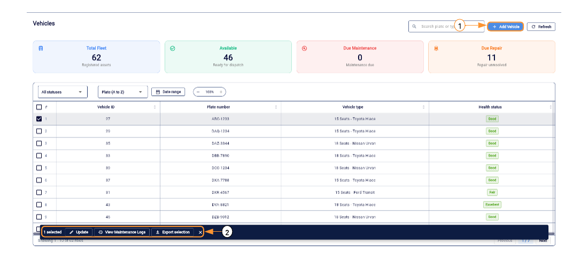
Figure 4-5 Vehicle Management Interface
As shown in Figure 4-5, this interface displays the main overview of the Vehicle Management module, which allows administrators to monitor the health and availability of the entire fleet. The top section features summary cards that track total fleet assets, available vehicles, and units that are currently due for maintenance or unresolved repairs. (1) Add Vehicle button enables authorized administrators to register new fleet assets into the system database. (2) Bottom Action Bar dynamically appears when a vehicle record is selected from the table, providing quick access to standard update and export functions, alongside a specific option to view the detailed maintenance logs of the chosen vehicle.
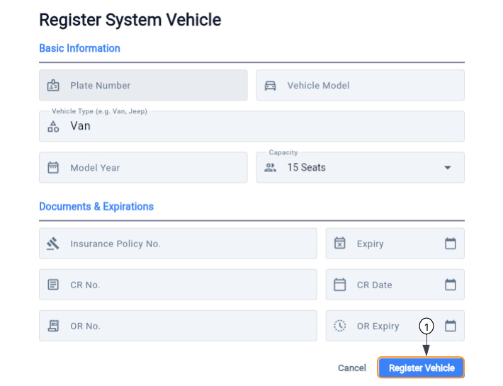
Figure 4-6 Vehicle Registration Form
As shown in Figure 4-6, this interface illustrates the data entry form utilized by administrators to register a new system vehicle. The form is structured to capture both basic identification details and critical compliance data required for fleet operations. The upper section collects essential specifications such as the plate number, vehicle model, type, and seating capacity. The lower Documents and Expirations section tracks important regulatory deadlines, including insurance policies and official receipt dates. (1) Register Vehicle button is used to submit the completed form and permanently save the new vehicle asset into the system database.
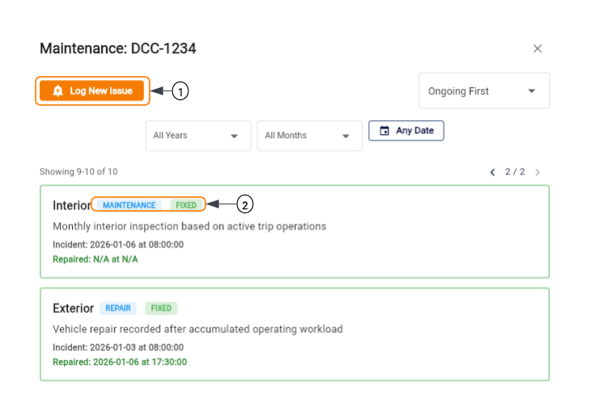

Objective 1.3: Biometric Attendance and Punctuality Tracking
Figure 4-13 Attendance Management Interface

As shown in Figure 4-11, this interface illustrates the Attendance Management module, designed to monitor employee timekeeping and attendance records for operational and payroll purposes. The top section features summary cards that evaluate overall punctuality by tracking total records and categorizing attendance metrics into on-time arrivals, accumulated late minutes, and missed shifts. The detailed data table logs specific time-in and time-out intervals for morning, afternoon, and overtime periods to ensure precise tracking. (1) Data Management Buttons allow authorized Staff users to efficiently import new attendance records via Excel from external biometric systems and export the compiled data for external processing. (2) Date Filter enables users to refine the displayed records based on specific timeframes, though custom date selections are strictly restricted to a maximum duration of one week to facilitate accurate, manageable data processing for payroll computation.
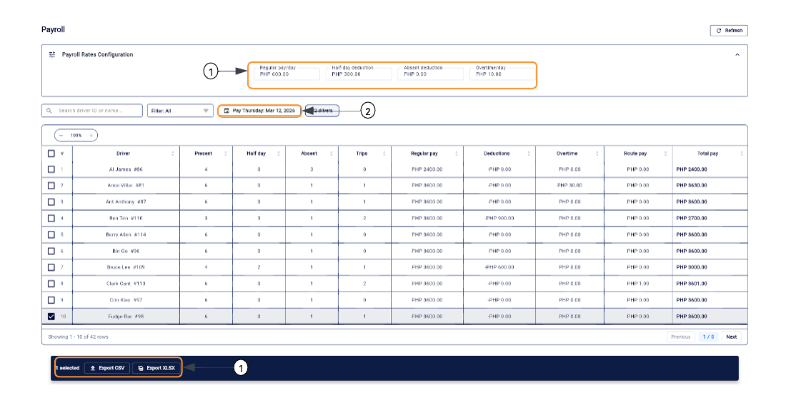
Figure 4-14 Payroll Management Interface

Figure 4-13 Payroll Management Interface
As shown in Figure 4-12, this interface illustrates the Payroll Management module, designed to automate the calculation of driver compensation by integrating operational attendance and trip records. The detailed data table aggregates these metrics to compute the final total pay, automatically factoring in regular earnings, specific route pay, and any attendance-based deductions for each individual driver. (1) Payroll Rates Configuration panel allows authorized personnel to establish the global financial parameters for the computation, providing input fields to define the standard daily wage, overtime rates, and exact deduction amounts for half-day or full absences. (2) Payroll Date Filter enables users to generate and review compensation records for a specific weekly period; however, to strictly align with the established payout schedule of the company, the calendar selection is restricted so that users can only choose Thursdays. (3) Bottom Action Bar dynamically appears upon row selection, providing essential export functions to download the finalized payroll data into CSV or XLSX formats for external financial processing.
Objective 1.4: Driver-Vehicle Assignment and Trip Summaries
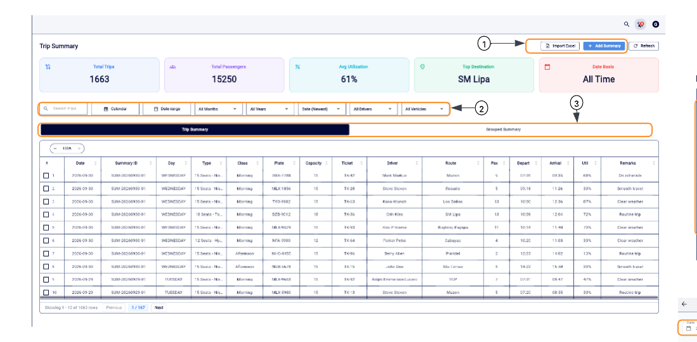
Figure 4-2 Trip Summary Management Interface

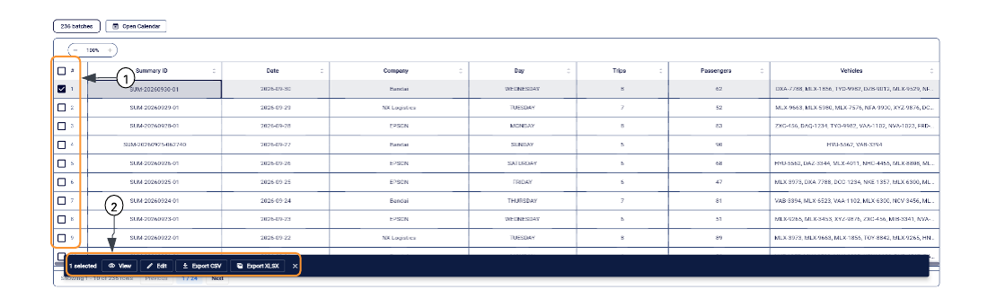
As shown in Figure 4-2, this interface displays the main overview of the Trip Summary module, which allows users to monitor and manage daily trip records and passenger volumes. The top section features summary cards that calculate total trips, passengers, and average utilization to give administrators a quick glance at operational efficiency. (1) Action Buttons allow authorized Staff users to manually add new trip summaries or import batch data directly via an Excel file. (2) Advanced Filters provide specific dropdown menus for date ranges, drivers, and vehicles to help users quickly sort through extensive historical trip data. (3) View Tabs allow users to seamlessly toggle between the detailed individual trip summary and a broader grouped summary layout.

Figure 4-3 Summary Trips

As shown in Figure 4-3, this interface illustrates the batch selection and record management capabilities within the Grouped Summary view. It demonstrates the standard data handling behavior implemented across the system for managing large datasets. (1) Row Selection checkboxes enable users to select one or multiple summary batches directly from the data table. (2) Bottom Action Bar dynamically appears when a record is selected, providing authorized users with quick access to view details, edit the entry, or export the selected data into CSV or XLSX formats for external reporting.

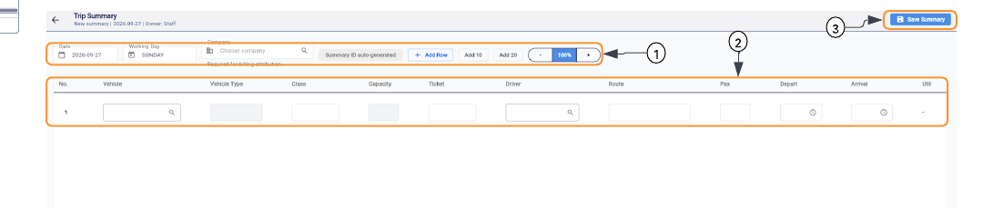

Figure 4-4 Add and Edit Summary Interface

As shown in Figure 4-4, this interface shows the data entry form utilized by Staff personnel to log new trip summaries into the database, which also serves as the identical user interface for editing existing records. The layout is designed to handle multiple trip inputs simultaneously to speed up the data encoding process. (1) Configuration Bar captures the primary details of the summary batch including the date and company attribution, while providing controls to dynamically add new entry rows. (2) Data Entry Table provides specific input fields for granular trip metrics, requiring the user to encode vehicle assignments, drivers, routes, passenger counts, and departure and arrival times. (3) Save Summary button commits the inputted operational records to the system database once the table is completely filled out.
Supporting Feature: Route and Company Management
As shown in Figure 4-8, this interface illustrates the Route Management module, which allows authorized personnel to oversee destination records and set operational rates. Unlike other system modules that utilize separate pop-up forms for data entry, this interface implements an inline management approach to streamline frequent updates. (1) Route Creation Panel is positioned directly at the top of the interface, allowing users to quickly input a new route name and financial rate without navigating to a separate registration page. (2) Inline Edit Icons are integrated directly into the data table rows, enabling administrators to modify specific route details or rates instantly within the list view. (3) Bottom Action Bar dynamically appears upon row selection; however, because editing is handled inline, this menu is streamlined to focus solely on exporting the selected route data.
The Company Management interface, which is restricted to authorized administrators for managing organizational profiles and client relationships. The data table categorizes registered entities by displaying essential details alongside specific entity classifications, utilizing color-coded tags to visually differentiate between the Primary company and various Partner clients. Because this module relies on the established data handling behavior of the overall system, the interface maintains a clean universal layout where administrators can click the top action button to initialize a new profile or select an existing row to trigger the standard update, delete, and export functions.
Objective 1.5: Maintenance and Compliance Tracking
Figure 4-7 Maintenance/Repair Log Interface

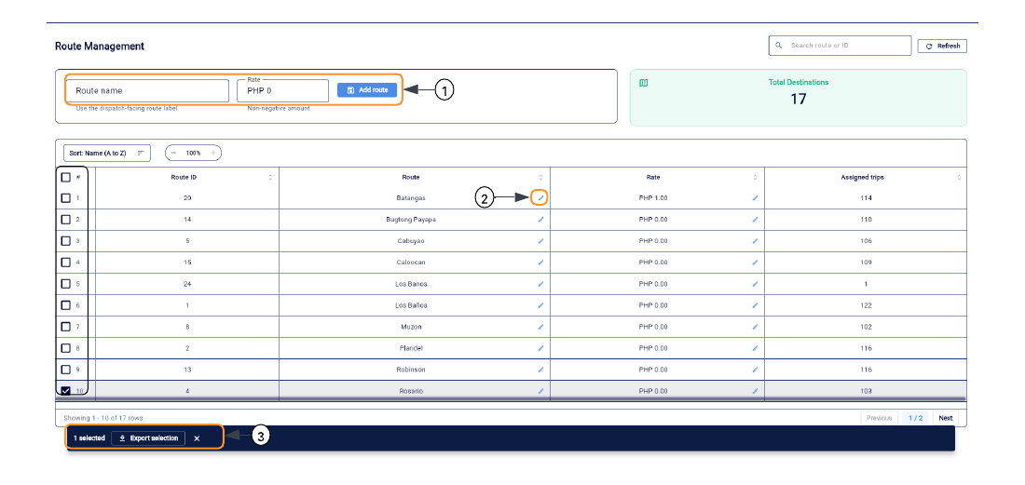
As shown in Figure 4-7, this interface presents the maintenance log modal for a specific vehicle, which provides a chronological history of all recorded repairs and maintenance activities. The module allows authorized personnel to track the health status of individual assets and review historical incidents, including specific dates for when issues occurred and when they were resolved. (1) Log New Issue button enables staff users to record a new vehicle problem or schedule upcoming maintenance, triggering a data entry form to capture the incident details. (2) Status Badges visually communicate the classification and current state of a specific log entry, utilizing color-coded tags such as MAINTENANCE, REPAIR, and FIXED to help users quickly differentiate between routine upkeep, active issues, and completed repairs.
Figure 4-8 Route Management Interface

Objective 1.6: Real-time Notifications, Alerts, and Access Control
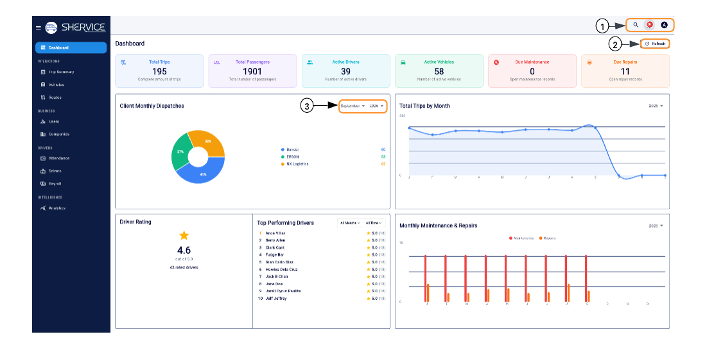
Figure 4-1 Admin and Staff Dashboard
As shown in Figure 4-1, this interface illustrates the main Dashboard of the Shervice system, designed to provide a comprehensive and high-level overview of the core operations of the company.
The dashboard displays critical performance indicators through top-level summary cards including Total Trips, Active Drivers, and Active Vehicles, alongside various data visualizations to help administrators quickly monitor the fleet status and overall business performance. (1) Global Header contains essential system tools like a search function, notification alerts, and user profile access for account management. (2) Refresh button is used to manually update the dashboard metrics to retrieve the most current operational data without reloading the entire web page. (3) Date Filter dropdown enables users to specify a particular timeframe, such as a specific month and year, which allows for targeted analysis of historical records within individual charts like the Client Monthly Dispatches.
Figure 4-9 User Management Interface

As shown in Figure 4-9, this interface illustrates the User Management module, which is accessible exclusively to system administrators for overseeing personnel credentials and system access. The data table provides a clear overview of all registered accounts, detailing their assigned roles and corresponding system permissions, such as Full Access or Logistics Only. (1) Register user button enables administrators to initialize new personnel profiles and assign appropriate role-based access control. (2) Bottom Action Bar dynamically appears when a specific user record is selected, providing the authorized administrator with standard tools to update account details, export selected data, or delete obsolete profiles to maintain strict system security.

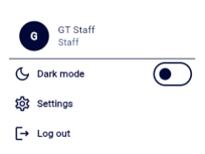
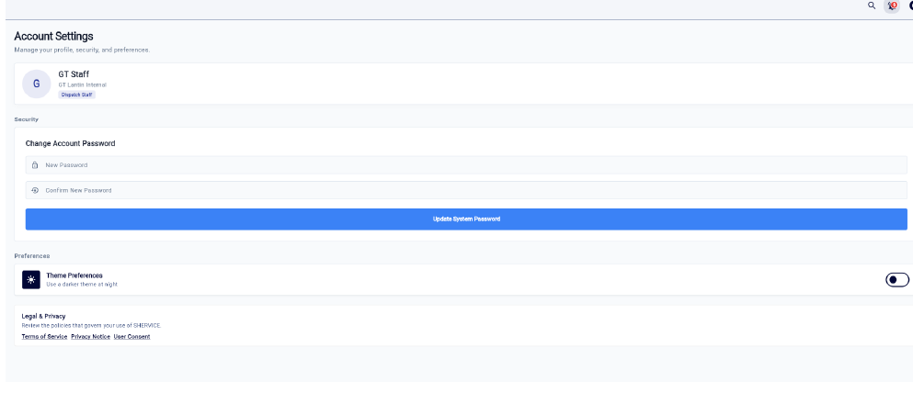
This section covers the foundational settings and security interfaces focusing on user-level account management. It documents the self-service configurations available to active personnel, such as visual theme preferences, credential updates, and the secure session management required to maintain data integrity and enforce privacy protocols across the platform.

Figure 4-15 Account Settings Interface

As shown in Figure 4-13, this interface illustrates the Account Settings module, which is accessed through the user profile dropdown located in the global header. The profile dropdown offers immediate tools to toggle the visual dark mode and securely log out of the active session. When navigating to the dedicated settings page, active personnel are provided with essential self-service capabilities to manage their individual system preferences and security. The interface allows users to review their current organizational role, dynamically update their system password to maintain account security, and access essential legal and privacy policies governing the use of the platform.
Objective 1.7: Staff Feedback Collection
Figure 4-19 Internal Driver Evaluation Form

As shown in Figure 4-17, this interface illustrates the data entry modal utilized by authorized staff to submit routine internal evaluations for active drivers. The form requires personnel to input specific five-star ratings for safety, punctuality, and professionalism. These newly submitted scores are systematically averaged into the driver's profile, subsequently updating the core features processed by the K-Nearest Neighbors algorithm during its next classification cycle. Furthermore, the form includes an optional text field for staff remarks, enabling dispatchers to record qualitative observations and context that quantitative ratings alone cannot capture.

Objective 2.1 and 2.2: Performance Analytics and Descriptive Analytics
Figure 4-16 Executive Operations Dashboard

As shown in Figure 4-14, this interface presents the Executive Operations Dashboard, which serves as the primary Fleet overview tab within the Analytics module. The dashboard is engineered to synthesize comprehensive operational data into high-level visual summaries for rapid administrative review. The upper section features key performance indicator cards that display the total passenger volume, current fleet readiness ratio, and the overall average driver performance rating. Below these primary metrics, the interface utilizes various data visualization techniques, including a dynamic line graph to track daily trip volume trends and a donut chart to illustrate the forecasted maintenance cycle distribution across the fleet. Furthermore, the lower section provides a detailed pie chart of route distributions alongside horizontal bar charts that specifically categorize monthly maintenance and repair activities. This consolidated view allows decision-makers to rapidly assess overall system health, logistical efficiency, and ongoing vehicle maintenance requirements without needing to navigate through individual database tables.

Objective 2.3: Predictive Analytics for Forecasting Vehicle Maintenance
Figure 4-20 Vehicle Predictive Maintenance Interface

As shown in Figure 4-18, this interface presents the Vehicle ML tab within the Analytics module, which leverages predictive machine learning to forecast upcoming fleet maintenance requirements. The system utilizes a Multiple Linear Regression algorithm to accurately estimate the number of days remaining until a specific vehicle requires its next service or repair. To generate this forecast, the predictive model processes nine distinct historical and operational features, including the age of the asset, trip volume over the last ninety days, average passenger load factors, and the number of days since its last recorded repair. The interface dynamically displays these calculated predictions alongside each registered fleet asset, utilizing color-coded status badges such as Excellent or Fair to indicate current vehicle health. For assets approaching their operational thresholds, the system explicitly flags the vehicle with a Due Repair Target date alongside a visual countdown of the remaining days, allowing administrators to proactively schedule upkeep before critical mechanical failures occur.

As shown in Figure 4-19, this interface illustrates the individual ML Forecast modal for a specific vehicle, which provides a detailed breakdown of the predictive maintenance results. The upper section prominently displays the final Multiple Linear Regression forecast, classifying the current operational health of the asset into specific categories such as Excellent Condition based on its recent trip workload and service history. To ensure transparency in the machine learning prediction, the lower section isolates the specific operational metrics that the algorithm processed to generate the final result. These detailed summary cards display the exact estimated days remaining until the next required service, alongside core algorithmic features including the total lifetime trips, physical age of the vehicle, total accumulated repairs and routine maintenance records, and the passenger volume transported over the preceding ninety days.

Objective 2.4: Driver Performance Classification
Figure 4-17 Driver Performance Classification Interface
As shown in Figure 4-15, this interface illustrates the Driver ML tab within the Analytics module, which leverages artificial intelligence to automatically evaluate and categorize fleet personnel. The system utilizes a K-Nearest Neighbors (KNN) classification algorithm configured with a distance-weighted approach to analyze historical performance. The machine learning model processes eight specific operational features per driver: average safety score, punctuality score, professionalism score, total trips completed, accumulated late minutes, and precise counts for present, half-day, and absent attendance records. By evaluating these metrics against historical ground truths, the KNN algorithm dynamically assigns predictive performance labels to each profile, utilizing color-coded badges such as Elite Performer or Tardiness Risk to immediately alert administrators to exemplary service or potential operational liabilities
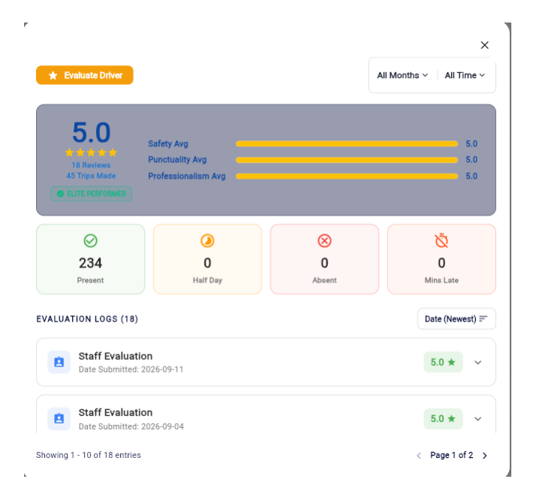
Figure 4-18 Individual Driver Performance Interface

As shown in Figure 4-16, this interface presents the comprehensive evaluation view for an individual driver, accessed by selecting a specific profile from the main classification list. The modal visually aggregates the exact core metrics utilized by the machine learning algorithm, prominently displaying the calculated average ratings for safety, punctuality, and professionalism alongside the raw attendance statistics. The upper section highlights the final ML classification badge derived from these numbers, while the lower section provides a chronological log of all past staff evaluations, allowing administrators to audit historical performance data and trace the origin of the current averages.


Objective 2.5: K-Means Clustering for Destination Demand Profiling
Figure 4-22 Destination Demand Profiling Interface
As shown in Figure 4-20, this interface illustrates the main dashboard of the Destinations tab within the Analytics module, which employs a K-Means clustering algorithm to automatically categorize destination demand profiles. The machine learning model evaluates three primary operational features for each route: total passenger volume, trip frequency, and the required fleet density, which is calculated based on the number of distinct vehicles assigned to that location. An integrated time filter allows administrators to dynamically adjust the analysis timeframe, supporting datasets ranging from a specific day to a full month. Based on these selected metrics, the algorithm groups destinations into distinct classifications, specifically High Demand, Steady Demand, and Low Demand Destinations. The lower section of the dashboard translates these data clusters into Actionable Dispatch Recommendations, explicitly suggesting operational adjustments such as increasing vehicle allocation for high-demand routes or deploying smaller vehicles to optimize fuel on low-demand routes.

Figure 4-23 Destination Demand Profiling Trip Breakdown Interface
As shown in Figure 4-21, this interface presents the Classified Trip Breakdown, which serves as a detailed supplementary view to support the destination demand clustering. The module lists individual trip records, visually mapping specific passenger counts, departure times, and vehicle assignments directly to their corresponding demand profiles. This detailed list ensures transparent algorithmic validation, allowing administrators to audit the exact historical data that the K-Means algorithm processed to generate the broader operational classifications.

4.2 Machine Learning Model Evaluation and Performance Metrics
A comprehensive evaluation of the machine learning algorithms integrated into the system to ensure the reliability of its automated operational insights. The intelligence module relies on three distinct algorithms to process fleet data: K-Nearest Neighbors (KNN) for driver performance classification, Multiple Linear Regression (MLR) for predictive vehicle maintenance, and K-Means clustering for destination demand profiling. Because these models solve fundamentally different mathematical problems encompassing classification, regression, and data clustering, their operational accuracy must be validated using distinct statistical frameworks. The subsequent evaluations utilize macro-averaged metrics to confirm the balanced identification of driver personnel tiers, continuous error measurements to quantify the practical variance in maintenance forecasting, and structural cohesion scores to verify the validity of the automated destination demand categories.
Table 4-1 Evaluation of Driver Performance Classification (KNN)
Metric | Score
Accuracy | 97.62%
Macro Precision | 0.9905
Macro Recall | 0.9167
Macro F1-Score | 0.9476

This evaluates the reliability of the K-Nearest Neighbors (KNN) driver performance classification model utilizing a four-fold stratified cross-validation approach. The model achieved a high overall accuracy of 97.62%, indicating that it correctly classified the vast majority of driver profiles into their respective performance tiers. To account for the imbalanced class distribution, macro-averaged metrics were calculated to ensure minority classes were equally weighted. The model recorded a macro precision of 0.9905, demonstrating that when it predicts a specific performance label, the prediction is highly accurate. A macro recall of 0.9167 indicates the model successfully identified most true instances across all classes, with perfect recall (1.00) for the Consistent Performer and Tardiness Risk categories, alongside a lower 0.75 recall for the minority Elite Performer class. The resulting macro F1-score of 0.9476 confirms a strong, balanced harmonic mean between precision and recall, establishing the KNN algorithm as a reliable tool for automated personnel evaluation.
Table 4-2 Accuracy of Vehicle Maintenance Forecasting (MLR)
Metric | Score
Mean Absolute Error (MAE) | 21.31 Days
Root Mean Squared Error (RMSE) | 26.01 Days
R-squared (R²) | -0.2723

Assessing the accuracy of the Multiple Linear Regression (MLR) model utilized for predictive maintenance, evaluated through a chronological split of 907 training samples and 227 testing samples. The model yielded a Mean Absolute Error (MAE) of 21.31 days, meaning its maintenance forecasts deviate from the actual recorded service dates by approximately three weeks on average. The Root Mean Squared Error (RMSE) was calculated at 26.01 days; because RMSE specifically penalizes larger prediction errors, its proximity to the MAE indicates that the model does not suffer from extreme outlier predictions. The evaluation recorded a negative R-squared value of -0.2723, indicating a high degree of variance in the operational maintenance schedules that the linear features could not fully explain. Despite this variance, the MLR significantly outperformed the comparative Random Forest baseline (MAE of 32.19 days, R-squared of -1.8700), validating its selection as the more optimal predictive engine for estimating remaining operational days.
Table 4-3 Validation of Destination Demand Profiling (K-Means)
Metric | Score
Number of Clusters (k) | 3
Silhouette Coefficient | 0.7517

This section validates the internal consistency of the K-Means destination demand profiling model using the Silhouette Score metric. Processing historical data across 17 unique destinations configured into three optimal clusters, the algorithm achieved a Silhouette Coefficient of 0.7517. Because the Silhouette Score ranges from -1 to 1, with values closer to 1 indicating that data points are highly similar to their own cluster and distinct from neighboring clusters, this result demonstrates strong structural separation. This high score confirms that the machine learning model successfully grouped the destinations into distinct, non-overlapping operational profiles based on passenger volume, trip frequency, and required fleet density, ensuring that the resulting dispatch recommendations are derived from highly reliable data clusters.

4.3.3 End-User Acceptance Testing
This section presents the comprehensive results of the User Acceptance Testing (UAT) conducted directly by the primary end users of the Shervice platform, specifically the administrative personnel and dispatching staff of GT Lantin. The evaluation deliberately focused on the system’s practical application in the field, measuring how well the software performs under the real world constraints of a fast paced transit environment. By utilizing the application during active operational shifts, the developers assessed whether the platform successfully addresses and resolves the critical inefficiencies inherent in their previous manual workflows. Furthermore, this testing phase validates that the transition from fragmented paper records to a centralized digital architecture genuinely enhances daily productivity and fleet oversight. The structured feedback gathered from these primary users serves as the final validation of the platform's usability, reliability, and functional suitability, ensuring that the software aligns perfectly with the strategic business needs of the company.

Table 4-8 Overall Summary of End-User Evaluation
Evaluation Criteria | Average Mean | Verbal Interpretation
Daily Functionality | 4.67 | Strongly Agree
Speed and Reliability | 4.53 | Strongly Agree
Ease of Use | 4.30 | Strongly Agree
Access and Trust | 4.60 | Strongly Agree
Overall Weighted Mean | 4.72 | Strongly Agree
This table presents the overall summary of the end-user evaluation, which yielded an Overall Weighted Mean of 4.72 ("Strongly Agree"). The administrative and dispatching staff rated the system highly across all criteria, specifically in Daily Functionality (4.67), Access and Trust (4.60), Speed and Reliability (4.53), and Ease of Use (4.30). This high consolidated score confirms that the Shervice platform successfully met GT LANTIN's operational requirements. Ultimately, the results validate that the system effectively replaced their manual processes with a fast, reliable, and secure digital environment built specifically for their dispatching and administrative workflows.

4.3.4 IT Expert Technical Evaluation
This section details the technical assessment conducted by a panel of IT experts. The evaluation strictly followed the ISO/IEC 25010 Software Quality Model to ensure the platform’s underlying architecture, backend logic, and integrated machine learning algorithms adhere to industry-standard software engineering practices.
Table 4-16 Overall Summary of IT Expert Evaluation
ISO/IEC 25010 Characteristics | Average Mean | Verbal Interpretation
Functional Suitability | 4.66 | Strongly Agree
Performance Efficiency | 4.77 | Strongly Agree
Usability | 4.30 | Strongly Agree
Security | 4.43 | Strongly Agree
Reliability | 4.40 | Strongly Agree
Maintainability | 4.58 | Strongly Agree
Portability | 4.55 | Strongly Agree
Overall Weighted Mean | 4.53 | Strongly Agree

The IT experts' results present the overall summary of the IT expert evaluation based on the seven ISO/IEC 25010 Software Quality characteristics. The technical assessment yielded highly positive results, achieving an Overall Weighted Mean of 4.53, which translates to a verbal interpretation of "Strongly Agree". Among the evaluated criteria, Performance Efficiency received the highest rating at 4.77, demonstrating the system's optimal processing speeds and resource utilization under varying data loads. Functional Suitability followed closely with a score of 4.66, confirming that the system accurately executes its intended logistical and machine learning tasks. The platform also demonstrated strong technical stability across its backend architecture, scoring 4.58 in Maintainability, 4.55 in Portability, 4.43 in Security, and 4.40 in Reliability. Finally, Usability received a solid score of 4.30. Collectively, these ratings confirm that the Shervice platform complies with rigorous software engineering standards and provides a highly capable, secure, and adaptable digital infrastructure for fleet management operations.

SUMMARY, CONCLUSIONS, AND RECOMMENDATIONS
This chapter presents the final summary of the study entitled "Shervice: A GT LANTIN Shuttle Service Management System with Driver Performance Analytics and Predictive Maintenance." It covers the main findings, conclusions tied to specific objectives, and actionable recommendations based on the system's development, rigorous testing, and the integration of its analytical components.

5.1 Summary
This study addressed the significant operational challenges at GT LANTIN Shuttle Rental Services, where the absence of a centralized, real-time system constrained effective fleet management. The transport provider relied on manual, redundant, and inconsistent physical logbooks, whiteboards, and spreadsheets to track driver records, vehicle assignments, and attendance. This process was laborious, prone to frequent inaccuracies, and resulted in data disorganization and operational delays. This limitation hindered service quality, reduced market competitiveness, and created significant barriers to proactive business analysis and strategic planning.
To address these challenges, a centralized web-based management system was designed and developed utilizing a modern technology stack composed of Flutter, Node.js, Python Flask, and PostgreSQL. The system was structured to manage complete driver and vehicle profiles, integrate biometric attendance and punctuality tracking, and streamline driver-vehicle assignments alongside trip summaries. It also established a framework for maintenance and compliance tracking, real-time notifications, and the manual collection of staff feedback, all operating within a secure, two-tier architecture restricted exclusively to Admin and Staff roles.
Furthermore, Business Analytics tools and Machine Learning concepts were integrated to transform raw operational data into actionable business intelligence. The system generated Performance Analytics Dashboards for real-time KPI visualization and descriptive reports detailing historical vehicle utilization. Moving from reactive to proactive management, the platform utilized Multiple Linear Regression to forecast upcoming vehicle maintenance, applied a classification model to categorize drivers based on behavioral and performance issues, and executed K-Means Clustering to profile destination demand across the cooperative's regular routes.
Finally, the system’s technical performance and the accuracy of the integrated analytical models were rigorously evaluated. The machine learning models were mathematically assessed using specific metrics: Accuracy, Precision, Recall, and F1-score for the driver performance classification; Mean Absolute Error (MAE), Root Mean Squared Error (RMSE), and R-Squared for the maintenance forecasting model; and the Silhouette Score for the destination demand profiling. The overall software architecture and user experience were evaluated through User Acceptance Testing based on the ISO/IEC 25010 Software Quality Standards to ensure the platform completely met the operational needs of GT LANTIN.

5.2 Conclusions
Based on the specific goals and the findings of the study, the developers concluded the following:
- A web-based management system utilizing a modern technology stack was successfully designed and developed. This was proven by the deployment of a centralized platform built on Flutter, Node.js, and PostgreSQL that operated on a strict two-tier access model for Admin and Staff. The system effectively replaced the transport provider's physical whiteboards and logbooks by digitizing driver and vehicle profiles, automating offline biometric attendance logs, and establishing a unified interface for trip summaries, maintenance tracking, and staff feedback collection.
- Business Analytics tools and Machine Learning concepts were successfully integrated to transform raw operational data into actionable insights. This was evidenced by the implementation of a Python Flask micro-framework that successfully executed data-driven algorithms. The system generated descriptive analytics for vehicle utilization and outputted real-time KPIs on the administrative dashboard. Furthermore, the successful execution of Multiple Linear Regression for maintenance forecasting, K-Nearest Neighbors for driver performance classification, and K-Means Clustering for destination demand profiling confirmed the system's capacity to deliver predictive business intelligence.
- The system’s performance and the accuracy of the integrated analytics models were successfully evaluated and validated. This was supported by the rigorous mathematical validation of the machine learning algorithms, where metrics such as MAE, RMSE, R-Squared, F1-score, and the Silhouette Score verified the predictive reliability of the models. Furthermore, the overall platform achieved highly positive User Acceptance Testing results, securing an Overall System Consolidated Score of 4.72 from end-users and 4.53 from IT experts based on the ISO/IEC 25010 standards, thereby confirming its operational readiness and technical stability.

5.3 Recommendations
With the system in place, the developers suggest the following improvements for better scalability, flexibility, and long-term use for GT LANTIN Shuttle Rental Services:
- Continuous Data Collection for Machine Learning Refinement: The administrative staff should continue the systematic data collection of vehicle mileage, repair logs, and passenger counts over the subsequent 12 to 24 months. Expanding the historical dataset will directly improve the training phases of the machine learning models, specifically increasing the forecasting accuracy and reducing the error margins of the Multiple Linear Regression maintenance algorithm.
- Integration of Automated Telematics Hardware: To further elevate the web-based management system, future developers should explore the integration of Internet of Things (IoT) hardware, such as passive On-Board Diagnostics (OBD) sensors. This would allow the system to fetch live vehicle mileage and engine health data directly into the dashboard, significantly reducing the manual encoding burden on the staff while maintaining the strict internal-only access policy.
- Development of an Automated Notification Gateway: To enhance the system's operational reach, an automated Short Message Service (SMS) or email notification gateway should be integrated. This feature would push formulated daily shift assignments, route schedules, and predictive maintenance alerts directly to corporate clients and drivers, standardizing external communication without requiring external users to access the secure web portal.

REFERENCES

Acasamoso, R., Santos, J., & Grefaldo, L. (2025). RFID-based attendance monitoring system with SMS notification and data analytics. IIARI Online Books. https://iiari.org/wp-content/uploads/Ch3.12.-RFID-based-Attendance-Monitoring-System-with-SMS-Notification-and-Data-Analytics.pdf
Adekunle et. al (2021) A Predictive Modeling Approach to Optimizing Business Operations: A Case Study on Reducing Operational Inefficiencies through Machine Learning. International Journal of Multidisciplinary Research and Growth Evaluation. https://www.researchgate.net/publication/390300594_A_Predictive_Modeling_Approach_to_Optimizing_Business_Operations_A_Case_Study_on_Reducing_Operational_Inefficiencies_through_Machine_Learning

Adenuga, O. I., et al. (2024). Optimizing port logistics through generative AI: Revolutionizing efficiency and resilience in the maritime industry. ODU Digital Commons. https://digitalcommons.odu.edu/cgi/viewcontent.cgi?article=1277&context=emse_fac_pubs

Alsaqqa, S., Sawalha, S., & Abdel-Nabi, H. (2020). Agile software development: Methodologies and trends. International Journal of Interactive Mobile Technologies, 14(11), 246-270. https://doi.org/10.3991/ijim.v14i11.13269

Amazon Web Services. (2024). What is Cloud Computing? https://aws.amazon.com/what-is-cloud-computing/

Amora, E. N. O., Romero, K. V., & Amoguis, R. C. (2021). Digital attendance and accomplishment report monitoring system (DIGIATT). IOER International Multidisciplinary Research Journal, 3(2), 124-132. https://www.researchgate.net/publication/360617825

Biswas, M. A. R., Rahman, M. M., & Hossain, M. M. (2022). IoT-based vehicle tracking system for Khulna University. Khulna University Studies, 120-132. https://doi.org/10.53808/KUS.2022.19.01.2132-se

Cabrera, E. J., & Magsino, A. (2025). Parking occupant management system using QR code solutions with AES algorithm. Asian Journal of Science and Technology Studies, 2(1), 45-56. https://journals.e-palli.com/home/index.php/ajsts/article/download/4717/2593/35440

California ARB (2025) OBD - On-Board Diagnostic Program. https://ww2.arb.ca.gov/our-work/programs/obd

Caynila, K. A. M., & Centeno, G. P. S. (2025). Adopting generative artificial intelligence: Opportunities and challenges in the Philippine IT-BPM industry. Bangko Sentral ng Pilipinas. https://www.bsp.gov.ph/Media_And_Research/Publications/EN25-01.pdf

Chandrika, T. S. (2025). A study on HR analytics for attendance patterns and organizational insights. International Journal for Research in Applied Science & Engineering Technology (IJRASET). https://www.ijraset.com/research-paper/a-study-on-hr-analytics-for-attendance-patterns-and-organizational-insights

Chen, F., Jia, H., & Zhou, W. (2025). Vehicle Maintenance Demand Prediction: A Survey. Applied Sciences, 15(20), 11095. https://doi.org/10.3390/app152011095

Ching, A., & Chian, B. (2024). Exploring the factors influencing commuters' satisfaction and the use of public utility buses in Quezon City, Philippines. International Institute of Academic Research and Innovation (IIARI), 5(1). https://iiari.org/wp-content/uploads/irssr.v5.1.2572.pdf

Creatio (2025) Client vs. Customer: What Are the Differences? https://www.creatio.com/glossary/client-vs-customer

Cueto, G., Baluyot, D. S., Ordonia, J. R., & Rivera, W. C. (2024). Intelligent transport system implementation in road transportation in Manila, Philippines: A four-step model approach. Transportation Science Society of the Philippines. https://ncts.upd.edu.ph/tssp/wp-content/uploads/2024/12/TSSP2024-11-Revised-Paper.pdf

Das, T., & Sharma, K. (2025). Student attendance monitoring system. International Journal for Research Trends and Innovation, 10(10), 84-90. https://www.ijrti.org/papers/IJRTI2510084.pdf

Data Bridge Market Research. (2025, July 24). Global fleet management market – Industry trends and forecast to 2033. Data Bridge Market Research. https://www.databridgemarketresearch.com/reports/global-fleet-management-market

Deka, U., Varshini, V., & Dilip, D. M. (2023). The journey of demand responsive transportation: Towards sustainable services. Frontiers in Built Environment, 8, 942651. https://doi.org/10.3389/fbuil.2022.942651

Dennis, A., Wixom, B. H., & Roth, R. M. (2021). Systems analysis and design (8th ed.). John Wiley & Sons. https://unidel.edu.ng/focelibrary/books/Systems%20Analysis%20and%20Design,%208e%20(Alan%20Dennis,%20Barbara%20Wixom,%20Roberta%20M.%20Roth)%20(Z-Library).pdf

Department of Science and Technology - Philippine Council for Industry, Energy and Emerging Technology Research and Development (DOST-PCIEERD). (2022). Transportation sector R&D roadmap. https://pcieerd.dost.gov.ph/wp-content/uploads/2022/02/02_Transportation_Sector.pdf

Detera, E. I., & Hanbal, I. (2024). Development of a utility vehicle express system framework using design thinking process for the province of Albay. TEM Journal, 13(3), 2218-2225. https://www.researchgate.net/publication/383521609_Development_of_a_Utility_Vehicle_Express_System_Framework_Using_Design_Thinking_Process_for_the_Province_of_Albay

Faßbender, M., Rößler, N., Eisenbarth, M., & Andert, J. (2024). An electric vehicle charging simulation to investigate the potential of intelligent charging strategies. SSRN Electronic Journal. https://dx.doi.org/10.2139/ssrn.4960376

Fathorrahman, F., & Widianto, S. (2024). Fleet management information system design PT. Bagus Amelia Jaya uses the user method web-based centered design. E-Journal UNUJA, 8(2), 15-25. https://ejournal.unuja.ac.id/index.php/jeecom/article/download/13084/pdf

Géron, A. (2022). Hands-On Machine Learning with Scikit-Learn, Keras, and TensorFlow: Concepts, Tools, and Techniques to Build Intelligent Systems (3rd ed.). O'Reilly Media. https://www.oreilly.com/library/view/hands-on-machine-learning/9781492032632/

Gheorghe, C., & Soica, A. (2025). Revolutionizing Urban Mobility: A Systematic Review of AI, IoT, and Predictive Analytics in Adaptive Traffic Control Systems for Road Networks. Electronics, 14(4), 719. https://doi.org/10.3390/electronics14040719

Grinberg, M. (2018). Flask Web Development: Developing Web Applications with Python. O'Reilly Media. https://www.oreilly.com/library/view/flask-web-development/9781491991725/

Gumasing, M. J. J., Bermejo, F. J. C. S., Elpedes, K. T. C., Gonzales, L. F. E., & Villajin, A. C. V. (2023). Antecedents of Waze mobile application usage as a solution for sustainable traffic management among Gen Z. Sustainability, 15(13), 10186. https://doi.org/10.3390/su151310186.

Haverbeke, M. (2024). Eloquent JavaScript: A Modern Introduction to Programming (4th ed.). No Starch Press. https://eloquentjavascript.net/

Ilagan, L. (2025). Technological development and sustainability of public transportation logistics in Calaca City, Batangas. International Journal of Scientific Research and Engineering Development, 8(4). https://www.ijsred.com/volume8/issue4/IJSRED-V8I4P68.pdf

Indeed (2025) Officers of a Corporation: Roles and Responsibilities. https://www.indeed.com/recruitment/c/info/officers-of-a-corporation-roles-and-responsibilities

InsiderPH. (2026, March 6). Fly Ace to build manufacturing hub at LIMA Estate in Batangas. InsiderPH. https://insiderph.com/fly-ace-to-build-manufacturing-hub-at-lima-estate-in-batangas

Insite. (2023). The future of fleet management: Technology & innovation. Insite. https://insite.training/the-future-of-fleet-management-embracing-technology-and-innovation/

International Transport Forum (ITF). (2022). How digitally-driven operational improvements can reduce global freight emissions. OECD. https://www.itf-oecd.org/sites/default/files/docs/digital-operation-reduce-freight-emissions.pdf

Investopedia. (2024) Key Performance Indicator (KPI): Meaning, Types, and Examples. https://www.investopedia.com/terms/k/kpi.asp

IRE Journals (2023) Impact of Predictive Analytics on Business Decisions Making. https://www.irejournals.com/formatedpaper/1708772.pdf

James, G., Witten, D., Hastie, T., & Tibshirani, R. (2021). An Introduction to Statistical Learning: with Applications in R (2nd ed.). Springer. https://www.statlearning.com/

Jarašūnienė, A., Batarlienė, N., & Šidlauskis, B. (2024). Management of Risk Factors in the Rental Car Market. Future Transportation, 4(4), 1457-1475. https://doi.org/10.3390/futuretransp4040070

Juliano, J. J., Armada, M. K. A., & Cosadio, A. N. P. (2025). Automated vehicle access control system utilizing computer vision-based license plate recognition. International Journal of Multidisciplinary: Applied Business and Education Research, 6(4), 1947-1977. https://doi.org/10.11594/ijmaber.06.04.27

Kaluvakuri, S., & Peta, K. (2024). Assessment of the effect of fleet management software on operational performance. Journal of Industrial Engineering & Management Research. https://jiemar.org/index.php/jiemar/article/download/619/482

Lim, A., & Tan, B. (2024). Efficient campus shuttle tracking and management mobile application for college campus. ALife Robotics, 18(1), 1-8. https://alife-robotics.co.jp/members2024/icarob/data/html/data/OS/OS18-1.pdf

Litman, T. (2024). Mobility management. Victoria Transport Policy Institute. https://transformative-mobility.org/wp-content/uploads/2024/01/GIZ_SUTP_SB2B_Mobility-Management_EN.pdf

Mac, T. T., Pham, N., & Nguyen, H. (2024). The development of fleet management system for mobile robots delivering medicine in healthcare environments. Acta Polytechnica Hungarica, 21(9), 58-75. https://acta.uni-obuda.hu/Mac_Pham_Nguyen_149.pdf

Miron, R., Hulea, M., Muresan, V., Clitan, I., & Rusu, A. (2025). Integrating Blockchain Technology into Mobility-as-a-Service Platforms for Smart Cities. Smart Cities, 8(1), 9. https://doi.org/10.3390/smartcities8010009

National Center for Transportation Studies (NCTS) UP Diliman. (2024). The Public Transport Modernization https://ncts.upd.edu.ph/tssp/archives/2967

Oladimeji, D., Gupta, K., Kose, N. A., Gundogan, K., Ge, L., & Liang, F. (2023). Smart Transportation: An Overview of Technologies and Applications. Sensors, 23(8), 3880. https://doi.org/10.3390/s23083880

Pagero. (2022, April 12). TMS solutions for SMEs: Transportation management FAQs. Pagero. https://www.pagero.com/blog/tms-solutions-for-smes

PISTON. (2024, October 7). On World Day for Decent Work: PISTON demands decent work for Filipino transport workers amid Marcos Jr's modernization program, questionable EV push. PISTON Land Transport Coalition. https://pistonph.com/on-world-day-for-decent-work-piston-demands-decent-work-for-filipino-transport-workers-amid-marcos-jrs-modernization-program-questionable-ev-push/

Pressman, R. S., & Maxim, B. R. (2020). Software engineering: A practitioner's approach (9th ed.). McGraw-Hill Education. https://www.researchgate.net/publication/365946272_Software_Engineering_A_Practitioner%27s_Approach_9_th_Edition

Reynoso, M. M., et al. (2025). RFID-based attendance monitoring system with SMS notification and data analytics. IIARI Online Books. https://iiari.org/online_book/information-technology-cross-platform-application-and-development/rfid-based-attendance-monitoring-system-with-sms-notification-and-data-analytics/

Saloma, C. A. (2025). An analysis of smart city development frameworks. UP Center for Integrative and Development Studies. https://cids.up.edu.ph/wp-content/uploads/2025/08/An-Analysis-of-Smart-City-Development-Frameworks.pdf

Santos, M., & Reyes, P. (2024). E-BIODEV: A systematized barangay attendance monitoring system. International Journal for Research Trends and Innovation, 9(11), 34-40. https://www.ijrti.org/papers/IJRTI2411004.pdf

Sommerville, I. (2021). Software engineering (11th ed.). Pearson. https://www.pearson.com/nl/en_NL/higher-education/subject-catalogue/computer-science/Sommerville-Engineering-Software-Products-An-Introduction-to-Modern-Software-Engineering.html

Sumampong, C. J., Sumampong, C. D., Paler, J. S., Prospero, A., Pineda, J. L., Borras, C., & Jayoma, R. R. B. (2026). Impact of shuttle service on employee retention and operational efficiency. Ascendens Asia Singapore – Bestlink College of the Philippines Journal of Multidisciplinary Research, 7(1). https://ojs.aaresearchindex.com/index.php/aasgbcpjmra/article/view/15580

Supabase Open Source. (2023). Supabase Documentation: The Open Source Firebase Alternative. https://supabase.com/docs

Sy, C. L., & Regidor, J. R. F. (2024). An assessment of the effectiveness of the Quezon City bus service based on users' satisfaction. University of the Philippines Diliman. https://ncts.upd.edu.ph/tssp/wp-content/uploads/2024/12/TSSP-2024-31-Revised-Paper.pdf

Turoń, K. (2023). Car-Sharing Systems in Smart Cities: A Review of the Most Important Issues Related to the Functioning of the Systems in Light of the Scientific Research. Smart Cities, 6(2), 796-808. https://doi.org/10.3390/smartcities6020038

Valacich, J. S., & George, J. F. (2020). Modern systems analysis and design (9th ed.). Pearson. https://www.google.com/url?sa=t&rct=j&q=&esrc=s&source=web&cd=&ved=2ahUKEwjPle6pn7aTAxViZvUHHRGFAC4QFnoECBsQAQ&url=http%3A%2F%2F103.203.175.90%3A81%2FfdScript%2FRootOfEBooks%2FE%2520Book%2520collection%2520-%25202024%2FECE%2FModern_Systems_Analysis_and_Design%2C_Global_E dition%2C_9th_Edition.pdf&usg=AOvVaw2qQdyDs6MiYb1eE8NNYgLo&opi=89978449

Wang, Y., & Li, X. (2021). Association between commute duration and sickness absence in the context of China: Mechanism and heterogeneous effects. Frontiers in Public Health, 9, 611162. https://doi.org/10.3389/fpubh.2021.61116

Zhai, Y. (2024). The impact of intelligent transportation technology on the operational efficiency of public transportation enterprises. Academic Journal of Science and Technology. https://www.researchgate.net/publication/384880731_The_Impact_of_Intelligent_Transportation_Technology_on_The_Operational_Efficiency_of_Public_Transportation_Enterprises

Zulueta, T. M. T., Ong, A. K. S., German, J. D., Gumasing, M. J. J., & Chico, J. C. D. (2024). Implications of the Progression to Sustainable Public Transportation: An Insight into Modern Jeepney Shift from the Philippines. Sustainability, 16(10), 3912. https://doi.org/10.3390/su16103912

Zulueta, T. M. T., Ong, A. K. S., Germar, J. D., Gumasing, M. J. J., & Castillo, J. C. D. (2024). Implications of the Progression to Sustainable Public Transportation: An Insight into Modern Jeepney Shift from the Philippines. Sustainability, 16(10), 3912. https://doi.org/10.3390/su16103912

APPENDECIES
Appendix A: SURVEY QUESTIONARE FOR EXPERTS
Appendix B: SURVEY QUESTIONARE FOR END-USERS
Appendix C: APPROVED LETTER
Appendix D: CLIENT ACCEPTANCE LETTER
Appendix E: ACCEPTANCE FORM
Appendix F: ENDORSEMENT FORM
Appendix G: MAINTENANCE COST
Appendix H: EXPENDITURES
Appendix I: WORKPLAN/TIMEFRAME
Appendix J: CV OF EXTERNAL EXPERTS
Appendix K: CV OF DEVELOPERS

Appendix A: SURVEY QUESTIONARE FOR IT EXPERTS
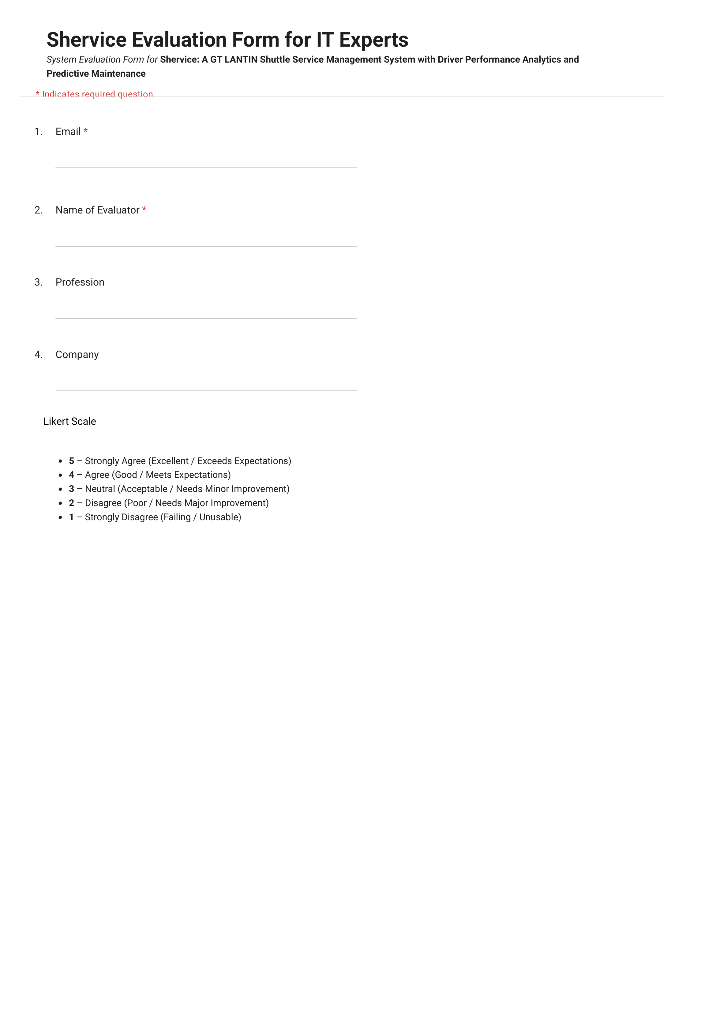
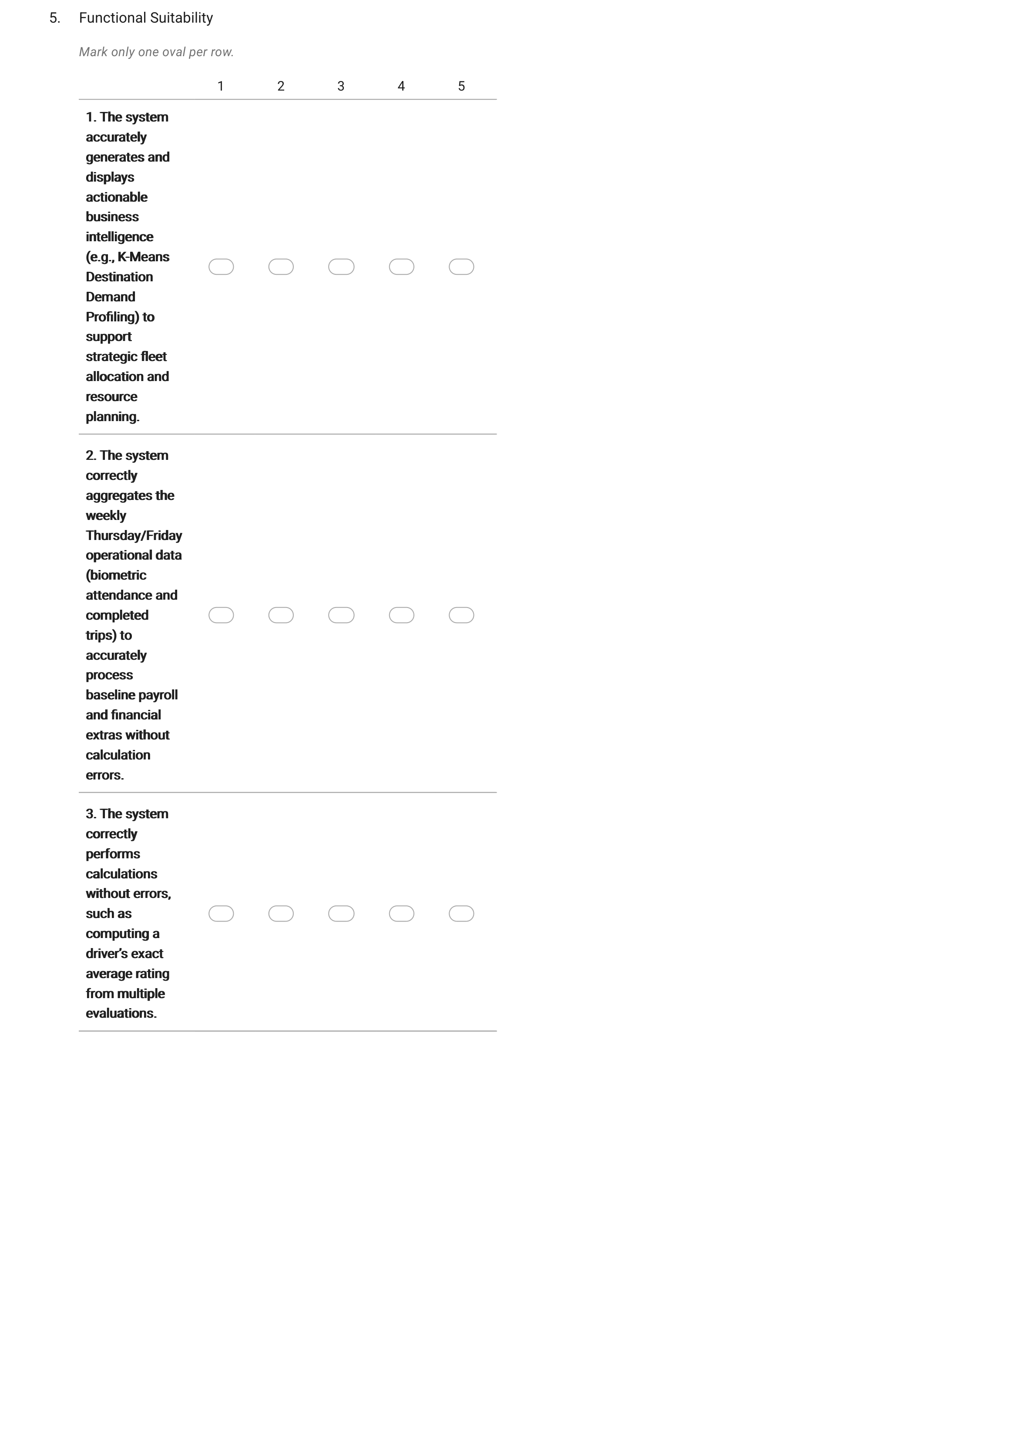
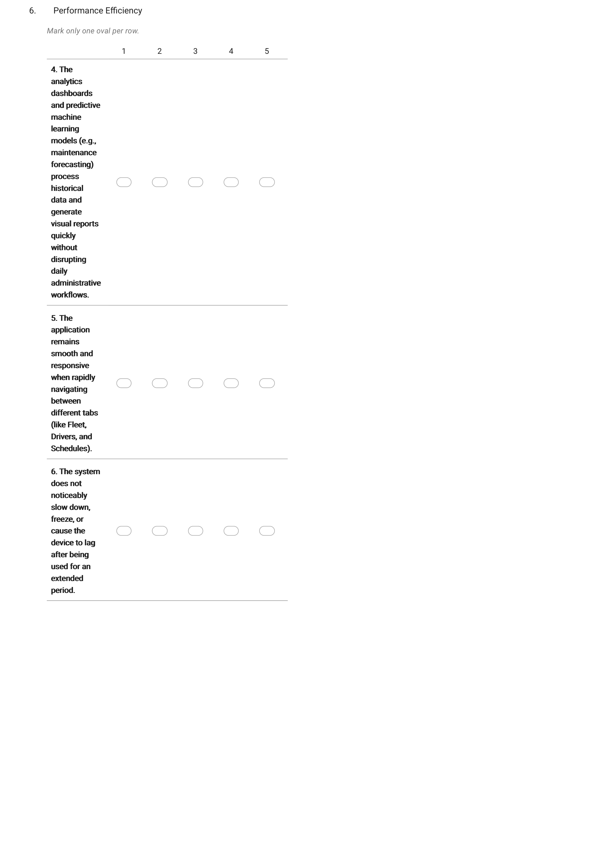
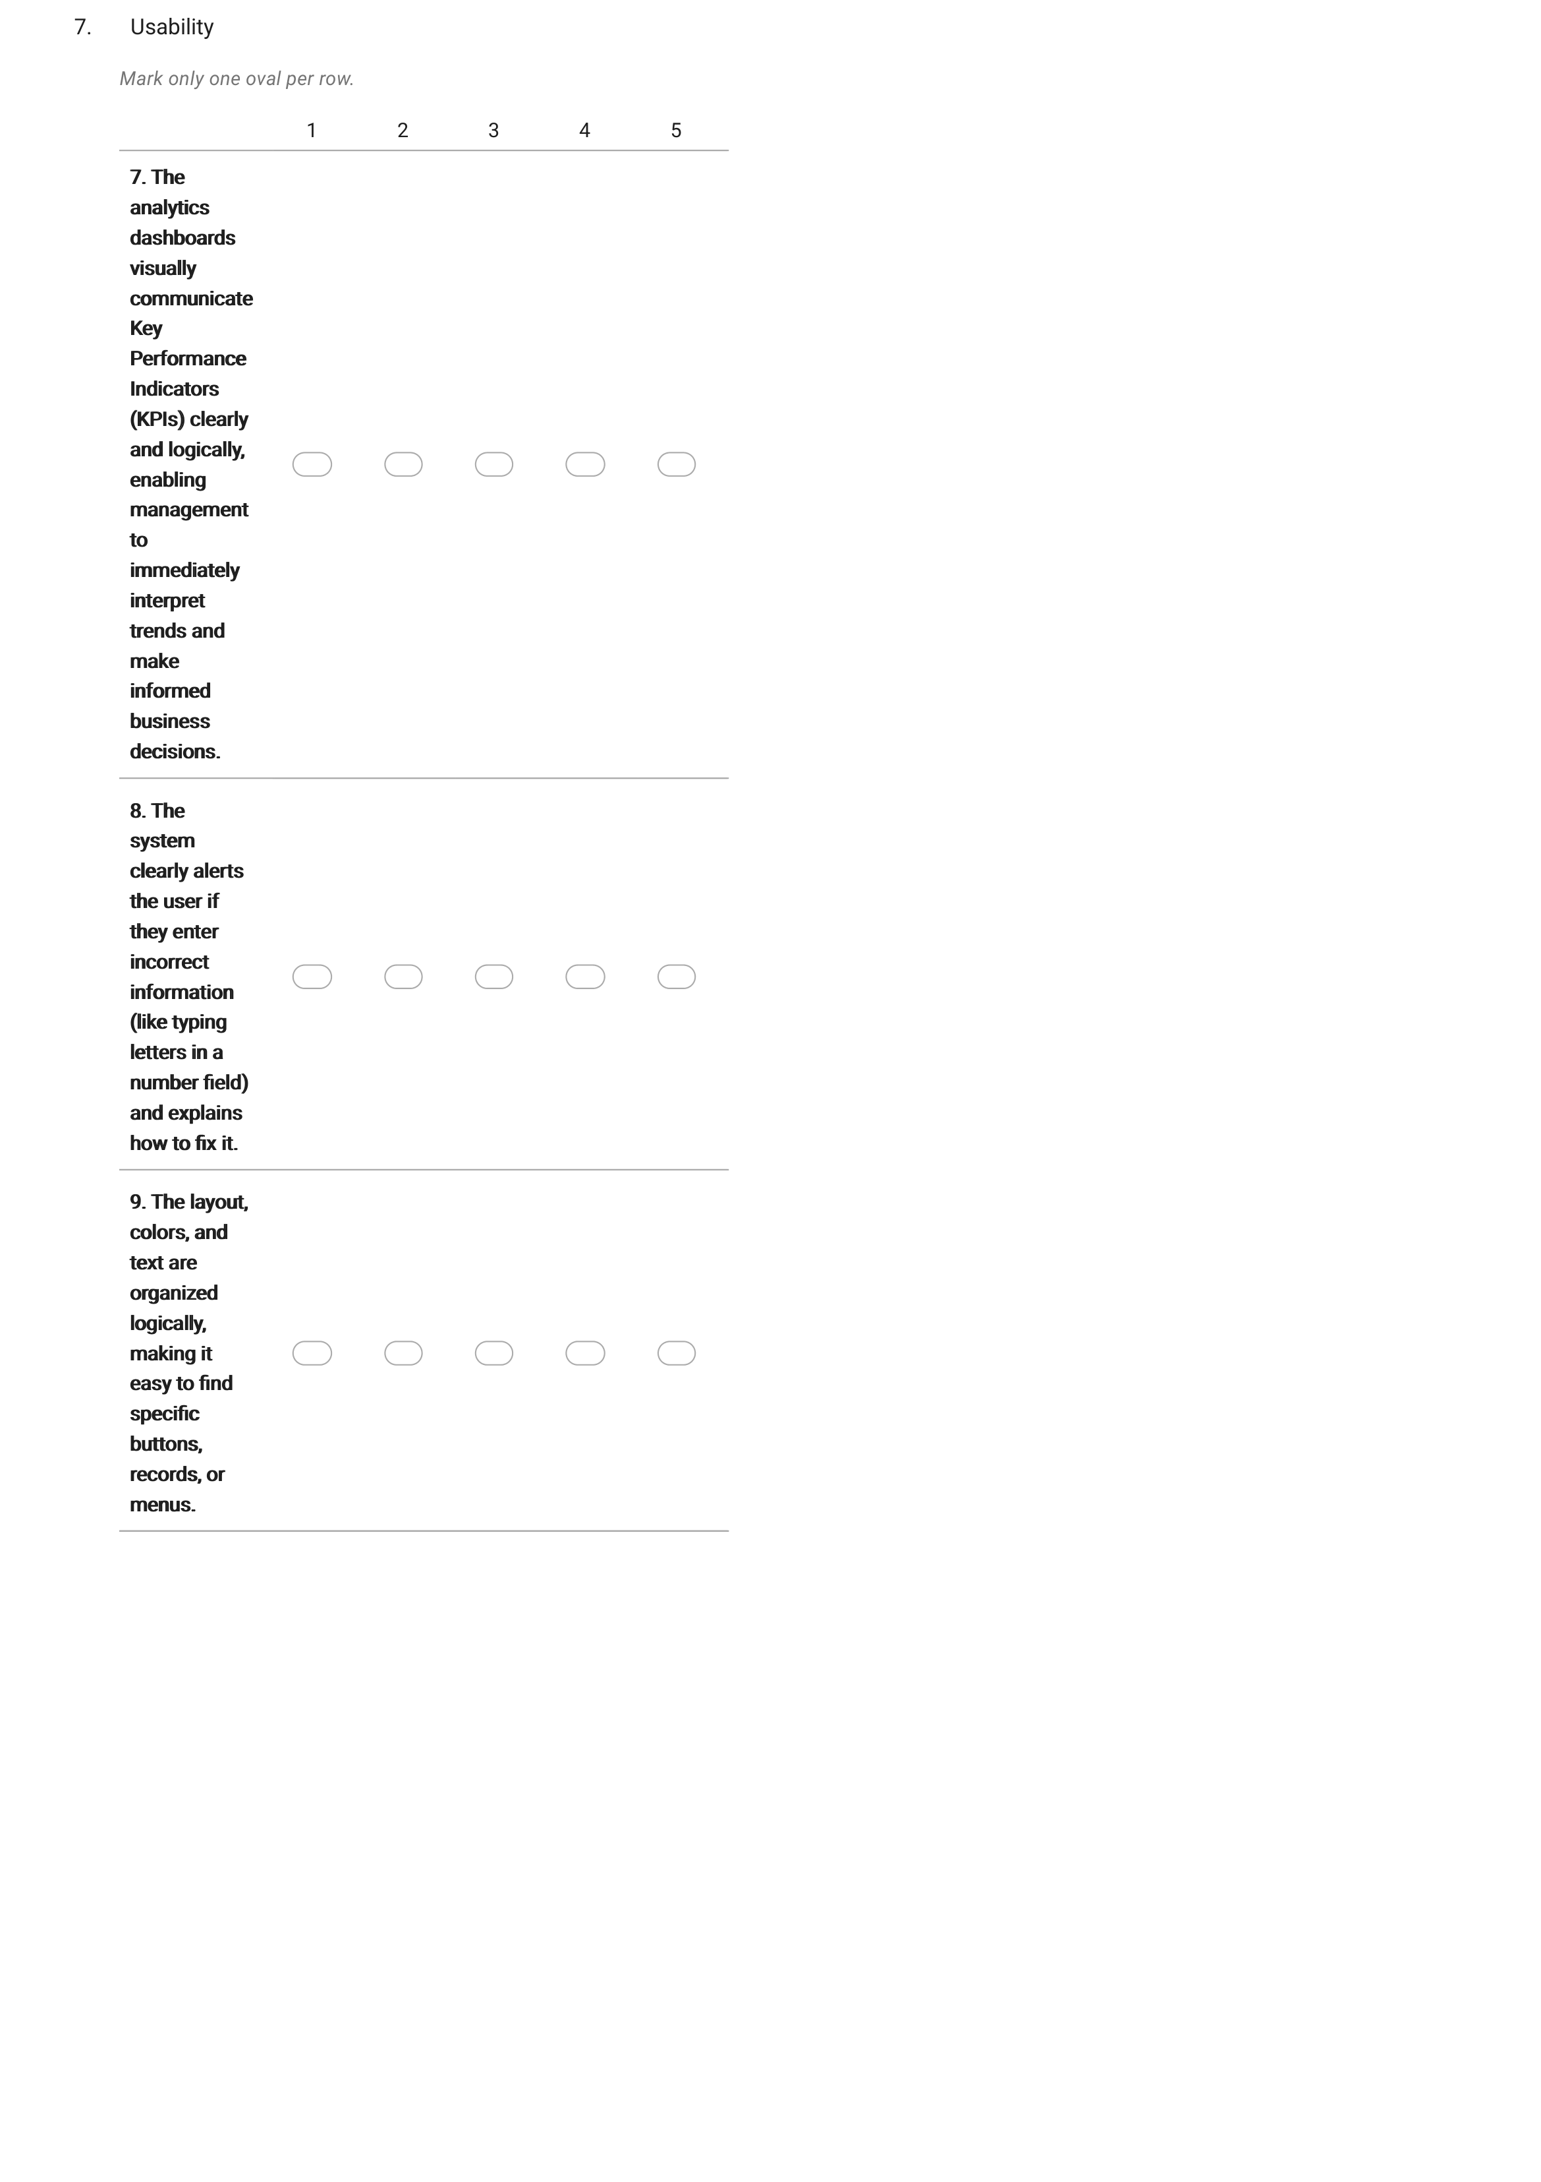
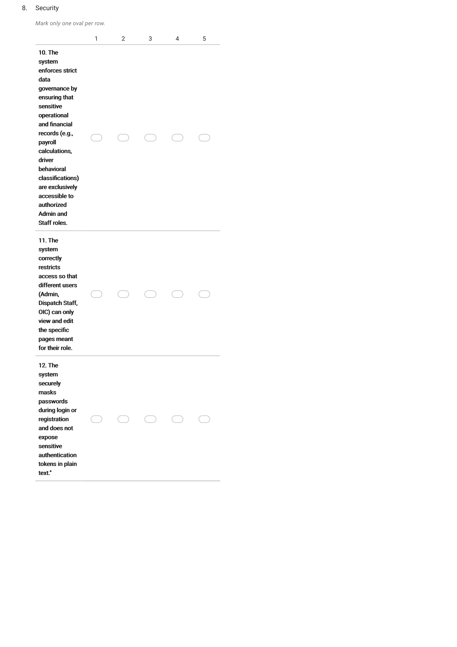

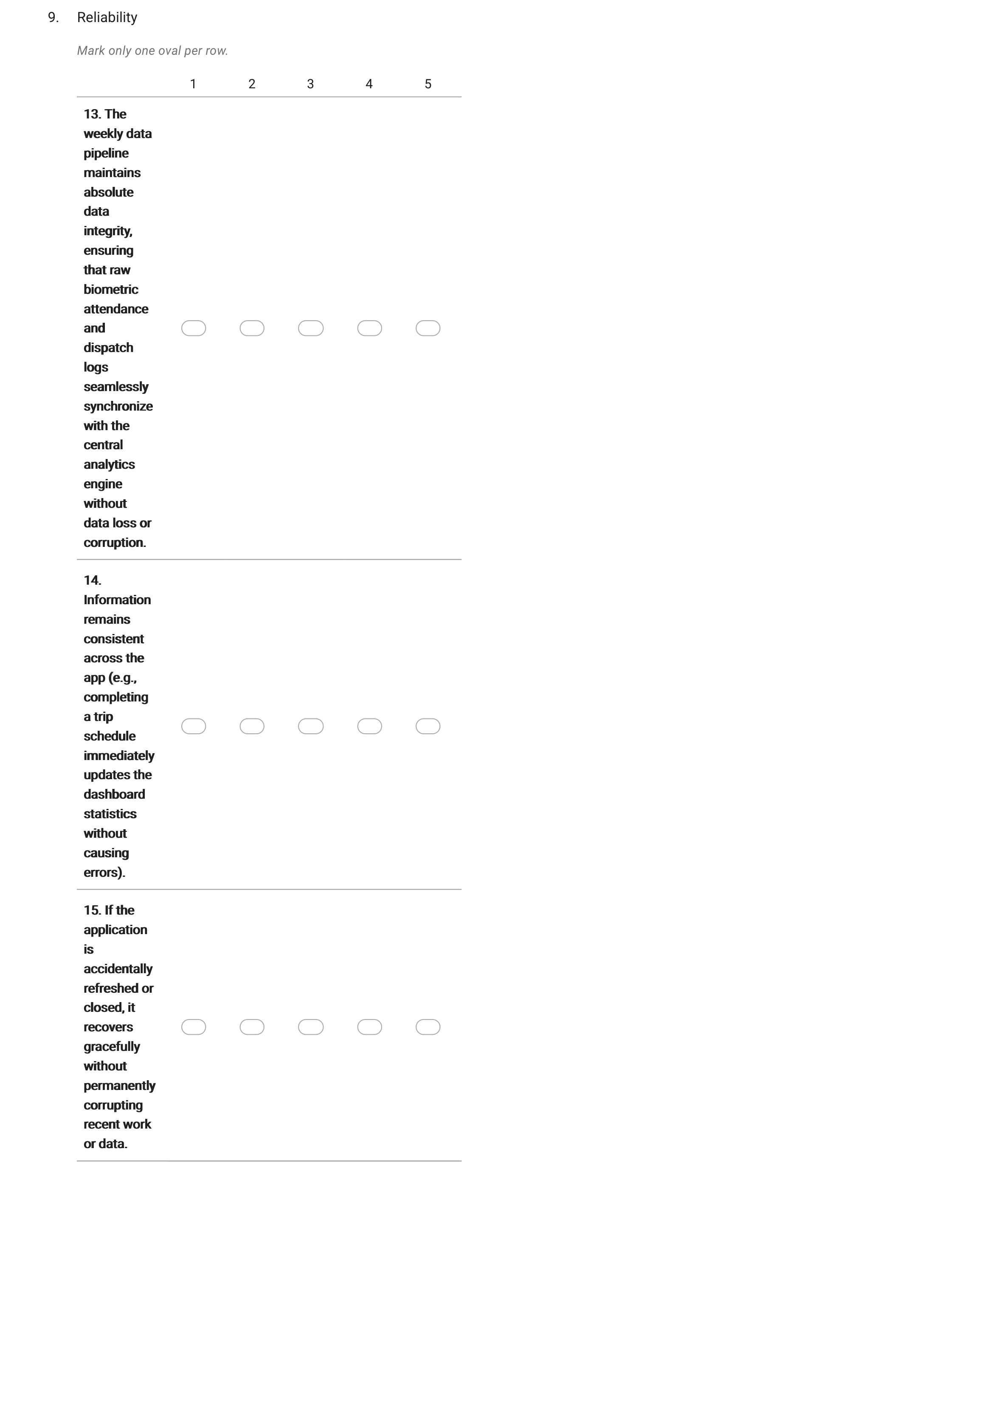
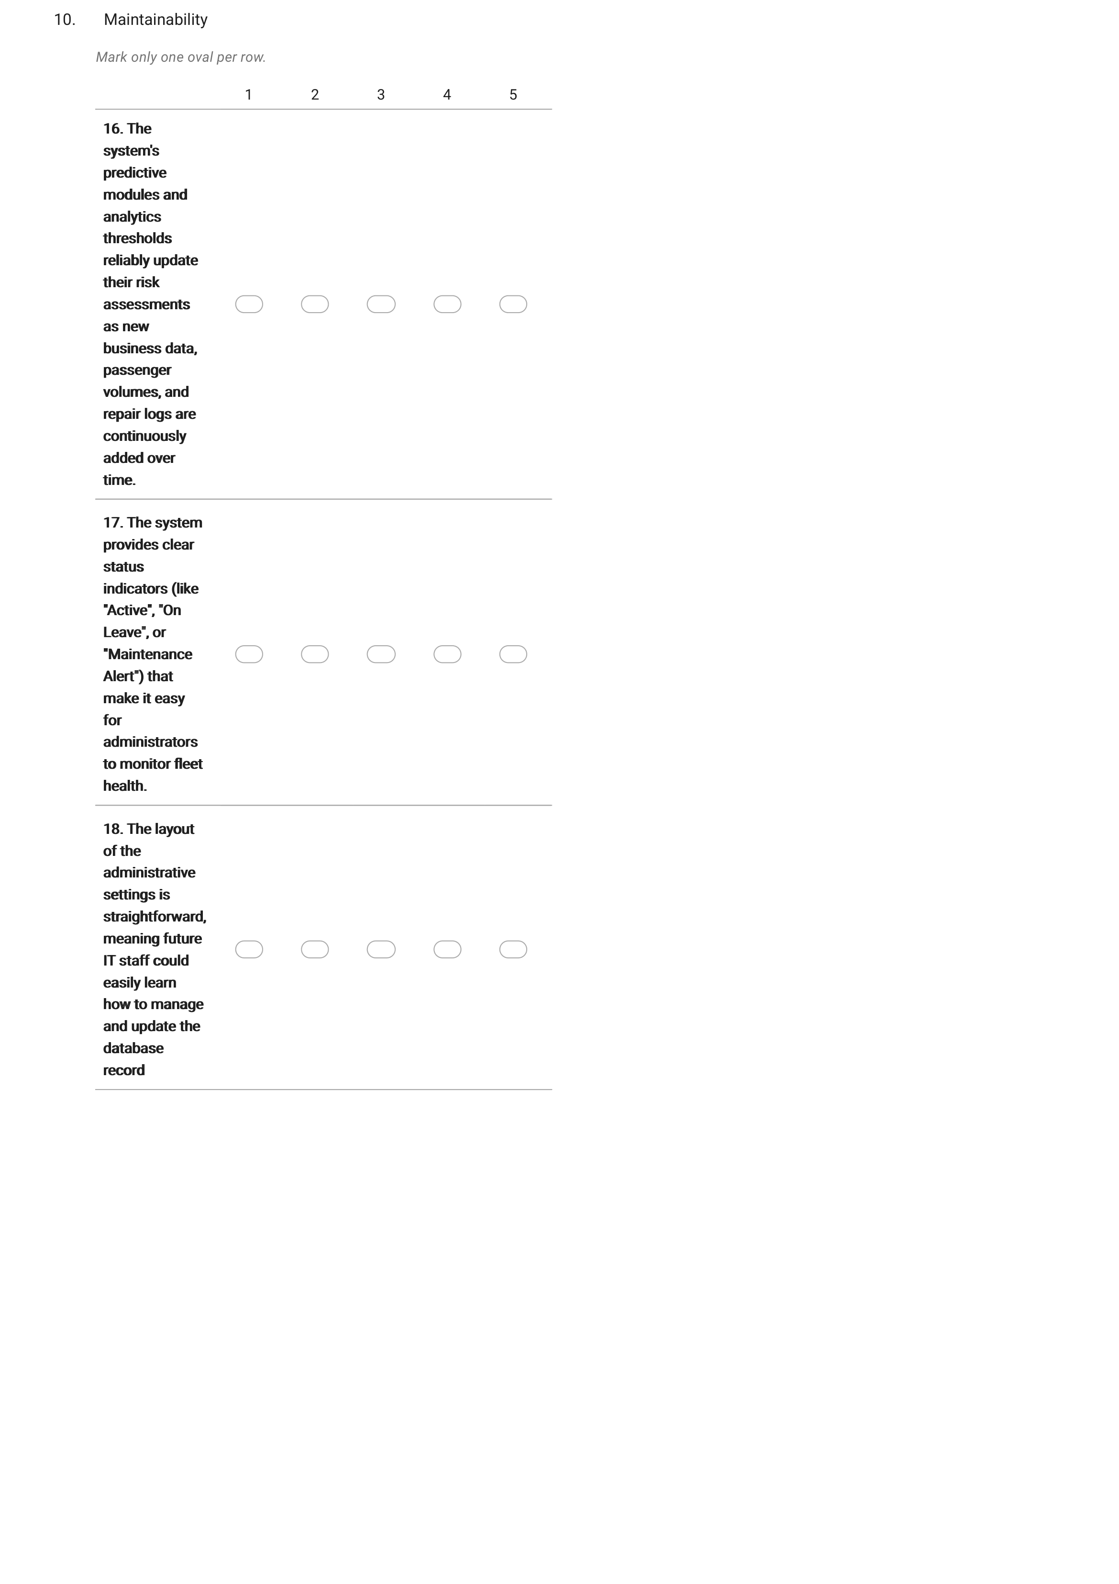
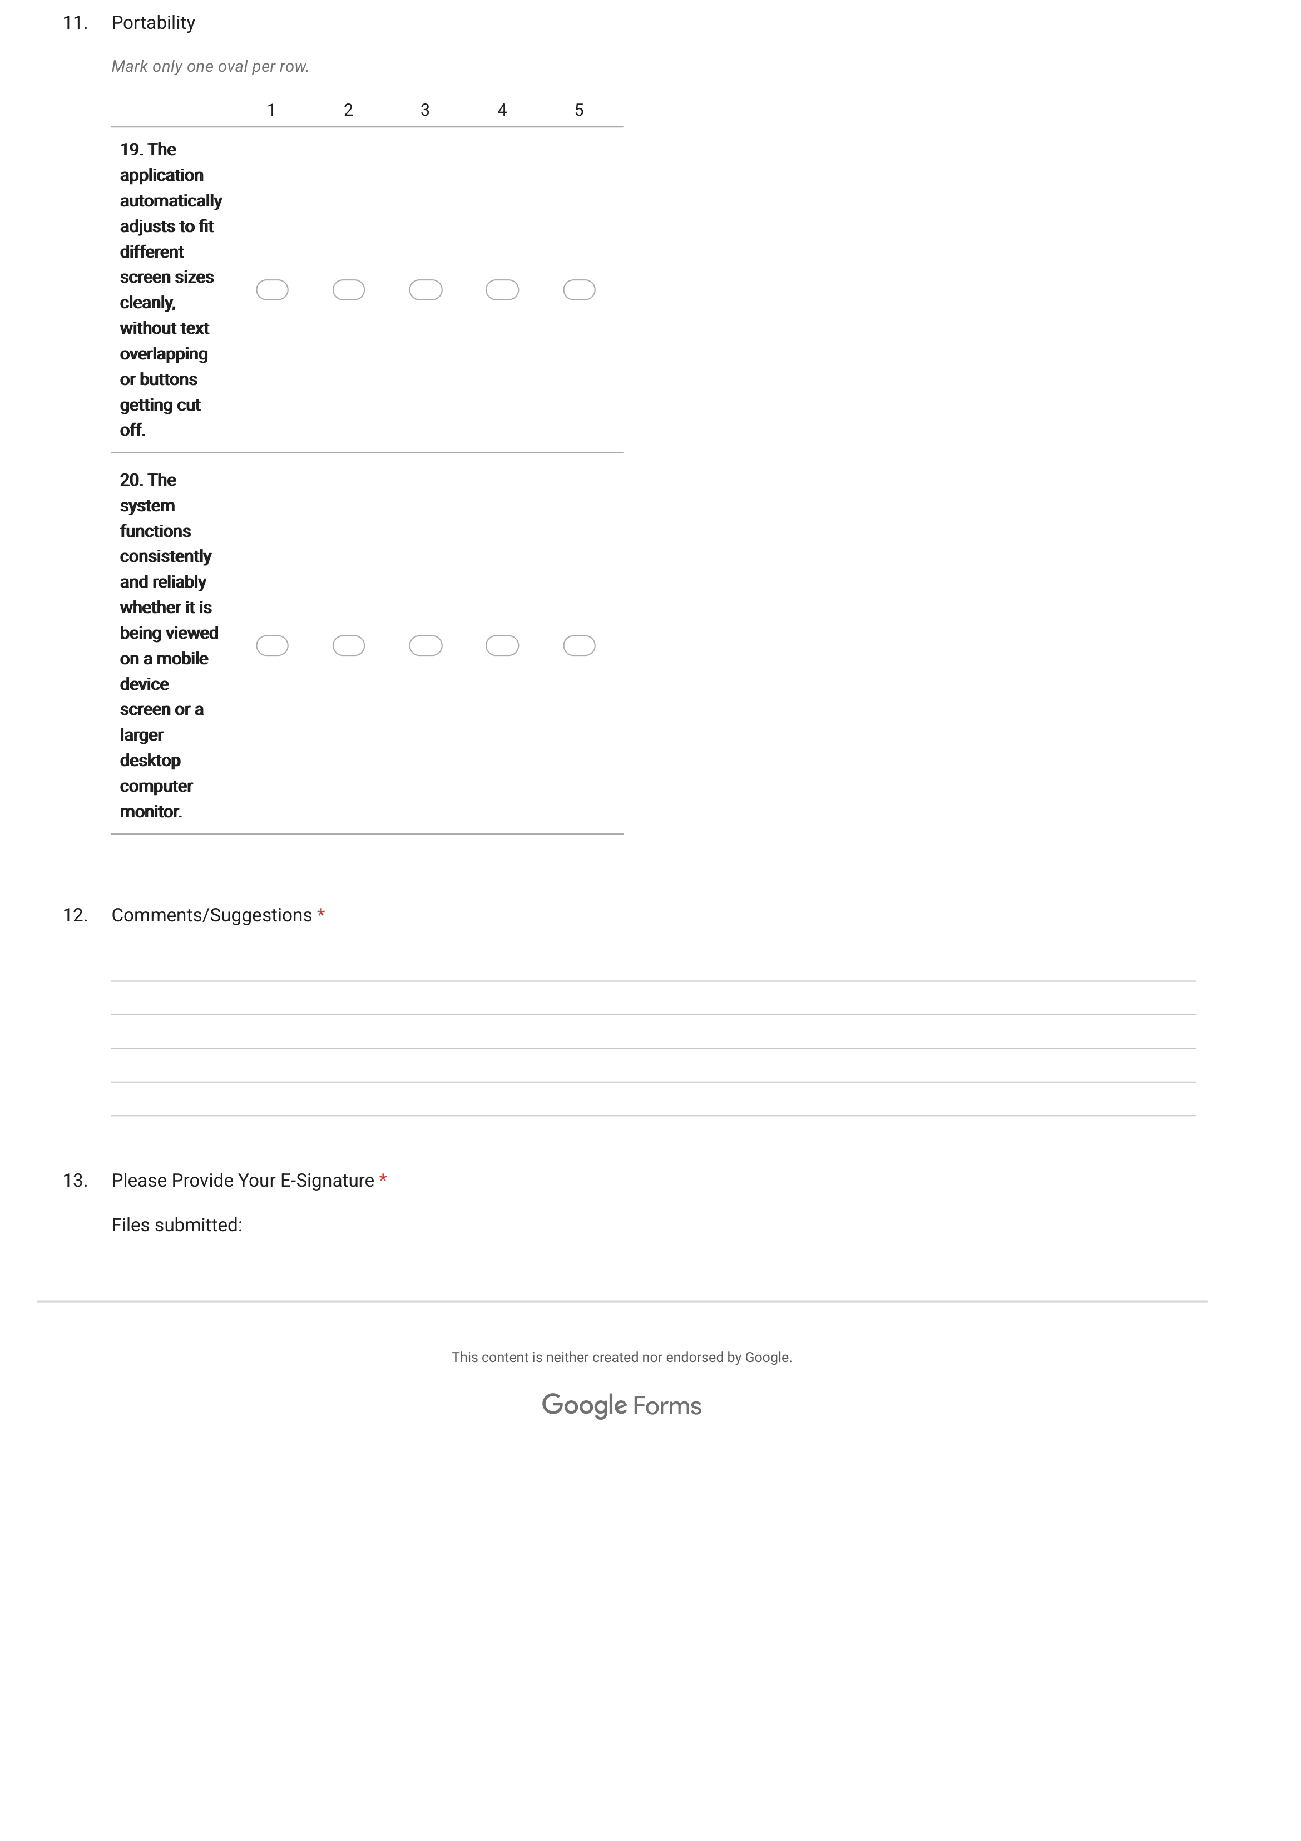
Summary of Functional Suitability
Statement | Mean | Verbal Interpretation
The system accurately generates and displays actionable business intelligence (e.g., K-Means Destination Demand Profiling) to support strategic fleet allocation and resource planning. | 4.60 | Strongly Agree
The system correctly aggregates the weekly Thursday/Friday operational data (biometric attendance and completed trips) to accurately process baseline payroll and financial extras without calculation errors. | 4.50 | Strongly Agree
The system correctly performs calculations without errors, such as computing a driver’s exact average rating from multiple evaluations. | 4.70 | Strongly Agree
Average Mean | 4.60 | Strongly Agree

Summary of Performance Efficiency
Statement | Mean | Verbal Interpretation
The analytics dashboards and predictive machine learning models (e.g., maintenance forecasting) process historical data and generate visual reports quickly without disrupting daily administrative workflows. | 4.50 | Strongly Agree
The application remains smooth and responsive when rapidly navigating between different tabs (like Fleet, Drivers, and Schedules). | 4.30 | Strongly Agree
The system does not noticeably slow down, freeze, or cause the device to lag after being used for an extended period | 4.60 | Strongly Agree
Average Mean | 4.47 | Strongly Agree
Summary of Usability
Statement | Mean | Verbal Interpretation
The analytics dashboards visually communicate Key Performance Indicators (KPIs) clearly and logically, enabling management to immediately interpret trends and make informed business decisions | 4.60 | Strongly Agree
The system clearly alerts the user if they enter incorrect information (like typing letters in a number field) and explains how to fix it. | 4.10 | Strongly Agree
The layout, colors, and text are organized logically, making it easy to find specific buttons, records, or menus. | 4.20 | Strongly Agree
Average Mean | 4.30 | Strongly Agree

Summary of Security
Statement | Mean | Verbal Interpretation
The system enforces strict data governance by ensuring that sensitive operational and financial records (e.g., payroll calculations, driver behavioral classifications) are exclusively accessible to authorized Admin and Staff roles. | 4.60 | Strongly Agree
The system correctly restricts access so that different users (Admin and Dispatch Staff) can only view and edit the specific pages meant for their role. | 4.50 | Strongly Agree
The system securely masks passwords during login or registration and does not expose sensitive authentication tokens in plain text." | 4.70 | Strongly Agree
Average Mean | 4.60 | Strongly Agree
Summary of Reliability
Statement | Mean | Verbal Interpretation
The weekly data pipeline maintains absolute data integrity, ensuring that raw biometric attendance and dispatch logs seamlessly synchronize with the central analytics engine without data loss or corruption. | 4.60 | Strongly Agree
Information remains consistent across the app (e.g., completing a trip schedule immediately updates the dashboard statistics without causing errors). | 4.30 | Strongly Agree
If the application is accidentally refreshed or closed, it recovers gracefully without permanently corrupting recent work or data. | 4.30 | Strongly Agree
Average Mean | 4.30 | Strongly Agree
Summary of Maintainability
Statement | Mean | Verbal Interpretation
The system's predictive modules and analytics thresholds reliably update their risk assessments as new business data, passenger volumes, and repair logs are continuously added over time. | 4.50 | Strongly Agree
The system provides clear status indicators (like "Active", "On Leave", or "Maintenance Alert") that make it easy for administrators to monitor fleet health. | 4.60 | Strongly Agree
The layout of the administrative settings is straightforward, meaning future IT staff could easily learn how to manage and update the database record | 4.40 | Strongly Agree
Average Mean | 4.50 | Strongly Agree

Summary of Portability
Statement | Mean | Verbal Interpretation
The application automatically adjusts to fit different screen sizes cleanly, without text overlapping or buttons getting cut off. | 4.60 | Strongly Agree
The system functions consistently and reliably whether it is being viewed on a mobile device screen or a larger desktop computer monitor. | 4.50 | Strongly Agree
Average Mean | 4.55 | Strongly Agree

APPENDIX B : SURVEY QUESTIONARE FOR END-USER
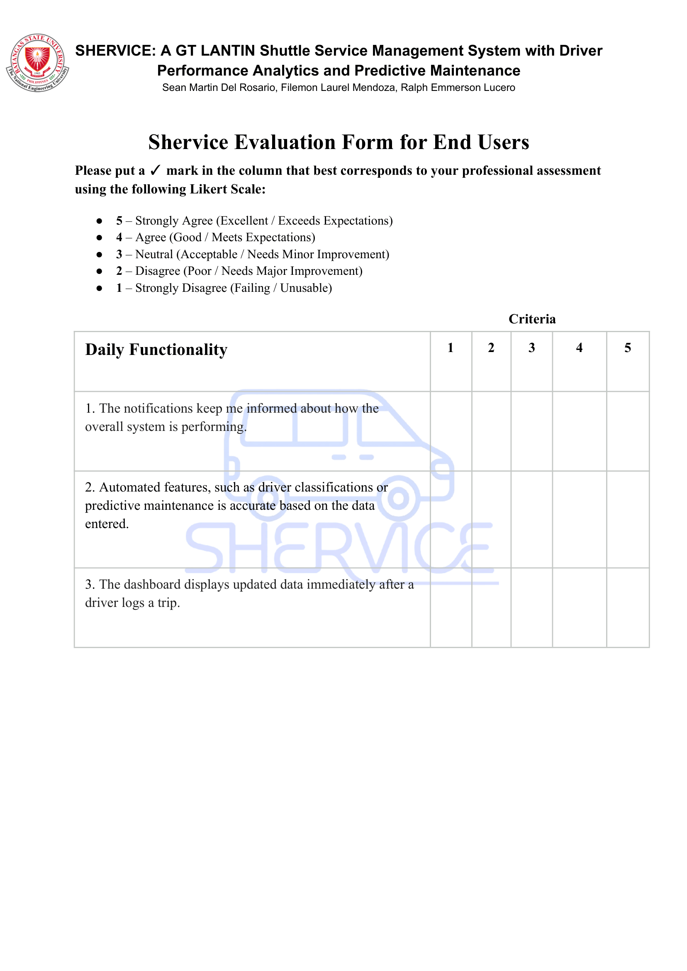
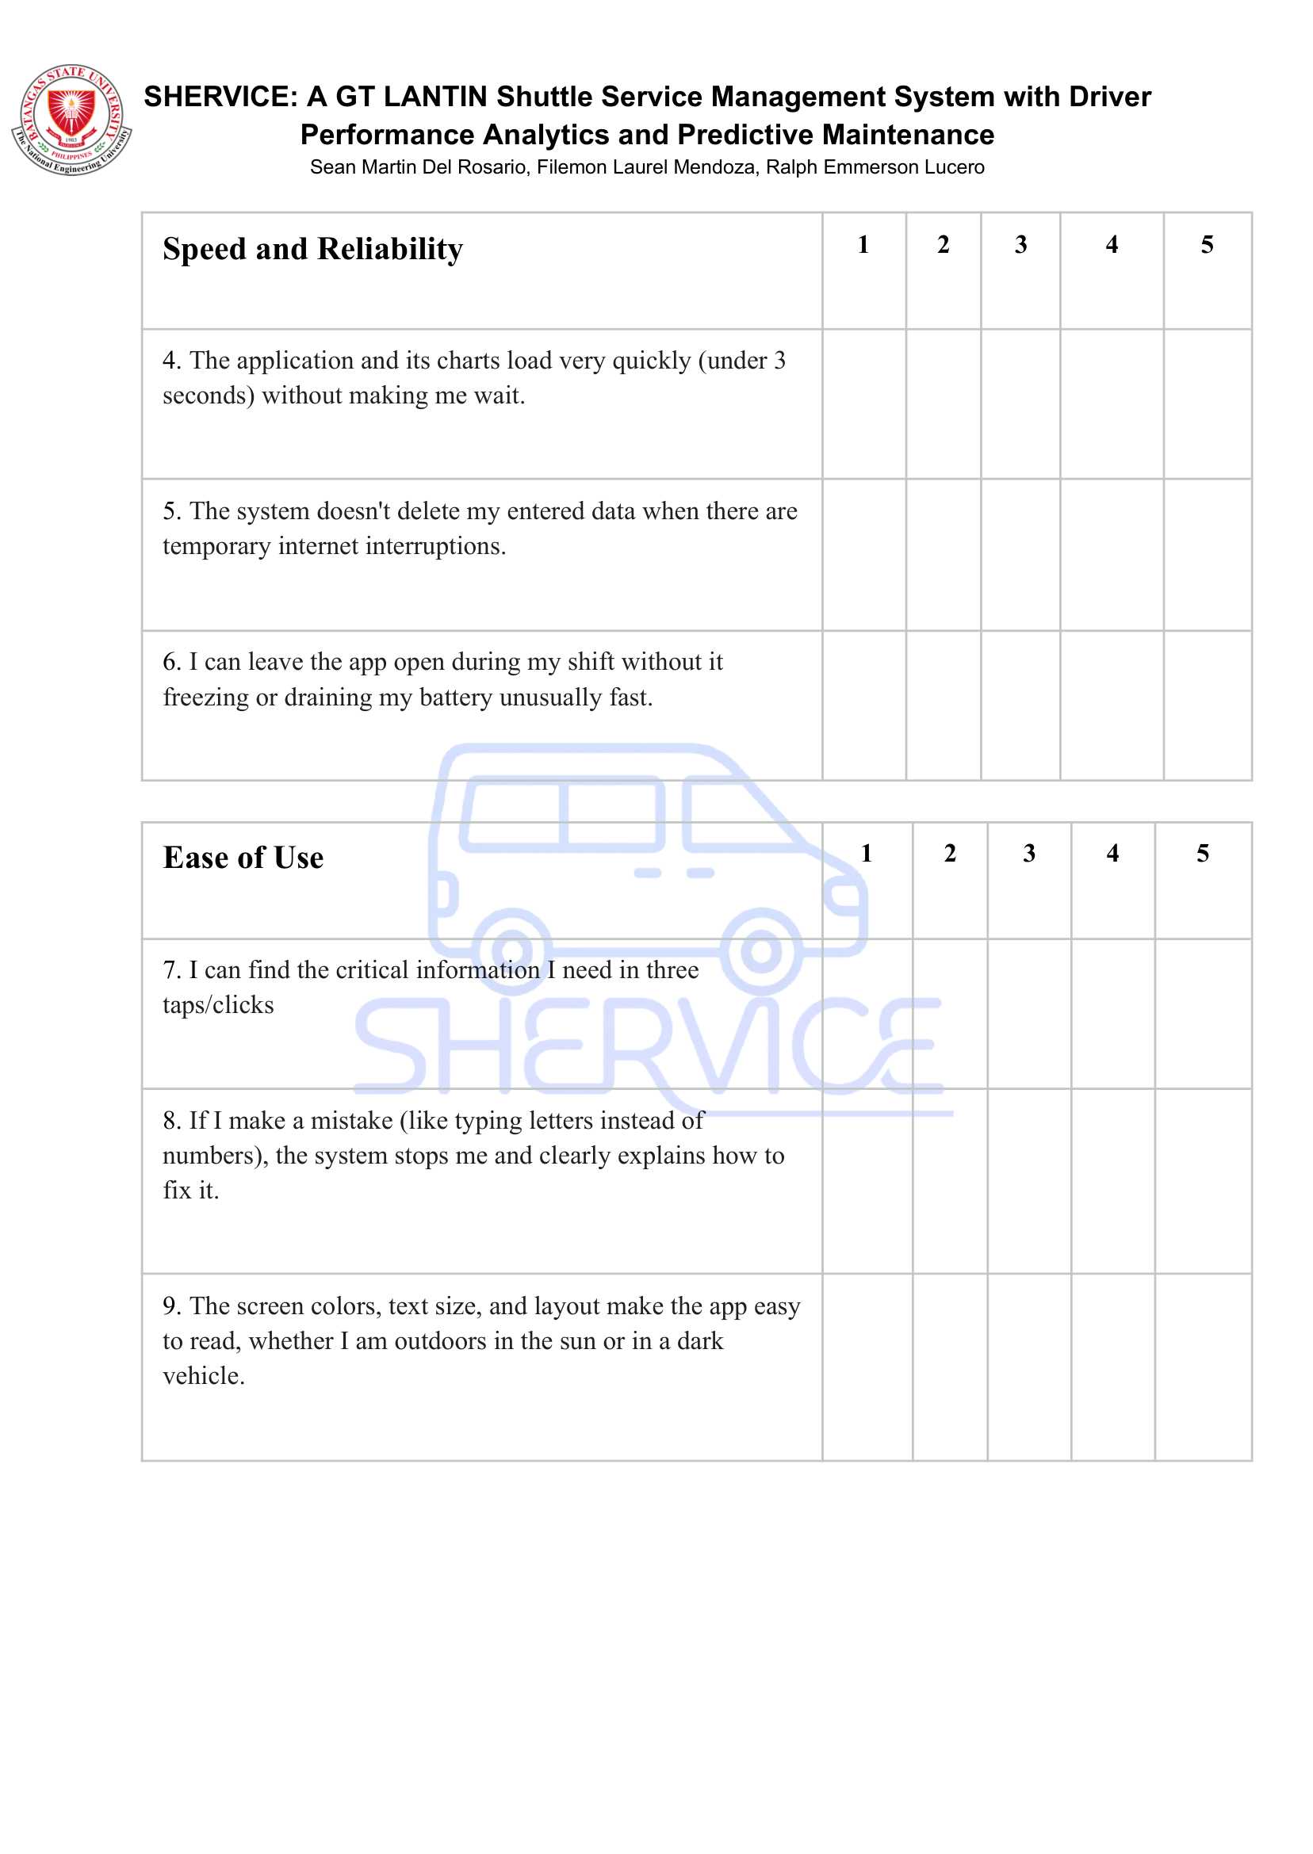
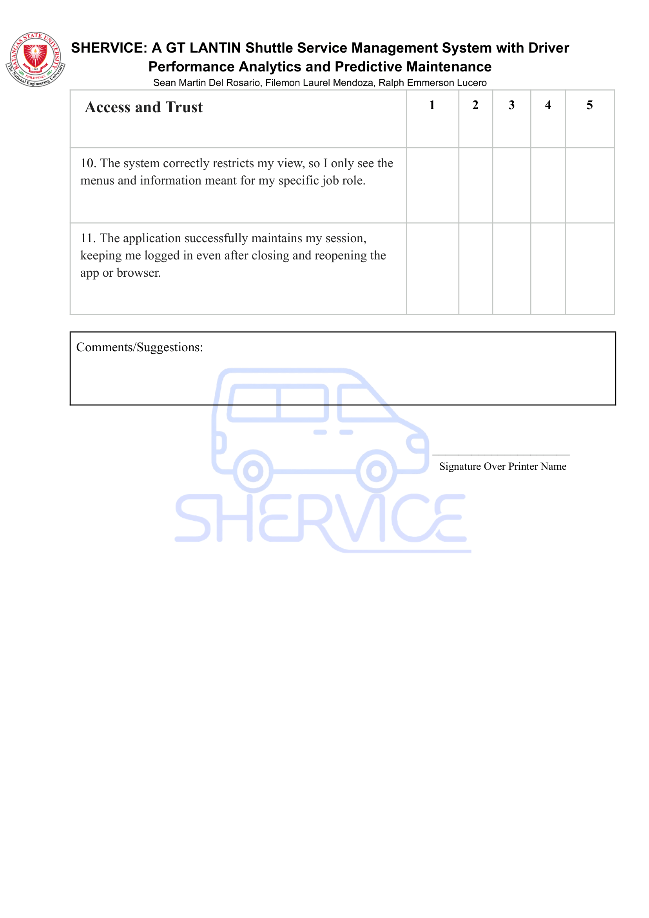

Table 4-4 Summary of Daily Functionality
Statement | Mean | Verbal  Interpretation
The notifications keep me informed about how the  The overall system is performing. | 4.70 | Strongly Agree
Automated features, such as driver classifications or predictive maintenance is accurate based on the data entered. | 4.70 | Strongly Agree
The dashboard displays updated data immediately after a  driver logs a trip. | 4.60 | Strongly Agree
Average Mean | 4.67 | Strongly Agree

Table 4-5 Summary of Speed and Reliability
Statement | Mean | Verbal Interpretation
The application and its charts load very quickly (under 3 seconds) without making me wait. | 4.70 | Strongly Agree
The system doesn't delete my entered data when there are temporary internet interruptions. | 4.50 | Strongly Agree
I can leave the app open during my shift without it freezing or draining my battery unusually fast. | 4.40 | Strongly Agree
Average Mean | 4.53 | Stronly Agree
Table 4-6 Summary of Ease of Use
Statement | Mean | Verbal Interpretation
I can find the critical information I need in three taps/clicks | 4.20 | Strongly Agree
If I make a mistake (like typing letters instead of numbers), the system stops me and clearly explains how to fix it. | 4.50 | Strongly Agree
The screen colors, text size, and layout make the app easy to read, whether I am outdoors in the sun or in a dark vehicle. | 4.20 | Strongly Agree
Average Mean | 4.30 | Strongly Agree
Table 4-7 Summary of Access and Trust
Statement | Mean | Verbal Interpretation
The system correctly restricts my view, so I only see the  menus and information meant for my specific job role. | 4.50 | Strongly Agree
The application successfully maintains my session, keeping me logged in even after closing and reopening the app or browser. | 4.70 | Strongly Agree
Average Mean | 4.60 | Strongly Agree

APPENDIX C : APPROVED LETTER FOR SURVEY
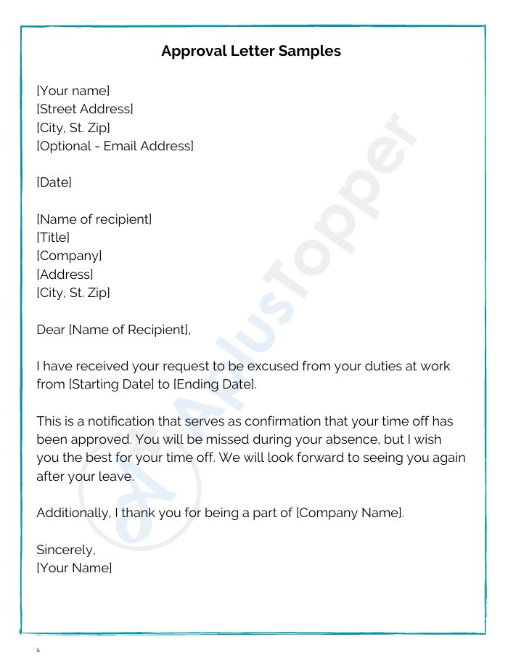

Appendix D: CLIENT ACCEPTANCE LETTER
Appendix E: ACCEPTANCE FORM
Appendix F: ENDORSEMENT FORM

Appendix G: MAINTENANCE COST
Maintenance Category | Description | Estimated Annual Cost (PHP)
Cloud Hosting | Hosting for web application and backend API services | ₱4,000.00
Domain | Annual custom domain renewal | ₱700.00
Technical Support | Bi-annual system maintenance, database optimization, and model retraining | ₱5,000.00
Total Estimated Annual Cost |  | ₱9,700.00

Appendix H: EXPENDITURES
Expense Category | Item Description | Billing Frequency / Basis | Cost (PHP)
Transportation | Fuel and transit expenses for client consultations and adviser meetings | Cumulative project estimate | ₱500.00
Development Tools | Codex subscription for code optimization and assistance | One-time | ₱1,100.00
Domain Registration | Railway custom domain registration | Annual fee | ₱693.00
Cloud Hosting & Infrastructure | Railway cloud hosting (Node.js API, Python Flask ML service, PostgreSQL) | ₱663.00 | ₱3,315.00
Total Project Expenditure |  |  | ₱5,608.00

Appendix I: WORKPLAN TIMEFRAME
Month (2026) | Development Phase | Specific Activities and Milestones
July | Project Initiation & Architecture Planning | Formulated the initial development plan, finalized the conceptual framework, and selected the modern technology stack (Flutter, Node.js, Python Flask, PostgreSQL) for the system architecture.
August | UI/UX Design & Client Consultation | Initiated frontend development and designed the user interface layout. Conducted coordination meetings with GT LANTIN representatives to oversee project direction and ensure alignment with their operational requirements.
September | System ntegration & Evaluation | Successfully completed the development and integration of the frontend, backend, analytical engine, and database. Conducted comprehensive User Acceptance Testing (UAT) with end-users and technical evaluations with IT experts.
October | Deployment & System Finalization | Procured Codex developer tools, Railway cloud hosting, and the system domain. Finalized the platform by polishing the user interface, securing system vulnerabilities, clearing legacy files, and preparing for the final defense.

Appendix J: CV OF EXTERNAL EXPERTS
Norman Atienza
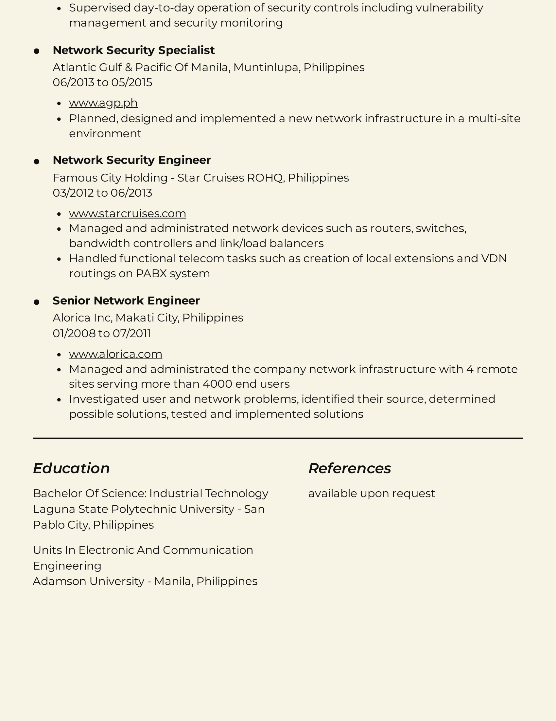

Rene Makalintal
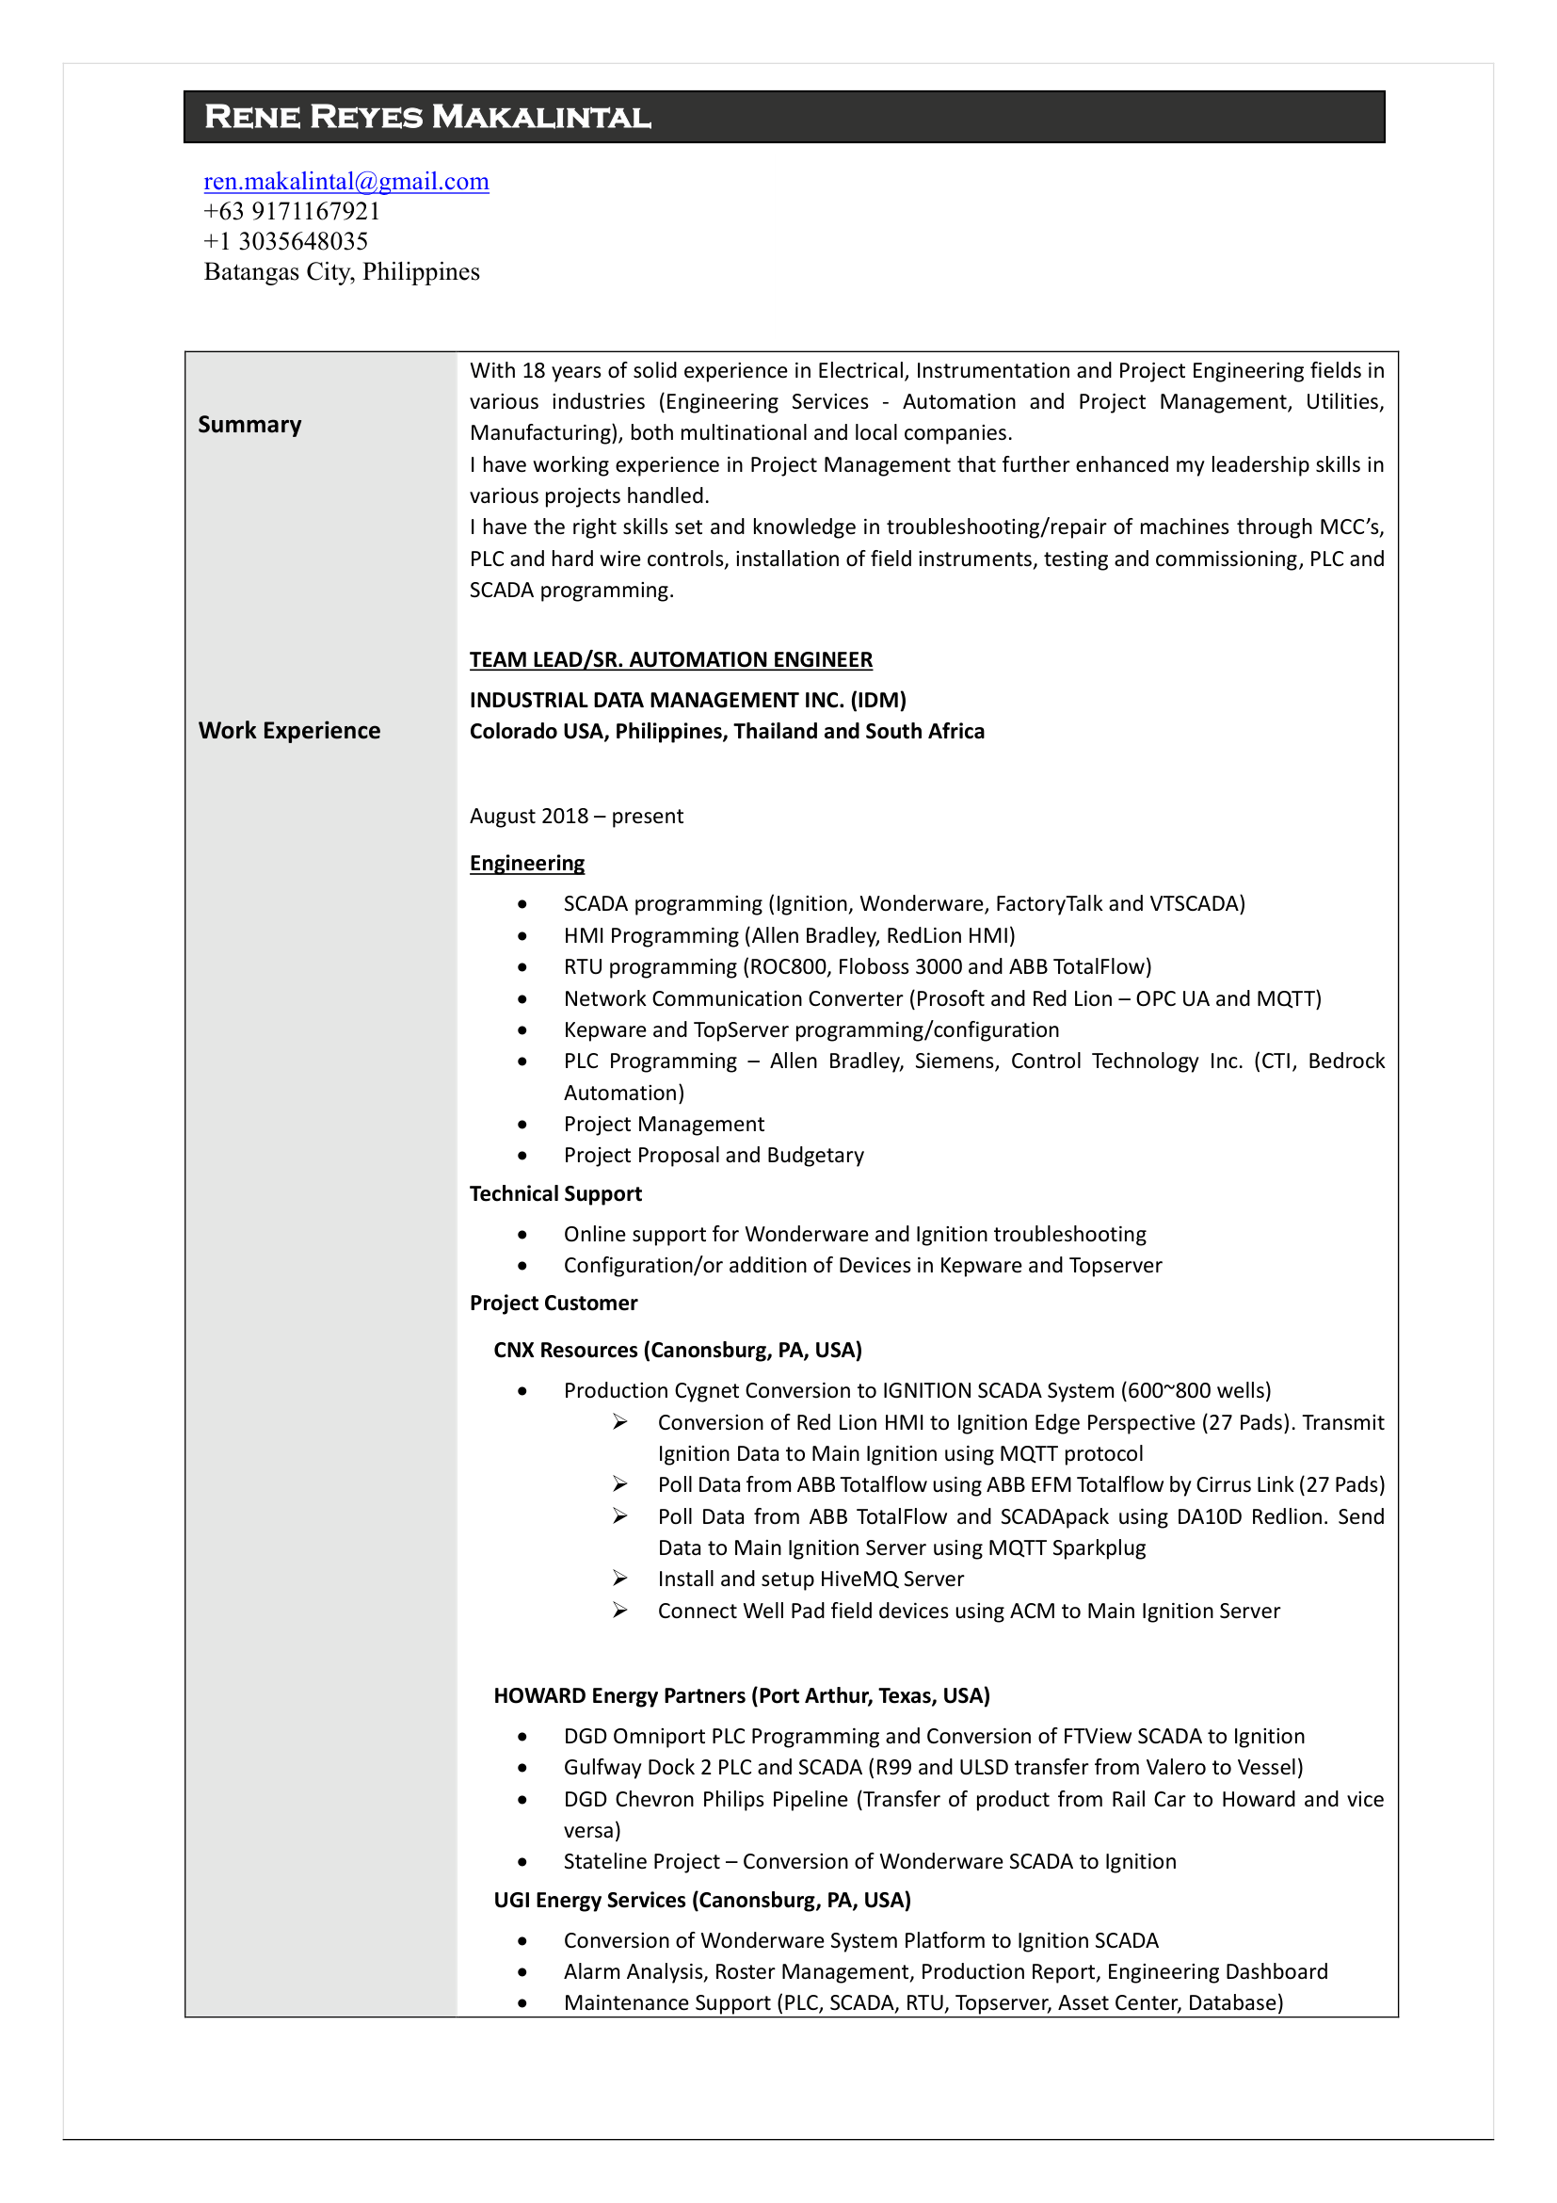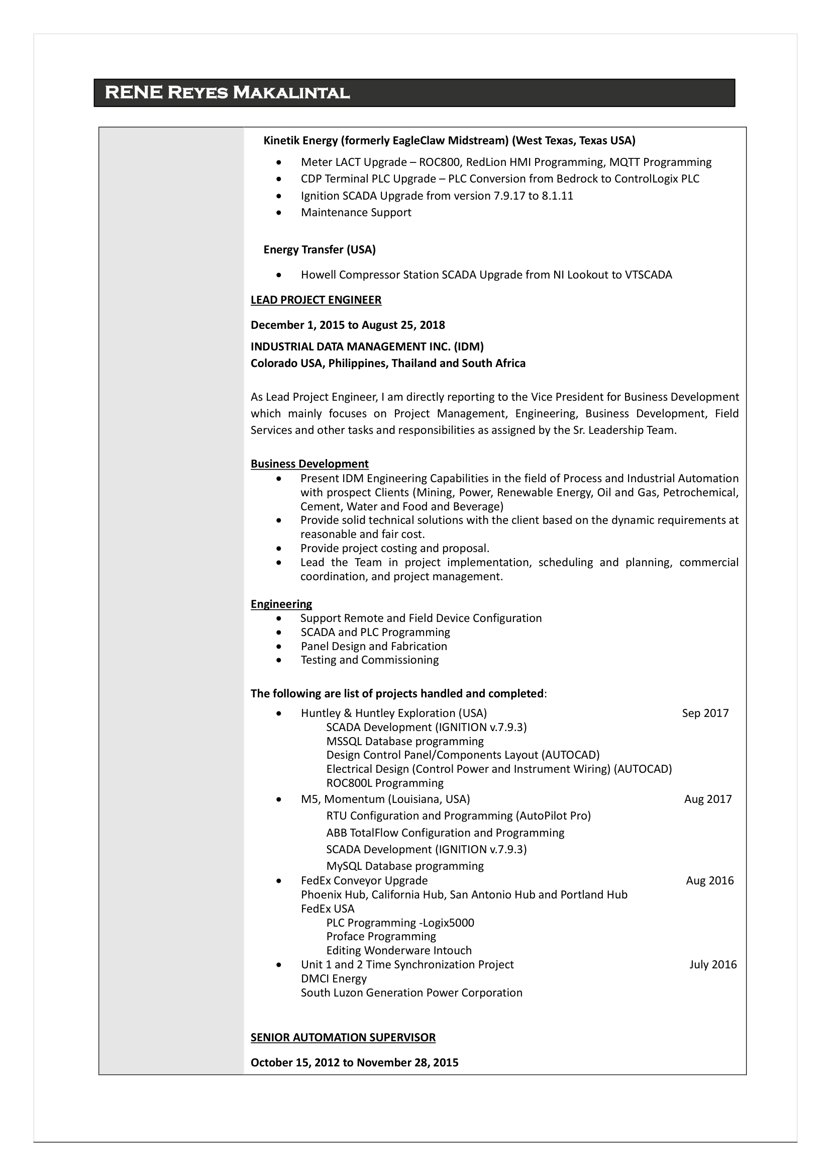
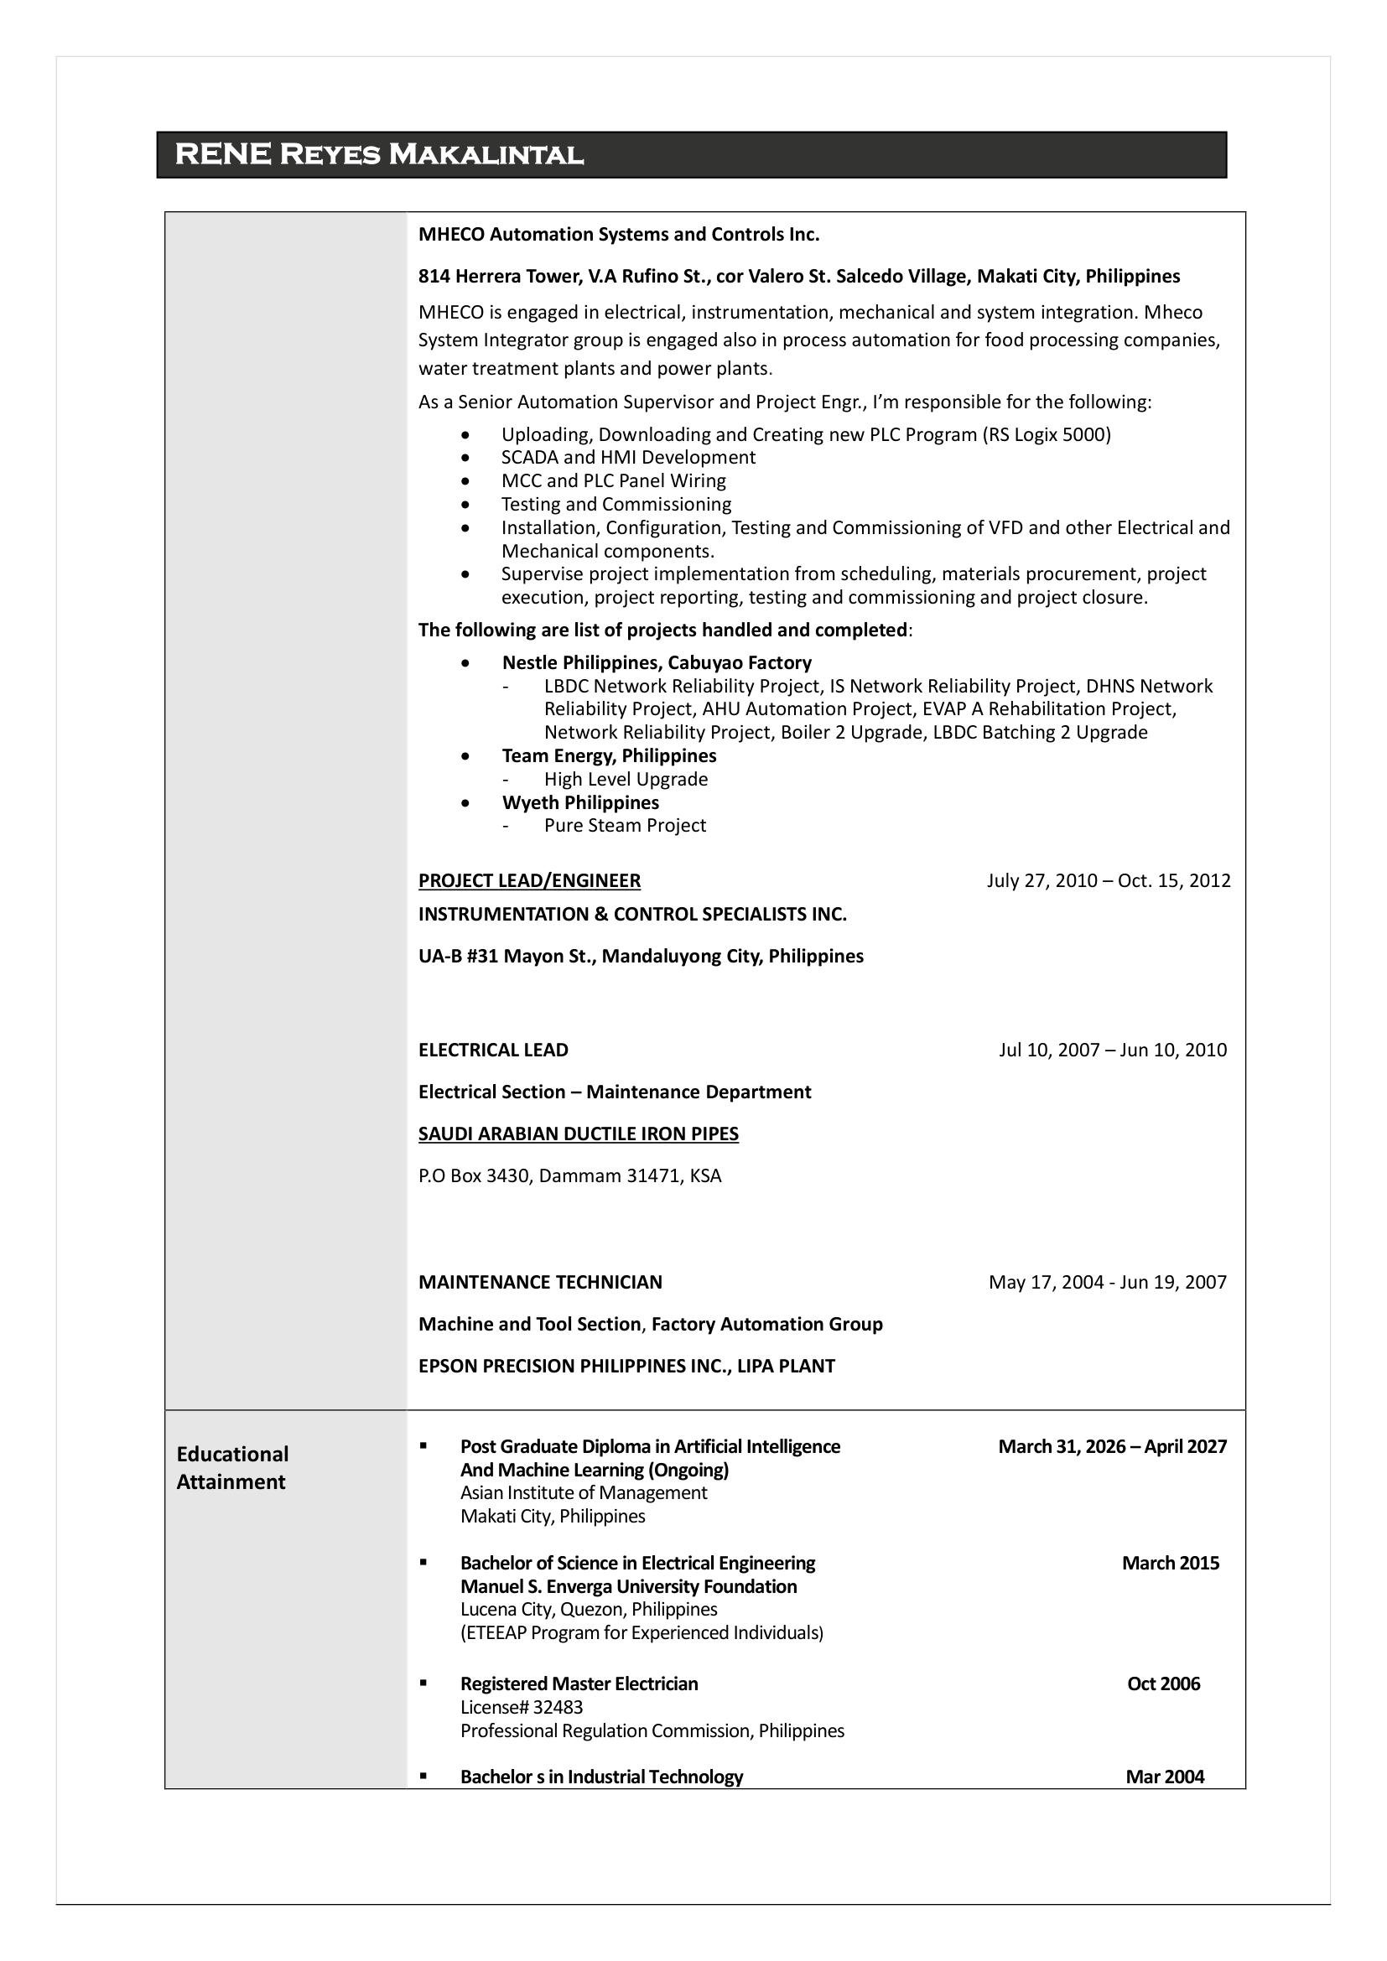

Maria Criselda Tapic
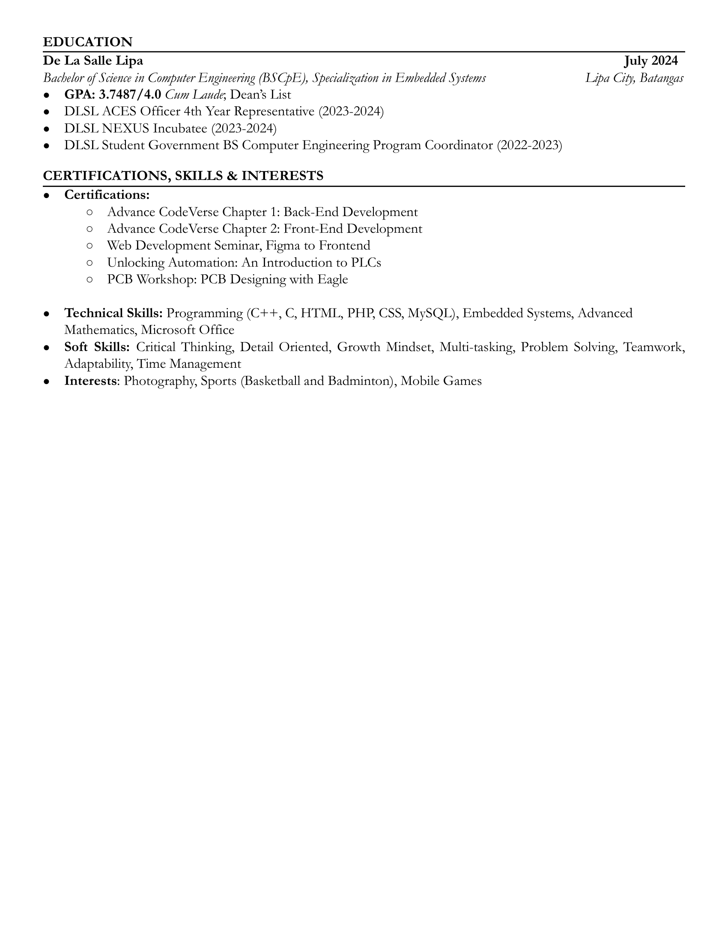

Jann Rose Tiongco
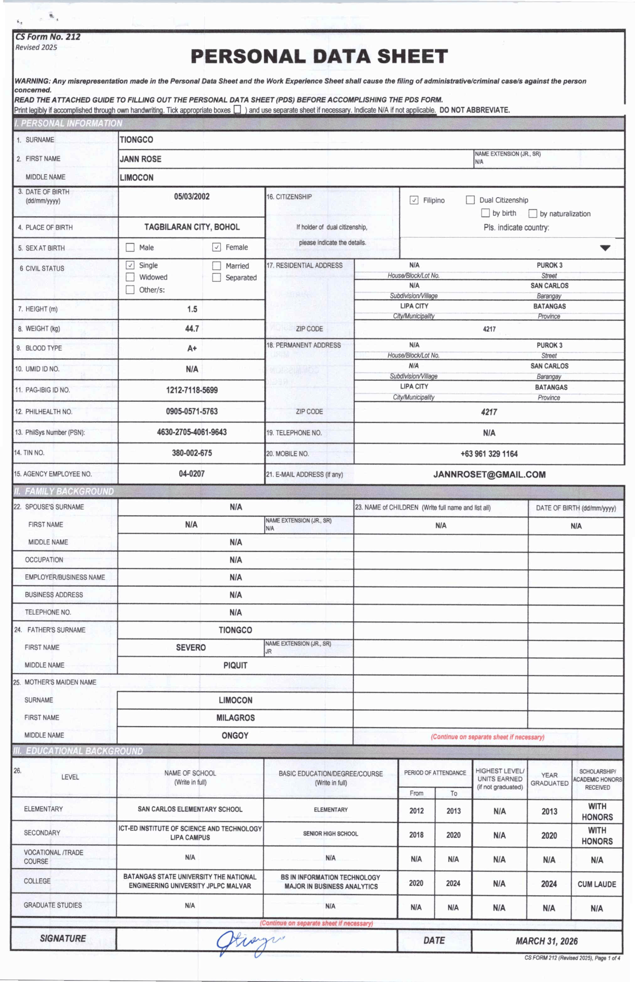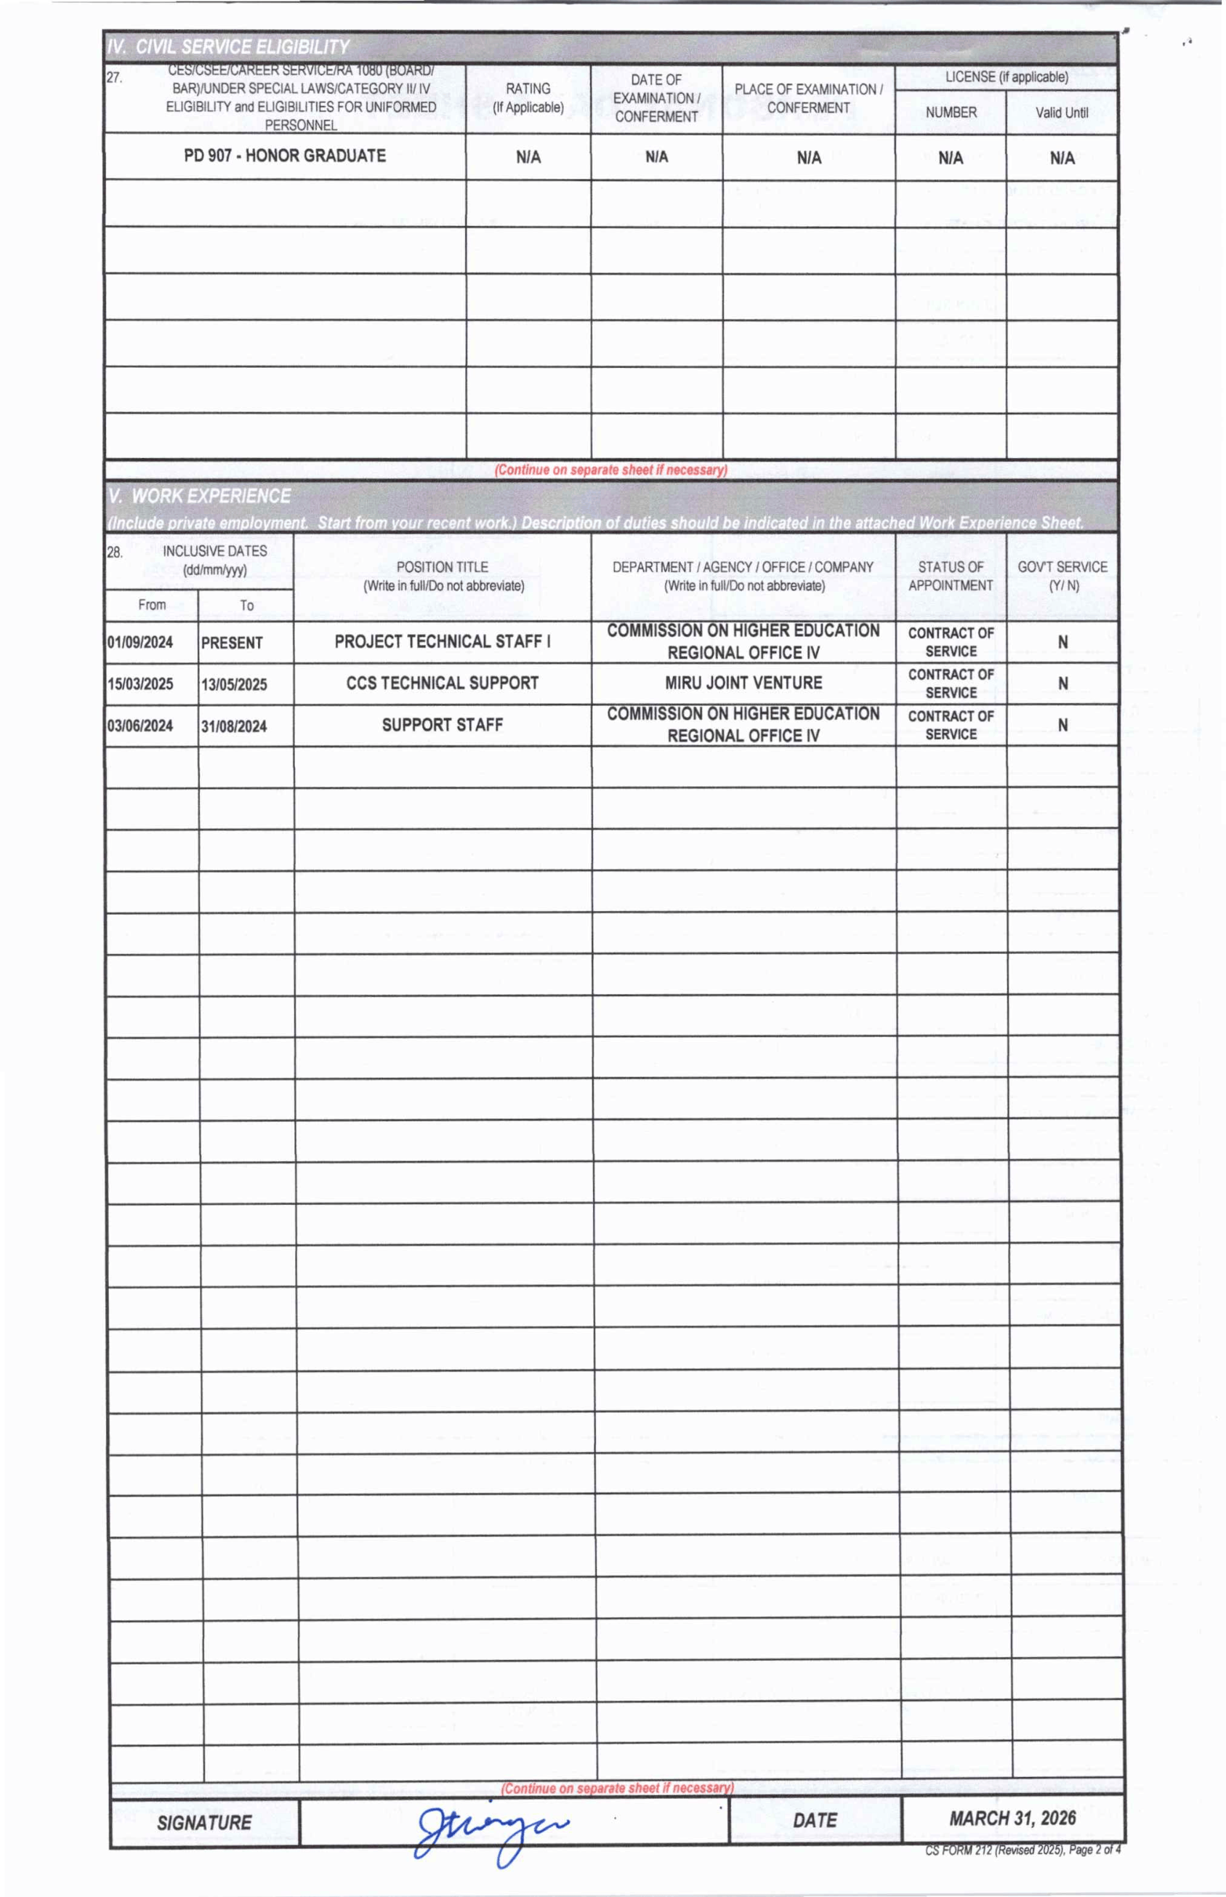

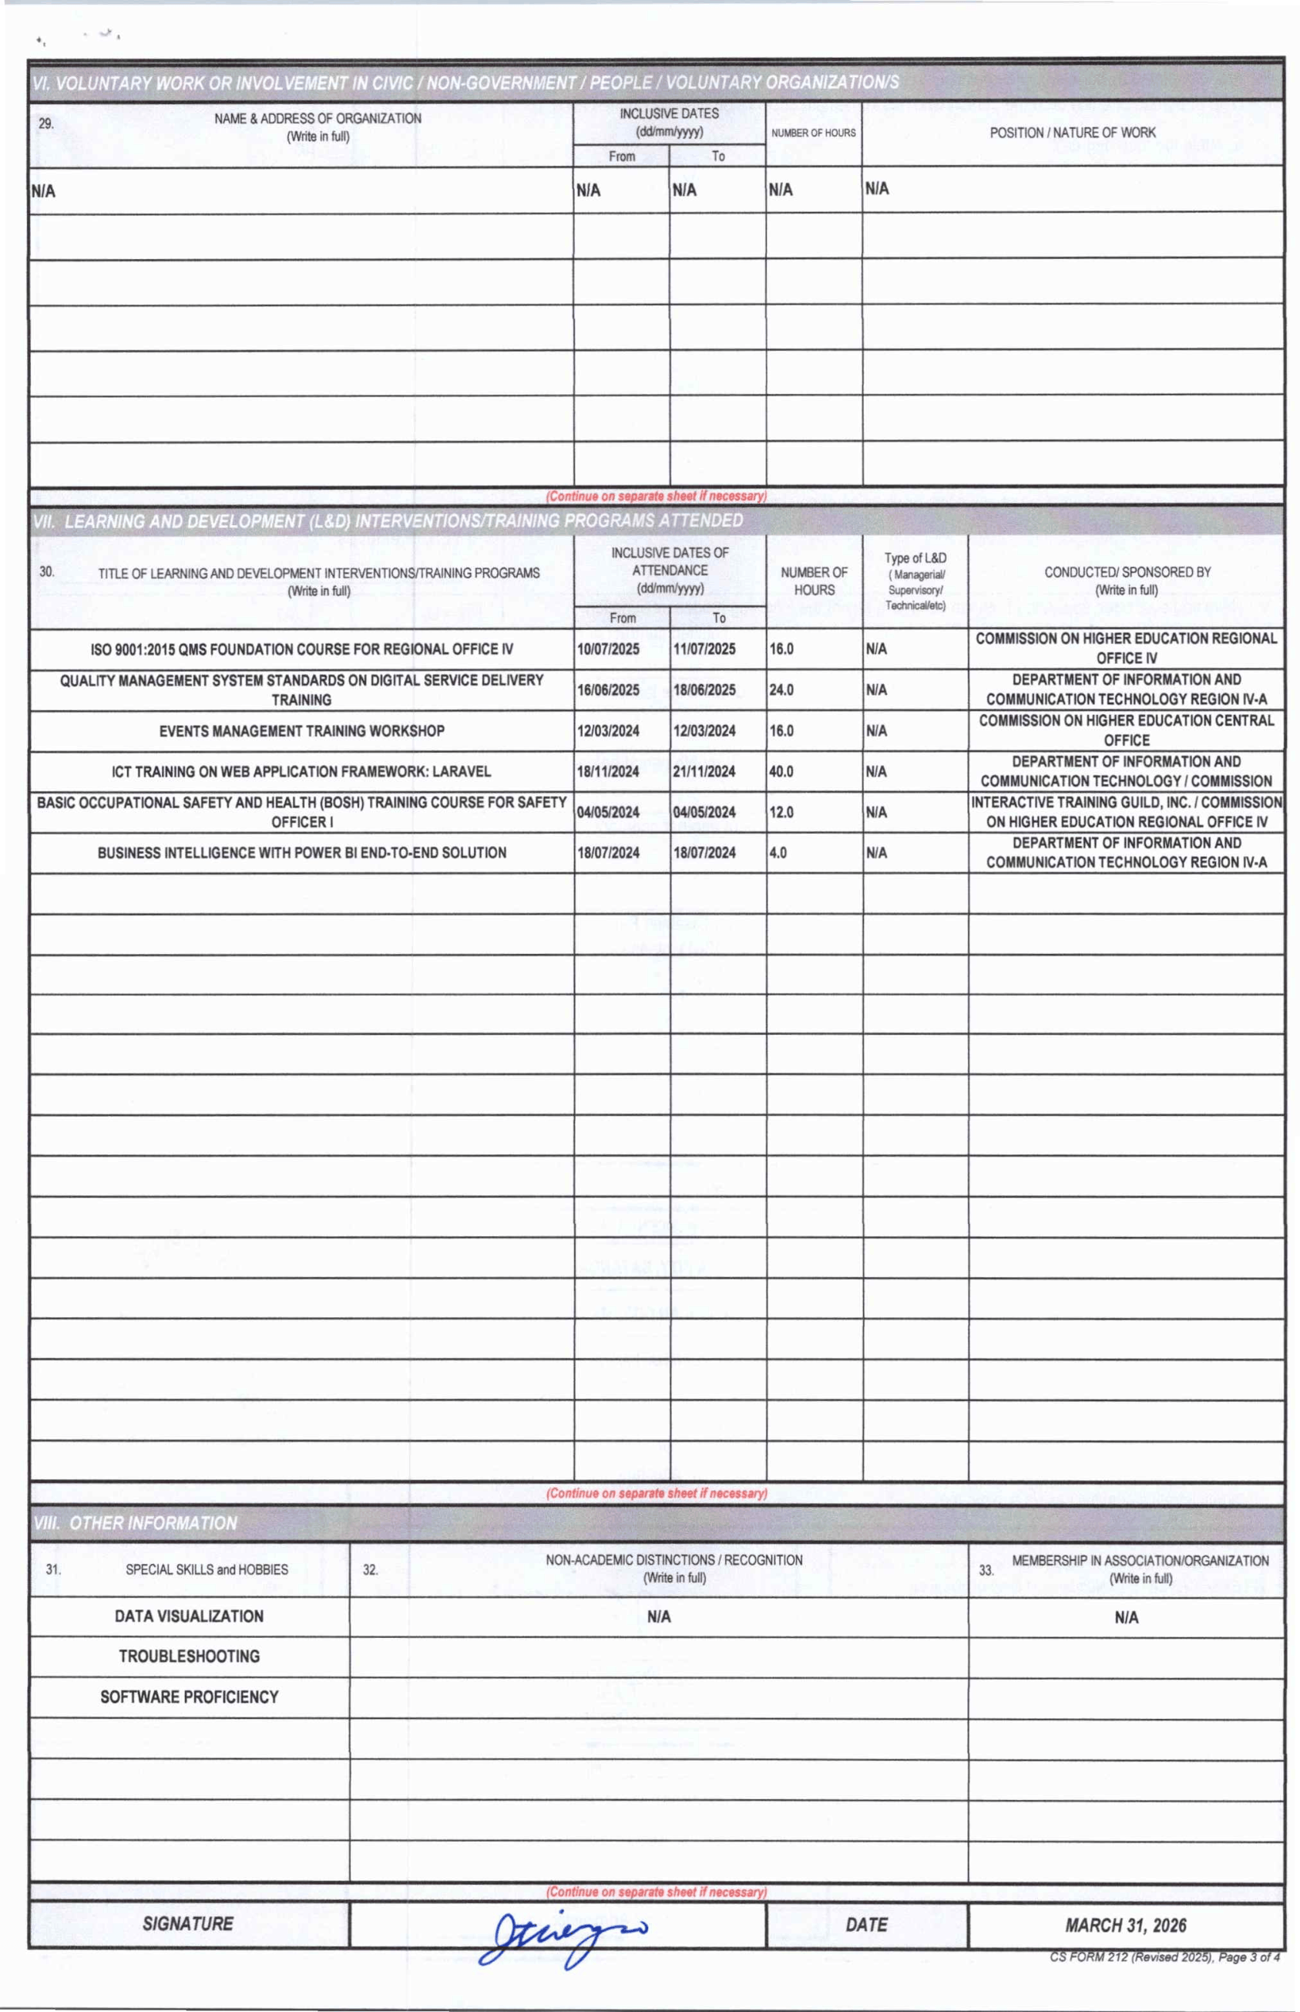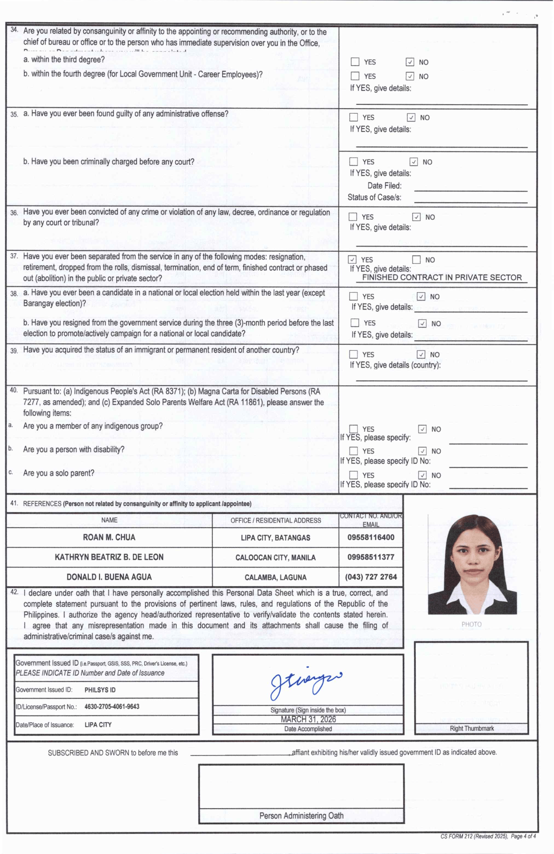

Fredric Ivan Salenga


